MINISTRY OF ENERGY
Republic of Kenya

KENYA OFF-GRID SOLAR ACCESS PROJECT (KOSAP) FOR UNDERSERVED COUNTIES

Comprehensive Project Report (CPR) FOR THE PROPOSED KILIBASI OFF-GRID SOLAR PROJECT AT COORDINATES 23°58'17.6"S 39°00'08.2"E
2023

CERTIFICATION
This Comprehensive Project Report (CPR) has been prepared by ESIA /EA Firm of Experts, Centric Africa Ltd, Reg. No.7112 and Norken International Ltd, Reg. No.0181. The report has been written with diligence in accordance with the World Bank Operational Procedures OP, Environmental Safeguards Standards (ESS), the EMCA 1999 (Amended, 2015) and the Environmental and Social Impact Assessment and Audit Regulations, 2003 to bring out the true nature of the intended development. The report was prepared based on the information provided by various stakeholders and village elders at Kilibasi, Kwale County as well as from primary and secondary sources. It is therefore, issued without any prejudice.
We the undersigned, certify that the particulars in this CPR are correct and righteous to the best of our knowledge.
PROPONENT:
Mr. Rodney I. Sultani
Project Coordinator, KOSAP
Ministry of Energy and Petroleum,
P.O. Box 30582-00100,
Kawi House, Nairobi, Kenya.

Signed:..........Date: .......

ESIA/EA FIRM OF EXPERTS:

Signature: ________________________ Date: ______________________
Isaiah Kegora
NEMA Expert (Reg. No. 1893).
For Norken (I) Ltd & Centric Africa Ltd

ACKOWLDEGEMENT
The consultant wishes to acknowledge and appreciate the efforts and inputs by MOEP, the Implementing Agencies (KPLC and REREC), and the World Bank Group teams in reviewing this report.

LIST OF ACRONYMS
ACRONYM DEFINITION
ADR Alternative Dispute Resolution
AoI Area of Influence
CBOs Community Based Organizations
CoK Constitution of Kenya
CDI County Development Index
CEMP Construction Environmental Management Plan
CGRCs County Grievance Redress Committees
CRA Commission on Revenue Allocation
CSR Customer Social Responsibility
CIDP County Integrated Development Plan
CPS Country Partnerships Strategy
DOSHS Directorate of Occupational Safety and Health Services
EHS Environment Health and Safety
EIA Environmental Impact Assessment
EPRA Energy Petroleum Regulatory Authority
EPT Energy and Petroleum Tribunal
EPRA Energy and Petroleum Regulatory Authority
ESI Electrical Supply Industry
ESIA Environmental and Social Impact Assessment
ESMF Environmental and Social Management Framework
ESMP Environmental and Social Management Plan
ESMMP Environmental and Social Management and Monitoring Plan
ESMS Environmental and Social Management Systems
EMCA Environmental Management and Coordination Act
EMF Electromagnetic Field
FGD Focus Group Discussions
GDC Geothermal Development Company
GoK Government of Kenya
HDPE High Density Poly Ethylene
IAs Implementing Agencies
IPPs Independent Power Procedures
IPs Indigenous Peoples
JV Joint Venture
KETRACO Kenya Electricity Transmission Company
KII Key Informant Interviews
KOSAP Kenya Off-Grid Solar Access Project
KPLC Kenya Power and Lighting Company
LEP Labour and Employment Plan
LGRCs Local Grievance Redress committee
MGs Mini Grids
MOE Ministry of Energy
MSDS Material Safety Datasheet
NEMA National Environmental Management Authority
NGOs Non-Governmental Organizations
NLC National Land Commission
NTSA National Transport and Safety Authority
OHS Occupational Health and Safety
OM Operation and Maintenance
OP Operational Policies
PAD Project Appraisal Document
PAPs Project Affected Persons
PCU Project Co-ordination Unit
PPAs Power Purchase Agreements
PPEs Personal Protective Equipment
PV Photo-voltaic
REREC Rural Electrification and Renewable Energy Corporation
RPF Resettlement Policy Framework
SA Social Assessment
SEA Strategic Environmental Assessment
SHS Solar Home Systems
SIA Social Impact Assessment
SOP Safe Operation Procedure
STDs Sexually Transmitted Diseases
STI Science, technology and innovation
SMMP Social Management and Monitoring Plan
ToR Terms of Reference
VMGF Vulnerable and Marginalised Groups Framework
VMGs Vulnerable and marginalized groups
VMGP Vulnerable and Marginalised Group Plan
WB World Bank
WMP Waste Management Plan
WRA Water Resources Authority

TABLE OF CONTENTS
CERTIFICATION ii
ACKOWLDEGEMENT iii
LIST OF ACRONYMS iv
LIST OF TABLES xiii
LIST OF FIGURES xiv
EXECUTIVE SUMMARY 1-15
1 INTRODUCTION 1-23
1.1 Context 1-23
1.2 Project Overview 1-24
1.3 Purpose and Scope of Work 1-25
1.4 ESIA Methodology 1-25
1.4.1 Screening and Scoping 1-25
1.4.2 Project Description 1-26
1.4.3 Baseline Condition 1-26
1.4.4 Impact Assessment Prediction 1-26
1.4.5 Environmental and Social Management and Monitoring Plan (ESMMP) 1-27
1.4.6 Stakeholder Consultation and Participation 1-28
1.5 Limitations 1-29
1.6 Layout of the Report 1-30
2 PROJECT DESCRIPTION AND ALTERNATIVES 2-31
2.1 Introduction 2-31
2.2 Project Location 2-32
2.2.1 Project site setting 2-32
2.3 Description of Project Facilities, Components and Activities 2-33
2.3.1 Technical aspects of Solar Mini grid 2-33
2.3.2 Project Components 2-34
2.3.3 Project Phases and Activities 2-35
2.4 Resource Requirement 2-37
2.4.1 Workforce Requirement 2-37
2.4.2 Water Requirement and Source 2-37
2.4.3 Raw Material Requirement 2-37
2.4.4 Power Requirement 2-37
2.4.5 Fire Safety and Security 2-38
2.5 Pollution Streams during Construction Phase 2-38
2.5.1 Solid Waste Generation 2-38
2.5.2 Air Emissions 2-39
2.5.3 Waste Generation 2-39
2.5.4 Noise Emissions 2-40
2.6 Analysis of Alternatives. 2-40
2.6.1 Site Selection 2-40
2.6.2 Power Scenario at Kilibasi 2-41
2.6.3 Analysis of Alternative 2-42
2.6.3.1 Alternative Power Distribution Lines Right of Way 2-42
2.6.3.2 Alternate Location for Project Site 2-43
2.6.3.3 Alternate Sources of Energy 2-44
2.6.3.4 Zero or No Project Alternative 2-45
2.6.3.5 Analysis of Alternative Construction Materials and Technology 2-45
2.6.4 Conclusion 2-45
2.7 Land Requirement and Procurement Process 2-45
2.7.1 Land Requirement 2-45
2.6.3 Compensation Details 2-46
3 BASELINE SETTINGS- ENVIRONMENT, ECOLOGY AND SOCIAL 3-47
3.1 Study Area 3-47
3.2 Environment Baseline 3-47
3.2.1 Geology and Soil 3-47
3.2.2 Topography 3-47
3.2.3 Hydrogeology and Drainage 3-47
3.2.4 Water Resources 3-47
3.3 Ecological Conditions 3-47
3.3.1 Ambient Noise Quality 3-48
3.3.2 Soil Type 3-50
3.3.3 Climate and Meteorology 3-51
3.4 Socio-economic Environment 3-51
3.4.1 Community Profile 3-51
3.4.2 Socio-economic status of Study Area 3-52
4 APPLICABLE POLICY AND REGULATORY FRAMEWORK 4-55
4.1 Introduction 4-55
4.2 Kenya Policy Provisions 4-55
4.2.1 Kenya Energy Policy, 2014 4-55
4.2.2 Policy paper on Environment and Development (Sessional Paper No. 6 of 1999) 4-55
4.2.3 National Policy on Water Resources Management and Development, 1999 4-56
4.2.4 Sessional Paper No. 10 of 2014 on the National Environmental Policy, 2014 4-56
4.3 National Legal Framework 4-57
4.3.1 Administrative Framework 4-57
4.4 Relevant statutes 4-58
The Employment Act No 11 of 2007 4-66
The Work Injury Benefit Act, 2007 4-67
Air Quality Regulations (2014) 4-68
4.5 National Administrative Requirements 4-69
4.6 International Safeguard Requirements 4-69
4.7 Comparison between the World Bank and Kenyan Laws to this Project 4-70
5 STAKEHOLDER ENGAGEMENT 72
5.1 Stakeholder Consultation and Disclosure Requirement for the Project 72
5.2 Stakeholder Characterization and Identification 72
5.2.1 Stakeholder Mapping 73
5.3 Stakeholder Analysis 73
5.4 Summary of Community Consultation Meeting Leading to Land Identification and GRC Constitution-(screening level) 74
5.4.1 Land for the Project 74
5.4.2 Plenary Session 74
5.4.3 Project Grievance Redress Mechanism 77
5.5 Summary of Community Consultation Meeting during the ESIA 80
5.5.1 Positive Comments about the Project from the Participants 81
5.5.2 The identified negative impacts of the project 81
5.5.3 Additional Responses from the Consultant 81
5.5.4 Consent 83
5.5.5 Community Presentation 83
6 IMPACT ASSESSMENT AND MITIGATION MEASURES 5-85
6.1 Identification of Impacts 5-85
6.2 Impact Assessment Methodology 5-85
6.3 Defining Impact 5-85
6.4 Assessment of Significance 5-85
6.5 Magnitude of Impact 5-87
6.6 Sensitivity of Resources and Receptors 5-87
6.7 Likelihood 5-88
6.8 Definition of Mitigation Measures 5-88
6.9 Positive Impacts - Pre-Construction 5-88
6.10 Positive Impacts During Construction Phase 5-89
6.10.1 Creation of Employment Opportunities 5-89
6.10.2 Improving local economy 5-89
6.11 Positive Impacts during Operation Phase 5-90
6.11.1 Quality, Reliable Power Supply 5-90
6.11.2 Employment Creation 5-90
6.11.3 Reduction of Pollution Associated with Thermal Power Generation, Kerosene and Wood Fuel Usage: 5-90
6.11.4 Improvement of Local and National Economy 5-91
6.11.5 Education 5-91
6.11.6 Health Benefits of the Project 5-91
6.11.7 Improved Standard of Living 5-91
6.11.8 Security 5-92
6.11.9 Communications 5-92
6.12 Positive Impacts during Decommissioning Phase 5-92
6.12.1 Employment Opportunities 5-92
6.12.2 Site Rehabilitation 5-92
6.13 Negative Impacts during Pre-construction Phase 5-92
6.13.1 Land Take 5-92
6.13.2 Way Leaves 5-92
6.14 Negative Impacts During Construction Phase 5-93
6.14.1 Vegetation Clearance 5-93
6.14.2 Soil Erosion Impact 5-93
6.14.3 Contamination of Soil from Fossil Fuels 5-94
6.14.4 Dust Emissions 5-94
6.14.5 Vehicle Exhaust Emissions 5-94
6.14.6 Pollution from Solid Waste Generation 5-95
6.14.7 Impacts on Water Resources and Water Quality 5-95
6.14.8 Noise and vibration 5-96
6.14.9 Impacts from Hazardous Materials 5-97
6.14.10 Accidental Oil Spills or Leaks 5-97
6.14.11 Fire Hazards 5-97
6.14.12 Impacts of construction material sourcing (e.g., quarrying) 5-98
6.14.13 Increased Water Demand 5-98
6.14.14 Energy Consumption 5-98
6.14.15 Occupational Health and Safety Impacts 5-99
6.14.16 Community Safety -Access to Site by General Public 5-99
6.14.17 Spread of HIV/AIDS and STIs 5-99
6.14.18 Increase in competition for scarce resources and strain on public utilities 5-100
6.14.19 Child Labor 5-101
6.14.20 Gender Based Violence- SEA and SH 5-101
6.14.21 Exclusion of VMGs, Vulnerable Individuals and Households 5-102
6.14.22 Public Health Impacts 5-104
6.14.23 Forced Labour 5-104
6.14.24 Risks related to Inadequate Stakeholder Engagement 5-104
6.15 Negative impacts during Operation phase of the project 5-105
6.15.1 Solid Waste Generation 5-105
6.15.2 Liquid Waste/Oils Generation 5-105
6.15.3 Increased oil Consumption 5-106
6.15.4 Increased Storm Water Flow 5-106
6.15.5 Fire Outbreaks 5-106
6.15.6 Visual Impacts 5-107
6.15.7 Water demand 5-107
6.15.8 Sanitary waste 5-107
6.15.9 Flooding 5-107
6.15.10 Workers Occupation Health and Safety 5-108
6.15.11 Hazardous waste 5-108
6.15.12 Noise and Vibration 5-108
6.15.13 Electric and magnetic fields (EMFs) 5-108
6.15.14 Shocks and electrocutions to the PAPs 5-108
6.15.15 Community safety -Access to the facility by general public 5-109
6.15.16 Risks related to poor or inadequate stakeholder engagement (Conflict) 5-109
6.15.17 Gender Based Violence- SEA/ SH 5-109
6.15.18 Public Health Impacts –HIV/AIDs 5-110
6.15.19 Public health Impacts -Covid 19 disease 5-110
6.15.20 Dust emissions 5-111
6.15.21 Vehicle exhaust emissions 5-111
6.16 Negative impacts during decommissioning phase 5-111
6.16.1 Noise and Vibration 5-111
6.16.2 Solid Waste Generation 5-112
6.16.3 Dust Emissions 5-112
6.16.4 HIV/AIDs awareness and prevention 5-112
6.17 Social Protection 5-113
6.18 Social Inclusion 5-113
7 ENVIRONMENTAL AND SOCIAL MANAGEMENT AND MONITORING PLAN 7-114
7.1 Management Plan during Construction Phase 7-2
7.1.1 Construction Management Plan 7-2
7.1.2 Rehabilitation and Site Closure Plan 7-3
7.1.3 Local Recruitment Plan 7-3
7.1.4 Workplace Health and Safety Plan 7-4
7.1.5 Community Health and Safety Plan 7-4
7.1.6 Emergency Preparedness Plan 7-4
7.1.7 SEA/SH Prevention and Response Action Plan 7-4
7.1.8 Stakeholder Engagement Plan 7-5
7.1.9 Labor Influx Management Plan 7-5
7.2 Grievance Redress Mechanism 7-7
7.2.1 Introduction 7-7
7.2.2 Grievance Mechanism 7-7
7.2.3 National Grievances Redress Committee (NGRC) 7-7
7.2.4 County Grievance Redress Committees (CGRC) 7-8
7.2.5 Locational Grievance Redress Committee (LGRC) 7-8
7.3 World Bank Grievances Redress Mechanism 7-10
7.3.1 World Bank Grievances Redress Service 7-11
7.3.2 World Bank Inspection Panel 7-11
7.3.3 Government Management of Land Acquisition Disputes 7-11
8 IMPACT SUMMARY AND CONCLUSION 8-1
8.1 Conclusions 8-1
8.2 Recommendations 8-2
9 REFERENCES 9-4
10 APPENDICES 10-5
10.1 Annex 1: Minutes and Attendance List for ESIA meeting 10-5
10.1.1 Minutes of ESIA Consultation 10-5
10.1.2 Public participation attendance List 10-12
10.1.3 Men Focus Group Discussion Attendance List 10-18
10.1.4 Women Focus Group Discussion Attendance List 10-21
10.1.5 Youth Focus Group Discussion Attendance List 10-22
10.2 Annex 2: Minutes and attendance List for the Consultation meeting Leading to land Identification 10-23
10.2.1 Minutes of the consultation meeting 10-23
10.2.2 Public Participation attendance List 10-42
10.2.3 Men Focus Group Discussion Attendance List 10-48
10.2.4 Women Focus Group Discussion Attendance List 10-51
10.2.5 Youth Focus Group Discussion Attendance List 10-55
10.3 Annex 3: Firm and Lead Expert’s License 10-57
Annex 4: Abbreviated Resettlement Action Plan(A-RAP) 10-59

LIST OF TABLES

Table 0-1: Summary of Pre-construction Impacts 1-19
Table 0-2: Summary of Construction and Decommissioning Phases Impacts 1-20
Table 0-3: Summary of Operation Phase Impacts 1-20
Table 1 : ESIA TEAM 1-26
Table 2: Structure of the ESIA Report 1-30
Table 3: Kilibasi solar Mini grid profiles 2-33
Table 4 : Noise measurement results for Kilibasi Dispensary 3-49
Table 5: Noise measurement results for Kilibasi Residence 3-49
Table 6: Soil Analysis results 3-50
Table 7 a summary of demographic profile of Kilibasi 3-52
Table 8: Relevant Enforcement agencies 4-69
Table 9: Comparison between the WB safeguard policies and the Kenya Legislation 4-70
Table 10: Feedback received during public participation process 82
Table 7-1: Pre-construction Phase ESMMP 7-116
Table 11: Institutional Framework and Compliance/Implementation of the ESIA/ESMP 7-1

LIST OF FIGURES
Figure 1: Proposed site 13
Figure 2. Map showing the proposed site 1-20
Figure 3: Summary of Environmental and Social Impact Assessment Methodology 1-24
Figure 4: Map Showing the KOSAP Counties Lot 3 2-28
Figure 5. School Enrolment and School Completion rate 7-71
Figure 6. KOSAP Grievance Redress Mechanism 8-76

EXECUTIVE SUMMARY
E-1- Introduction and Project Brief
The Ministry of Energy (MOE) hereinafter refer to as proponent is implementing the Kenya Off-Grid Solar Access Project (KOSAP) in 14 underserved counties in Kenya. The aim of the project is to provide clean and modern energy services through off-grid solar solutions. The Proponent is coordinating the implementation of the project through the implementing agencies; Kenya Power (KP) and the Rural Electrification and Renewable Emergency Corporation (REREC). The project is funded by the World Bank Group with $150 million and a $5 million grant from the Carbon Initiative for Development. The goal of the project is to bring electricity to around 250,000 households, 476 community facilities, and 380 boreholes in the target counties, benefiting low-income groups. It also includes the sale and installation of 150,000 efficient cook stoves. The project focuses on marginalized areas based on the County Development Index (CDI) and aims to address infrastructure deficits, lack of access to roads, electricity, water, and social services in these underserved counties. To ensure sustainability, the project relies on public funding, local community participation, and the institutional capacity of KP, REREC, and the MOE.
The KOSAP consists of four main components. The first component, focuses on the implementation of mini-grids to provide electricity to community facilities, enterprises, and households in areas where mini-grids are the most cost-effective option. The second component, aims to electrify households through standalone solar systems in areas without load clusters where standalone systems are the best technical and financial solution. The third component, supports the electrification of public institutions and community facilities using standalone solar systems. It also includes the installation of solar PV-powered water pumps for consumptive purposes. Lastly, the fourth component, provides funding for implementation support, technical assistance, and capacity building activities to ensure the sustainability and impact assessment of the interventions carried out under the other components of KOSAP.
In Kwale County, one of the target counties, the Proponent is proposing to develop 8 No. mini grid facilities including Kilibasi Mini Grid discussed in this report. In order to adhere to both national and donor requirements, the Proponent engaged the services to the consortium of Norken International Limited and Centric Africa Limited to undertake the ESIA. The ESIA has been conducted following the requirements outlined in the Environmental Management and Coordination Act (EMCA) 1999 and its amendments, as well as international environmental and social policies such as the World Bank's OP 4.01 on environmental assessment.
E-2- Project Categorization and Justification
In the World Bank context, there have been several projects supported by the organization that aim to provide electricity to communities located far from the national grid. These projects utilize off-grid approaches, meaning they are independent of a national or regional grid. The experience gained from these projects provides valuable guidance for designing sustainable off-grid electrification initiatives, particularly those targeting dispersed and economically disadvantaged communities. The Kilibasi proposed site aligns with this category of projects that the World Bank has been involved in.
In the Kenyan context, the Environmental Management and Coordination Act (EMCA) of 1999, as amended in April 2019 through Legal Notice No. 31, classifies solar power farms and plants as medium risk projects. This categorization provides a framework for assessing and managing the potential environmental and social impacts associated with such projects. By categorizing the Kilibasi site as a solar power facility, it falls within the medium risk project category as per the Kenyan legislative framework.
E-3 Approach and Methodology
The Environmental and Social Impact Assessment (ESIA) for the proposed project followed a structured process, beginning with kick-off meetings and online discussions involving the Proponent, Implementing agencies, and the World Bank Environmental and Social Safeguard Team. These consultations were instrumental in establishing the project's scope, deliverables, timeline, and methodology. Subsequently, screening and scoping exercises were conducted to evaluate potential social and environmental risks. A thorough desk-based review was also undertaken to assess existing project documentation, legal requirements, and relevant plans.
The study employed a comprehensive approach to gather primary and secondary data for the project. Both qualitative and quantitative methods were utilized, with secondary data obtained through literature reviews. Primary data collection involved various techniques, including physical observations, photography, interviews, and stakeholder consultations. This comprehensive approach enabled a comprehensive examination of the project's environmental and social aspects, ensuring a holistic understanding of its potential impacts.
The study further involved the identification and assessment of potential impacts throughout the project's life cycle. Key areas of evaluation included land use, water resources, biodiversity, air quality, noise levels, community health and safety, and socio-economic conditions. To mitigate adverse effects, the study developed environmental and social management and monitoring plan, aiming to address both positive and negative impacts that may arise from the project. These measures aimed to ensure the project's sustainability and enhance its overall environmental and social performance.
E-4 Legislative Regulatory Framework
The evaluation, planning, and implementation of the proposed project is guided by the World Bank's Environmental and Social Framework, the national legislative framework, and the project's safeguard instruments. These measures aim to ensure environmental sustainability, protect the rights and needs of indigenous peoples and marginalized groups, and minimize adverse impacts through effective management and mitigation measures.
The Government of Kenya established the Environmental Management and Coordination Act (EMCA) in 1999, providing a legal framework for environmental management. EMCA takes precedence over other sectoral laws related to the environment. In 2013, the government formulated a national Environmental Policy with the goal of promoting sustainable management and use of the environment.
Collaboration and consultation among government agencies and stakeholders are essential for coordinating environmental management effectively. Key institutions in Kenya responsible for environmental issues include the National Environment Management Authority (NEMA), County Environment Committees, National Environmental Complaints Committee, National Environment Action Plan Committee, Standards and Enforcement Review Committee, National Environment Tribunal, and National Environment Council (NEC).
The project also adheres to the World Bank Safeguard Policies, which aim to improve decision-making processes, promote sustainable project options, and involve affected people in consultations. The applicable operational policies for this project include Environment Assessment, Natural Habitats, Indigenous Peoples, and Involuntary Resettlement. The Environmental and Social Impact Assessment (ESIA) considers these policies and addresses potential environmental and social concerns.
Additionally, the ESIA references other Safeguard Instruments prepared under the Kenya Off-Grid Solar Access Project (KOSAP), including the Environmental and Social Management Framework (ESMF), Resettlement Policy Framework (RPF), and Vulnerable and Marginalized Groups Framework (VMGF). These instruments provide procedures and guidelines for assessing and managing environmental and social aspects specific to the proposed subprojects under KOSAP.
E-5 Environmental Setting
The project is an open area with gentle slope of about 5% and mild undulations. The land use within 5 km radius of project site represents grassland (70%) and open shrub land (30%). The area is majorly semi-arid with a sparse population within the area. The topography of the project site is an open area with gentle slope of about 5% and mild undulations. The elevation difference of about 15m is observed within the project site. The general slope of the surrounding areas leads into seasonal wetland that is located on the eastern part at about 1.5km from the project site.
The project area encompasses scarce tree species and several shrubs. Kwale county has a robust ecological system that residents depend on for agriculture, tourism, water and many other benefits. The area’s ecological conditions are influenced by the soil type, altitude, vegetation, rainfall pattern and human activities. The two dominant vegetation types in the area include grasslands and shrubs in the west region of Kwale. Grasslands are suitable for livestock rearing Various plant species were identified during the ESIA study. Thes included; Abutylon fruiticosa, Acalypha indica, Agave sisalana, Amaranthus graecizanzi, Cencharus ciliaris, Comellina begalensis, Cynodon dactylon, Cynodon nlemfuensis, Flavelia trineria, Leersia hexandra, Leucas glabrata, Limnophyton laviflora, Oleracea portulaca, Zehneria scabra, Solanum incanum, Vachellia robusta, Azima tetracantha, Acacia jerradii, Achyranthes aspera.

E-6 Project Description
The Kilibasi Mini Grid project aims to provide electricity to approximately 299 residential and 16 non-residential consumers in Kilibasi Village in Kilibasi sub-location, Mackinnon location, Mackinnon ward, Kwale County. The project will utilize solar photovoltaic panels, a Battery Energy Storage System, and a Diesel Generator to generate electricity. A Low Voltage Power Distribution Network will be established to distribute the power to customers. The estimated cost of the project is around USD 529,945, although this amount may change as more detailed plans are developed.
The project will utilize solar photovoltaic panels, a Battery Energy Storage System, and a Diesel Generator to generate electricity. A Low Voltage Power Distribution Network will be established to distribute the power to customers. The project utilizes solar panels with a total capacity of 84 kWp to harness solar energy. Solar power is a clean and renewable energy source that will provide a significant portion of the electricity needed for the project. A 272 kWh Battery Energy Storage System is incorporated to store excess solar energy during the day, ensuring a consistent power supply even during cloudy or nighttime conditions. A 50 kVA diesel generator is included to serve as a backup power source for periods of low solar generation or in case of battery depletion. It provides reliability and backup in the event of extended periods of cloudy weather or high demand. A 2,000-liter fuel tank is provided to store diesel fuel for the generator, ensuring continuous operation during extended periods of low solar or high demand. Additionally, PV Inverter: A 49 kW solar PV inverter is used to convert the direct current (DC) electricity generated by the solar panels into alternating current (AC) electricity suitable for consumer use.

The project consists of two main components: Hybrid Mini-Grids and power line reticulation lines. The Hybrid Mini-Grids will combine solar panels and diesel power generation. These energy sources will be integrated through a centralized photovoltaic plant connected to a 3-phase AC busbar line. The configuration is designed to prioritize direct supply from the solar generator during daylight hours, reducing reliance on battery storage. The battery storage will primarily be used when solar generation is low, or demand is high. The construction of power line reticulation lines will ensure the efficient distribution of electricity to residential, commercial, and other consumers, ensuring a reliable and efficient power supply.
To develop the Kilibasi Mini Grid approximately 1.14 hectares of land will be acquired from the community in line with the national laws and World Bank provisions. In accordance with the World Bank's Operation Policy (OP) 4.12 on Involuntary Resettlement, an abbreviated Resettlement Action Plan (A-RAP) was prepared, outlining the principles and procedures for land acquisition and compensation. This plan is annexed to this ESIA.
E-7 Project Alternatives
Solar energy is identified as a non-polluting and site-specific option, and the proposed site for Kilibasi MG is chosen as the most suitable location for the mini grid based on factors such as sunlight availability and the community's lack of grid connectivity. The use of wind power, thermal power, fossil fuels, and power import from neighbouring countries are considered as alternative methods of power generation but are found to have limitations or environmental concerns. Solar energy is favoured due to its low production costs, versatility, clean nature, and economic savings. The "No Project" alternative is deemed unfavourable as it would maintain the current lack of electricity access and hinder socio-economic development. The project will be constructed using modern materials and technology, with a focus on public health, safety, security, and environmental requirements. The technology will involve a Battery Energy Storage System.
E-8 Stakeholder Engagement
It is important to highlight that two forms of stakeholder engagement were carried out for the project. The first form as noted earlier, focused on the acquisition of land for the project and involved the Proponent and the implementing agency (KP). The second form of engagement was conducted specifically for the Environmental and Social Impact Assessment (ESIA) study.
For the ESIA study, various methods were employed to engage stakeholders, taking into consideration their different categories. Face-to-face discussions were held with government officials and key stakeholders, while separate focused group discussions were conducted with men, women, and youth. Additionally, a public baraza or meeting was organized to allow community members to participate.
During the ESIA stakeholder engagement public meeting, which took place on October 01, 2021, a total of 76 stakeholders attended. The meeting provided an opportunity to discuss project details, including the preliminary design, positive and negative impacts, and mitigation measures. Stakeholders were encouraged to share their views and provide feedback on the project.
Some of the concerns raised by stakeholders included; Concerns on whether the site would be protected from wild animals, livestock and children, Concerns on how employment opportunities will be distributed for the skilled and unskilled personnel, Concerns on how power will be distributed around the area. The study team addressed these concerns by assuring stakeholders that the site will be well fenced to avoid accidents and also for security purpose, it will be in appropriate surveillance everyday by members from KP and that the available opportunities will always be advertised and information provided on basic requirements and qualifications. The power will also be generated from the project site and distributed to an average distance of 1.5km radius around the area.

E-9 – Impacts and Mitigation Measures
The Environmental and Social Impact Assessment (ESIA) for the proposed Solar Mini-grid project has identified both positive and negative impacts across its different phases: pre-construction, construction, operation, and decommissioning. In the construction phase, positive impacts include local employment opportunities, boosting local businesses, and sourcing materials locally. During the operation phase, positive impacts encompass reliable power supply, economic improvement, education, health benefits, improved living standards, and enhanced security and communication. Similarly, the decommissioning phase offers positive impacts such as local employment and sourcing.
On the negative side, the pre-construction phase involves minor impacts like land acquisition, while the construction phase encompasses various minor to moderate impacts such as vegetation clearance, soil erosion, dust emissions, and occupational health and safety concerns. Challenges related to stakeholder engagement, labor influx, child labor, and exclusion of vulnerable individuals are also anticipated. In the operation phase, negative impacts include waste generation, increased oil consumption, fire outbreaks, occupational health and safety concerns, and inadequate stakeholder engagement. Issues of exclusion, inadequate grievance management, and public health concerns may arise as well.
During the decommissioning phase, negative impacts primarily relate to solid waste generation, noise and vibration, and challenges in stakeholder engagement, labor influx, child labor, gender-based violence, and exclusion of vulnerable individuals and households.
Tables 0-2 to 0-5 below present summaries of anticipated impacts and their corresponding levels of significance, both pre- and post-mitigation.
Table 0-1: Summary of Pre-construction Impacts
Impact | Significance Of Impact (Pre-Mitigation) | Residual Impacts (Post-Mitigation)
Land acquisition | Minor | Negligible
Way leaves | Minor | Negligible
Stakeholder identification and consultations | Major | Minor

Table 0-2: Summary of Construction and Decommissioning Phases Impacts
Impact | Pre-construction | Construction phase | Decommissioning phase
Impacts on Local Economy and Employment | Not Applicable | Positive | Positive
Change in land use | Not Applicable | Moderate | Positive
Site rehabilitation | Not Applicable | Not Applicable | Positive
Topography | Not Applicable | Minor | Not Applicable
Soil environment | Not Applicable | Minor | Minor
Air Quality | Not Applicable | Moderate | Moderate
Ambient noise | Not Applicable | Minor | Minor
Visual intrusion and change in landscape | Not Applicable | Minor | Positive
Waste generation and soil contamination | Not Applicable | Minor | Minor
Impact on water environment | Not Applicable | Minor | Not Applicable
Impacts from hazardous materials | Not Applicable | Minor | Not Applicable
Fire hazards | Not Applicable | Moderate | Minor
Impacts of construction material sourcing | Not Applicable | Moderate | Not Applicable
Energy consumption | Not Applicable | Negligible | Not Applicable
Occupational safety and health | Not Applicable | Moderate | Moderate
Community safety and health | Not Applicable | Moderate | Moderate
Labor influx | Not Applicable | Minor | Minor
Child labor | Not Applicable | Minor | Negligible
Cultural heritage | Not Applicable | Minor | Not Applicable
Gender based violence, SEA and SH | Not Applicable | Minor | Minor
Exclusion of VMGs, Vulnerable individuals and households | Not Applicable | Major | Major
Risk of communicable diseases | Not Applicable | Minor | Minor
Increased water demand | Not Applicable | Negligible | Negligible
Forced labor | Not Applicable | Minor | Negligible
Acquisition of land and wayleaves | Minor | Not Applicable | Not Applicable
Table 0-3: Summary of Operation Phase Impacts
Impact | Significance Of Impact (Pre-Mitigation) | Residual Impacts (Post-Mitigation)
Impact On Economy and Employment | Positive | Positive
Quality, reliable power supply | Positive | Positive
Reduction of pollution associated with thermal power generation, kerosine and wood fuel usage | Positive | Positive
Education | Positive | Positive
Health benefits | Positive | Positive
Improved standard of living | Positive | Positive
Security | Positive | Positive
Communication | Positive | Positive
Soil environment | Minor | Negligible
Waste generation and management | Minor | Negligible
Water environment | Negligible | Negligible
Landscape and visual impacts | Minor | Negligible
Increased oil consumption | Minor | Negligible
Increased storm water flow | Minor | Negligible
Fire outbreaks | Moderate | Minor
Water demand | Negligible | Negligible
Sanitary waste | Negligible | Negligible
Flooding | Negligible | Negligible
Noise and Vibration | Negligible | Negligible
Electric and magnetic fields (EMFs) | Negligible | Negligible
Dust Emission | Negligible | Negligible
Vehicle Exhaust emission | Minor | Negligible
Collision and electrical hazards from distribution infrastructure | Minor | Negligible
Occupational safety and health | Moderate | Minor
Community safety and health | Moderate | Minor
Gender based violence, SEA and SH | Minor | Negligible
Exclusion of VMGs, Vulnerable individuals and households | Major | Minor
Risk of communicable diseases | Minor | Negligible
Shocks and electrocution to the beneficiaries | Moderate | Minor
Risks related to poor and inadequate stakeholder engagement (conflict) | Minor | Negligible

E-10 Environmental and Social Management and Monitoring Plan
A comprehensive set of mitigation measures in the form of an Environmental and Social Management and Monitoring Plan (ESMMP) have been prepared for the project. The ESMMP serves as a comprehensive framework for the integrated management of all environmental and social impacts throughout the project's lifecycle. It has been prepared to ensure that the social and environmental impacts and risks identified during the Environmental and Social Impact Assessment (ESIA) process are appropriately managed during the construction, operations, and decommissioning phases of the project. It specifies the mitigation and management measures that the project proponent and contractor are committed to implementing and outlines how organizational capacity and resources will be mobilized to achieve these measures. The ESMMP also ensures compliance with the relevant laws, regulations within Kenya, as well as the environmental and social sustainability requirements of the World Bank's Operational Policies (OPs).
These measures emphasize a proactive approach, prioritizing prevention rather than reaction. They encompass various aspects such as proper waste handling and disposal to prevent pollution, engaging stakeholders to address grievances, providing personal protective equipment (PPE) for workers, ensuring adequate supervision, and emphasizing good workmanship from the contractor. Specific plans are also outlined to address specific issues that may arise. The ESMMP also highlights environmental performance indicators that should be regularly monitored. Monitoring serves as a means to detect and draw attention to any changes or problems in environmental quality. It involves continuous or periodic reviews of the ESMMP implementation progress, allowing for adjustments and improvements as necessary.
While accommodating the recommended mitigation measures to the extent practical and economically viable, the project proponent and contractor should ensure that the measures do not compromise the economic viability of the project or have long-lasting adverse impacts on the environment.
For the mitigation measures to be successful, it is imperative that the Kenya Power and Lighting Company (KPLC) allocates sufficient resources for the implementation of the ESMMP. Adequate resources will enable the proper execution of the proposed measures and ensure their effectiveness in minimizing the identified negative impacts.
Following the project's commissioning, it is mandatory to conduct statutory Environmental and Safety Audits in accordance with national legal requirements. These audits serve to evaluate the environmental performance of the site operations and assess their compliance with the recommended mitigation measures.
E- 11 Conclusion
Based on the assessment findings, the consultant concludes that there are no substantial reasons to hinder the proposed project from progressing to the next stage of planning and development. However, this progression is conditional upon the implementation of the recommended mitigations and the monitoring of potential environmental and socio-economic impacts as outlined in the ESMMP.
It is in the opinion of the Environmental expert that the anticipated negative impacts can readily and effectively be mitigated and on the whole the proposed project does not pose any significant threat to the Environment and may be licensed to proceed

INTRODUCTION
The Ministry of Energy (MOE) Kenya is coordinating the implementation of the Kenya Off-Grid Solar Access Project (KOSAP) to provide access to clean and modern energy services through off-grid solar to 14 underserved counties. Kwale county was identified as one of the underserved Counties and others include Mandera, Narok, Garissa, Tana River, Samburu, Isiolo, Marsabit, West Pokot, Turkana, Taita Taveta, Kwale, Kilifi and Lamu.
Driven by the imperative to provide equal opportunities across the entire Kenyan territory as key to achieving Kenya’s Vision 2030, and the National target of achieving universal access to electricity by 2020, the GoK now seeks to close the access gap by providing electricity services to remote, low density, and traditionally underserved areas of the country. The World Bank’s (WB)Country Partnerships Strategy (CPS) for Kenya (2014-18) also recognizes the access to basic electricity, as a key developmental issue. The Strategy sets at improving core infrastructure as one of the Projects the WB will be engaged in. It also emphasizes the importance of mobilizing concessional funding to expand the sector including electricity generation, transmission, and distribution to meet the Government’s economic growth targets.
KOSAP directly promotes the achievement of these objectives by supporting the use of solar and clean cooking Solutions to drive electrification of households (including host communities), enterprises, community facilities, and water pumps in Kwale county as one of the counties in Kenya that have been defined as “marginalized areas” based on the County Development Index (CDI) by the Commission on Revenue Allocation (CRA). According to the CRA as the communities in the marginalized areas have been excluded from social and economic life of Kenya for different reasons” (CRA, 2013).
Kwale County and other identified underserved counties, collectively represent 72% of the Country’s total land area and 20% of the Country’s population, including historically nomadic societies that even today continue to rely on pastoralism. The population in Kwale county is highly dispersed, at a density four times lower than the national average. They present profound infrastructure deficits, including lack of access to roads, electricity, water, and social services. There is also significant insecurity in certain areas, giving rise to substantial numbers of displaced persons and livelihood adaptations that further undermine economic prosperity.

Context
This ESIA report has been prepared based on Site visit baseline survey, desktop survey, documentation review, consultation with stakeholders and in accordance Environmental Management and Coordination (Amendment) Act, 2015 and World Bank’s Environmental and Social Safeguards. The study has also assessed the requirement of the project with respect to the local and national regulations relevant to the project.
Norken International Limited in Joint Venture with Centric Africa Limited were appointed by Ministry of Energy to undertake consultancy services for the Environmental and Social Impact Assessment (ESIA), Social Assessment (SA) and Vulnerable and Marginalized Groups Plan (VMGP) as per the standard TOR and NEMA and WB ESS. As reported, land acquisition has not resulted in any economic or physical displacement and no resettlement is envisaged for the proposed project.
Due to the remoteness and sometimes dispersed nature of the target populations and considering the lifestyles and socio-economic status of those residing in underserved Counties, the Project is designed to address low affordability of the potential users, and sustainability of service provision. Therefore, sustainability of the proposed approach to energy access expansion beyond the Nationally owned power network is predicated on two primary factors - public funding, local community participation: and institutional capacity of Kenya Power and, Rural Electrification and Renewable Energy Corporation (REREC) and the Ministry of Energy (MOE) as the implementing agencies.

The project components are:
- Component 1- US$40M: Mini-grids for Community Facilities, Enterprises, and Households -This component will support electrification of areas where electricity supply through mini-grids represents the least cost option from a country perspective.
- Component 2- US$48M: Stand-alone Solar Systems and Clean Cooking Solutions for Households; This component will support electrification of households using standalone solar systems in areas where load clusters do not exist, and the best technical and financial solution is standalone solar systems.
- Component 3- US$40M: Stand-alone Solar Systems and Solar Water Pumps for Community Facilities; This component will support electrification of public institutions and community facilities using standalone systems. This component will also support the installation of solar PV-powered water pumps for consumptive purposes.
- Component 4- US$22M: Implementation Support and Capacity Building; This component will finance various technical assistance and capacity building activities to ensure the sustainability and measure the impact of the interventions devised and implemented within the other components of KOSAP.
The MOE provides overall coordination of the project as well as lead in the implementation of components 2 and 4. Components 1 and 3(a&b) will be implemented by the Kenya Power and Lighting Company (KPLC) and the Rural Electrification and Renewable Energy Corporation (REREC), respectively.

Project Overview
The project is located in Kilibasi village near the Kwale-Taita Taveta border at Kilibasi sub-location, Mackinnon location, Mackinnon Ward in Kwale County at coordinates of latitude 3°58'17.6"S and longitude 39°00'08.2"E. The proposed solar mini grid will be located on a 1.214 hectares piece in Kilabasi. The solar mini grid will contain Solar panels, batteries, invertors, perimeter fence and length of distribution line to cover a radius of approximately 1.5km.
The project is expected to serve 315 consumers of which 299 are residential and 16 are non-residential.
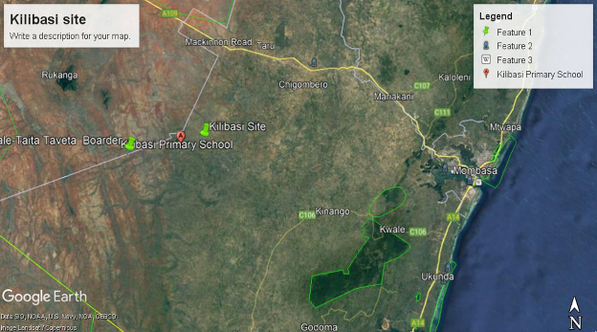
Figure 1. Map showing the proposed site
The solar mini grid will contain Solar panels, batteries, invertors, perimeter fence and length of transmission line to cover a circuit distance of approximately 10.55 km.

Purpose and Scope of Work
This report discusses the environmental and social baseline within which the proposed solar power project is commissioned and assesses the potential adverse and beneficial impacts that the project could have, along with suitable mitigation measures and an Environmental and Social Management Plan (ESMP) for the project. The report also evaluates the environmental and social risks associated with the project and implements mitigation measures to avoid adverse impacts for the remainder of the project’s lifecycle. The project must comply with international standards (World Bank Environmental and Social Safeguards) along with applicable national, state, and local regulations.

ESIA Methodology

Screening and Scoping

Screening Methodology
Evaluation of ESIA procedure has been undertaken as a fundamental procedure to implementation of the solar power mini-grid development project which is systematically mainstreamed into the project’s Cycle. World Banks Social safeguards underpin and demonstrate this commitment. The main aim of this is to enhance positive social opportunities and benefits as well as ensure that adverse social and environmental risks and impacts are avoided, minimized, and mitigated.
The below steps were followed.

Kick-off Meeting
Norken and Centric team had a brief kick-off meeting with the Proponent on 12th July 2021 followed by subsequent online meetings and discussion on various aspects of the project up to 5th August, 2021 and 15th September, 2021. The meetings addressed varied deliverables and thresholds to be achieved and maintained during this assessment in terms of scope of work, deliverables, timeline and the methodology. All communication and meetings were done online.

Desk based review and baseline assessment
A comprehensive description of the KOSAP Component 1: project includes a desktop review of all the existing project documentation including the Project Appraisal Document and the four main safeguard framework documents prepared under KOSAP- these are Social Assessment, Vulnerable and Marginalized Group Framework, Resettlement Policy Framework and the Environmental and Social Management Framework.

This ESIA study was conducted by a team of experts that comprised the following professionals;

Table 1 : ESIA TEAM
S/No | Names | Position
1 | Tom Maruti | Ministry of Energy - MOE
2 | Samuel Mbugua | Environmental and Social specialist- KPC
3 | Salama Mwafrika | County Renewable Energy Officer- Kwale County
4 | Allan Owino | Norken International Limited /Centric Africa Limited- EIA/EA Expert
5 | Umulkheir Abdi | Norken International Limited /Centric Africa Limited- EIA/EA Expert
6 | Lydia Komen | Norken International Limited /Centric Africa Limited- EIA/EA Expert
7 | Martin Gitonga | Norken International Limited /Centric Africa Limited- EIA/EA Expert

Project Description
The consultant firm has concisely described the project location including its geographical, ecological and the general layout of associated infrastructure including maps at an appropriate scale where necessary. Location of all projects related development sites, including proximal offsite investments; general layout; flow diagrams/drawings of facilities/operation design basis, size, capacity, flow-through of unit operations, including pollution control technology included if any; pre-construction activities and construction activities; construction schedule; staffing size and support; facilities and services around; commissioning, operation and maintenance activities and plan

Baseline Condition
This entails description and collection of relevant primary data within the project site’s bio-physical, socio-economic, and cultural profile with respect to the biodiversity profile, land use types, cultural heritage and practices, social and economic issues likely to be affected, expected project activities to be involved during the design, construction, and operation of the proposed facility. The information also includes description of the community social structure, employment and labour market, sources and distribution of income, cultural/religious sites and properties, vulnerable groups, and indigenous populations. This also covers description of the sites’ physical environment including their topography, land cover, geology, climate and meteorology, air quality and hydrology. This entails use of secondary data sources and for some specific environmental parameters the deployment of specialized equipment to measure and record the environmental readings as primary data for analysis and inclusion in the ESIA CPR report. The ecological and biophysical environment will focus on describing the flora and fauna resident in the Kwale county at the mini-grid site level. This will be based on ecological surveys, KPIs on local indigenous knowledge on historical and status of rare, endemic, and endangered plant and animal species known to occur in these localities. Vegetation assessment was done to gain an understanding of the mini-grid sites habitat type. This has provided for an in-depth description of existing land use type and their linked socio-economic activities.

Impact Assessment Prediction
The anticipated impacts generated by the project and subsequent evaluation of their significance is provided by this report. A suite of field data collection methods was deployed including public forums discussions, Focus Group Discussions, Key Informant Interviews incorporating questionnaires for social risks assessment. Based on the outcome of the evaluation, the need for emphasis on critical areas was discussed. To accomplish this task an initial listing of the range of all issues and concerns identified during the study has been undertaken subsequently followed by analysis of the identified potential environmental and social impacts in terms of type (direct, indirect, cumulative, positive, negative), magnitude (local, widespread, random, severity) and duration (temporary, permanent, long term, short term). Consequently, an evaluation system will be used to categorize these impacts and evaluate them. This aided in determining the significance of the identified potential impacts in relation to established criteria or standards, geographic extent of effects, cumulative nature of the impact, community tolerance and preferences, etc. This culminated into generation of a short list of the most critical issues in terms of environmental, ecological, and social impacts both positive and negative associated which the different phases of the project activities that are likely to affect the baseline environmental and social conditions presently occurring at the mini-grid sites.
Socio-cultural risks linked to Component 1 of KOSAP were identified during the assessment. These include, Labour influx, Gender Based Violence, Sexual Exploitation and Abuse, workplace Sexual Harassment, Spread of HIV/AIDS, STDs & other communicable diseases, Gender biases and inequality exclusion of vulnerable and marginalized groups (VMGs) and vulnerable individuals and households from accessing project decision making and governance structures, engagement processes, opportunities, and benefits. The vulnerable individuals and households will include the poor, elderly persons, PWDs, the sick, poor women, poor single mothers, child-headed households. The VMG’s include ethnic minority communities that are present in Kilibasi area.
The impacts and risks were identified in relation to free, prior, and informed comprehensive stakeholder consultations on land acquisition for construction of mini-grid, contractor’s facilities e.g., yard and workers camp site, way leave acquisition for the powerline distribution network; restricted access to grazing lands, water resources, soils and tree resources, economic/livelihoods displacement etc.

Environmental and Social Management and Monitoring Plan (ESMMP)
The ESMP as the implementation instrument of the ESIA has captured all the parameters that need to be monitored on a routine basis. The parameters as indicated in an Environmental and Social Management and Monitoring Plan (ESMMP) matrix, a detailed description of the implementation and monitoring program.
The ESMMP has a detailed arrangement of responsibilities for managing and monitoring the implementation of mitigation measures and the impacts of the project during construction, operation, and decommissioning. This include: a description of monitoring methodology, specific operations, and features to be monitored, monitoring reporting relationships and arrangements to ensure that monitoring is effective. Simple and straightforward monitoring processes established for ease of implementation through the project cycle. This plan follows through a description of the impacts and areas affected, key mitigation measures, monitor-able indicators, timeframe, responsibilities, and budget implications.
The ESMP include an implementation schedule and budget cost estimates for the mitigation measures both capital and recurrent costs estimates and the financing entity. It also describes institutional arrangements regarding the implementation of the ESMP among the implementing agencies, and the mini-grid contractor(s). This has specific responsibilities, procedures and resources required by each institutional actor engaged in implementing the ESMP.
The “Chance Find Procedures” has also been included in the ESMP as part of prevention and mitigation measures that will be implemented in the event physical cultural resources are encountered during subproject implementation.
Additionally, the ESMP has a component on contracting management that will ensure the implementation of the ESMP by all contractors and subcontractors. A contracting mechanism is included in the ESMP to incentivize contractors and their subcontractors to comply with the ESMP or alternatively penalize them for failure to comply with the ESMP. It also includes contractor clauses that will cover worksite health and safety, the environmental and social management of construction sites; labour camps/out of area workers, HIV/AIDS, and other Sexually Transmitted Diseases (STDs), stakeholder engagement plans, grievance redress mechanism, child protection, gender equity and sexual harassment, labor rights and the employment of community members. The ESMP also have a budget to guide the contractor on resources required for the implementation and monitoring of the ESMP.
Figure 2 is a summary of the methodology the firm will adopt in undertaking environmental and social impacts assessment for the proposed KOSAP project
- Preparation and Planning

- Desk Review of available reports and documents

Inception Report

- Stakeholders Consultation and Participation:
  - Key informant interviews
  - Focus Group Discussions (FGDs
Draft ESIA Reports

Incorporation of Review Comments from PCU & IAs

Deliverable 1

Deliverable 2

Final ESIA Reports for the proposed Kilibasi Minigrid
Deliverable 3
- Baseline data gathering
- Identification of Potential Social Impacts
- Summary of mitigation & Management mmeasures
Figure 2: Summary of Environmental and Social Impact Assessment Methodology

Stakeholder Consultation and Participation
Section 17 of the Environmental (Impact Assessment and Audit) Regulations of 2003, requires that all ESIA Studies undertake Public Consultation (PC) as part of the study. The aim of the PC is to ensure that all stakeholders interested in a proposed project such as project beneficiaries, government officers and the general public in the vicinity of the proposed project be identified and their opinion considered during project planning, design, construction, operation and decommissioning phases. Consequently, public consultations were carried out in the project area in a bid to inform the public and other interested parties on the proposed project and obtain their views on the same. The consultations also presented an opportunity for the community to raise issues and concerns pertaining to the project.

This assessment recognizes that consultation is an ongoing process throughout Project implementation phases. Under this Project consultation was undertaken during the ESIA process and will continue during the construction operational and decommissioning phases of the project. A suite of field data collection methods was deployed including public forums discussions, Focus Group Discussions with men, women and youth, Key Informant Interviews incorporating questionnaires for social risks assessment with an aim of giving the community a platform to express their environmental and social concerns in relation to the project.

Prior to the community engagement meetings, a two weeks’ notice was done/issued to inform the community members of the meeting. This was done by the county renewable energy officer (CREO). The officer called the Chief of the area where the meeting was to take place and requested him to inform the people of the meeting in regard to KOSAP community engagement forums. The chief then informed the people about the meeting through announcement by word of mouth given by the local leaders’ key among them was village administrator and village elders in Kilibasi village.

A detailed CPP and community engagement for Kilibasi Solar Mini Grid was held at Kilibasi Baraza park in Kilibasi village on 1st October 2021 chaired by the area chief. The general stakeholder consultation was done in a public meeting (Baraza) organized at Kilibasi community baraza park where 36 males and 40 women were in attendance. Background information document (BID) with project details was posted clearly at the Chief’s office and Kilibasi shopping center. Community engagement proceedings and resolutions are presented in form of minutes taken/written during the meetings. The meetings were well attended by all people including men, women, youth and persons with special needs.
Interactive approach was adopted for the immediate neighbourhood in discussing relevant information key among them being;
- Land use aspects,
- Project acceptability,
- Social, cultural and economic aspects,
- Environmental Impacts
  - Physical impacts,
  - Biological impacts,
  - Legal Compliance.
The meeting was held in accordance with the requirements of NEMA and the WB OP. 4.01 policy and guidelines for conducting an ESIA. The specific objectives of this public consultation were to: Disseminate information on the proposed project to the community members; Collect views and issues to be considered in the ESIA; Evaluate perceptions about positive and negative impacts of the project and; Receive concerns about environmental and social impacts and other implementation challenges.

Limitations
The limitation experienced during the study are illustrated below.
- Due to drought that was being experienced the community member were engaged in looking for water and pasture thus delaying in attending public participation meetings
- Some data which the consultants sought from the community could not be assertained eg. the exact number of the VMG’s, orphans,rate of HIV infections, number of cases of GBV etc.

Layout of the Report
Table 2: Structure of the ESIA Report
SECTION | TITLE | DESCRIPTION
Section 1 | Introduction | (This section) Introduction to the Project and ESIA scope and methodology adopted.
Section 2 | Project Description | Technical description of the Project & related infrastructure and activities.
Section 3 | Environmental and Social Baseline | Outlines Environmental, Ecology and Social Baseline status in the study area of the Project
Section 4 | Applicable Legal and Regulatory Framework | Discusses the applicable environmental and social regulatory framework and its relevance for the Project. (The world bank safeguards and EMCA and environmental regulations)
Section 5 | Stakeholder Engagement | Provides an overview of the stakeholder engagement activities undertaken during the ESIA, stakeholder categorization and profiling Additionally, it details the provision of Grievance Redress Mechanism for the project
Section 6 | Impact Assessment and Mitigation Measures | This section includes details of identified environmental impacts and associated risks due to Project activities, assessment of significance of impacts and presents mitigation measures for minimizing and /or offsetting adverse impacts identified.
Section 7 | Environmental and Social Management Plan | Outline of the ESMMP considering identified impacts and planned mitigation measures and monitoring requirements.
Section 8 | Impact Summary and Conclusion | Summary of impacts identified for the Project and conclusion of the study.

PROJECT DESCRIPTION AND ALTERNATIVES

Introduction
This section provides a description of the project in terms of location, facilities and associated project infrastructure and activities during the project lifecycle and facilitates and identification of the potential impacts on resources and receptors that could result from project activities during the pre-construction, construction, operation, and decommissioning stages.
The components of the proposed solar mini grid are provided as follows.
Table 3 . Component of the proposed Solar Mini-grid
S/NO. | PARTICULARS | DESCRIPTION
1. | Project location | The project is located in Kilibasi village near the Kwale-Taita Taveta border at Kilibasi sub-location, Mackinnon location, Mackinnon Ward in Kwale County at coordinates of latitude 3°58'17.6"S and longitude 39°00'08.2"E.  The solar mini grid will contain Solar panels, batteries, invertors, perimeter fence and length of distribution line to cover a radius of approximately 1.5 km.
2. | Land Size/Tenure | The proposed solar mini grid will be located on a 1.14 hectares piece of land in Kilibasi village. The land is in Puma Ranch
3. | Mini grid Capacity | - PV Capacity of 84kW; 272 kWh Battery; Minimum Pv Inverter of 49kW
4. | Energy Demand | Monthly energy demand of 4110 kWh and daily energy demand of 292 kWh
6. | Generator & Fuel Tank | The generator capacity of 50kV and the fuel tank for diesel generator of 2000 liters.
5. | Distribution line | Approximately 11km
6. | Target Consumers | 315 (299 Residential and 16 Non-Residential)
8. | Climatic condition | The average temperature is about 23ºC with maximum temperature of 25ºC being experienced in March during the inter-monsoon period and minimum temperature of 21ºC experienced in July a month after the start of the southwest monsoon (also known as Kusi). Rainfall is bi-modal with short rains (Mvua ya Vuli) being experienced from October to December, while the long rains (Mvua ya Masika) are experienced from March/April to July. There is a strong east to west gradient of decreasing precipitation with eastern (coastal) parts of the County receiving greater than 1000 mm of precipitation per year, while a majority of the County central to west around 500-750 mm. Some areas along the western side of the County receive less than 500 mm of precipitation per year.
9. | Site Conditions | The side is generally in open area with minimal fauna and flora.
10. | Road Accessibility | Murram road.
11. | Nearest Airport | Mombasa Moi International Airport
 | River/canal/nallah/ pond present in project footprint | None
12. | Protected areas (National Park/ Sanctuary)/ Forest land within 10 kms | None

Project Location
The project site is located in Kilibasi village near the Kwale-Taita Taveta border at Kilibasi sub-location, Mackinnon location, Mackinnon Ward in Kwale County at coordinates of latitude 3°58'17.6"S and longitude 39°00'08.2"E. The proposed power plant will be constructed on approximately 1.14 hectares of land in a school compound. The proposed project is situated south east of Kwale-Taita Taveta county and about 3 km from Kinango Town. The site is located to the north west side of Shimba Hill National reserve. The site soil is primarily sandy loam within the area.

Project site setting
The proposed Kilibasi mini grid is in Kwale County. It falls under cluster 3 with a total of 48 minigrids and lot 5 which has a total of 11 mini-grids. Geographically, Kilibasi site falls on coordinates latitude 3°58'17.6"S and longitude 39°00'08.2"E.

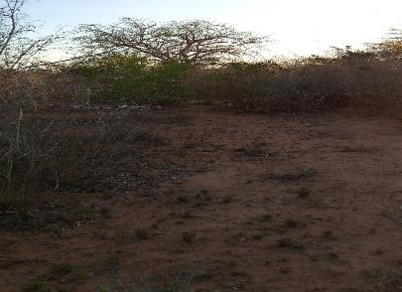
Figure 3: Proposed site for the Kilibasi Solar Mini-grid project with scattered scrubland

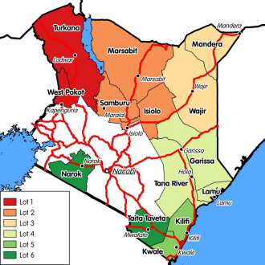

Figure 4: Map Showing the KOSAP Counties Lot 3

Description of Project Facilities, Components and Activities

Technical aspects of Solar Mini grid
Kilibasi is among the beneficiaries of the KOSAP based on an aerial survey done in 2019 and has a potential customer base approximated at 1700 households within the Kilibasi area, and a 48 kWp solar Mini-grid to supply power to the community will be installed. The Solar PV hybrid system is based on a centralized photovoltaic plant connected to a 3-phase 415V AC busbar line, where the multi-mode battery inverter and the diesel generator are also connected. The noise rating for the inverter and the diesel generator is 85-90dB.

Table 4: Kilibasi solar Mini grid profiles
Name | Residential | Nonresidential | Circuit(km) | Peak demand (kw) | Monthly Demand kWh | PV(DC-KWp) | Batteries | Generator (kva) | Cost (USD
Kilibasi | 299 | 16 | 11 | 29 | 8750 | 84 | 272 | 50 | 529,945

Project Components

Solar PV modules
The project will use PV Array (DC-kW) 190 polycrystalline silicon module with three strings connected in series. Each string will have five sets of panels connected in series, with output converged at the six-way combiners. The life expectancy of the PV modules is estimated at 25-30 years.
The batteries will be stored separately at site on a suitable leak proof base before being collected and transported by NEMA licensed waste collector for proper disposal.

Battery Energy Storage System
The Battery Energy Storage System (BESS) will comprise of Lithium-ion Battery pack that conforms to IEC standards with warranty of 10 years, 3,000 cycles minimum. The Lithium-ion Battery Power Packs will be used to cater for required energy capacity, or equivalent as per approved design, minimum 80% DOD for Lithium-Ion. Batteries will be capable of at least C/4 charge and discharge rate. Batteries will be charged by Battery Inverter / Charger. A 272kWh Battery Capacity is incorporated to store excess solar energy during the day, ensuring a consistent power supply even during cloudy or nighttime conditions.

Battery Inverters/ Chargers
A 49-kW battery inverter charger is employed to manage the energy flow to and from the battery storage system. The Inverters/charges shall be designed for nominal voltage of 415 Vac which will be continuous, reliable power supply as per specification and shall have internal protection arrangement against any sustained fault in the feeder line and against lightning strikes in the feeder line. The inverters shall be capable of complete automatic operation including wake-up, synchronization & shut down independently & automatically. The inverter shall be 3-phase multi-mode (DC to AC and AC to DC), bi-directional, four-quadrant capability.

Distribution lines
The site will have a distribution line circuit of 11km in total. Supply of concrete poles for the distribution lines will be based on detailed survey and accessories like phase plates, circuit plates, number plates, danger plates, anti-climbing devices as per KPLC requirements/specifications. Erection of the Poles, fixing of insulator strings, stringing of conductor and earth wires along with all necessary line accessories and earthing will be as per KPLC requirements/specifications.

Project Metrics:
Monthly Energy Demand: The project is expected to meet a total monthly energy demand of 8750 kWh.
Daily Energy Demand: The average daily energy demand is approximately 292 kWh, ensuring a consistent supply for the consumers.
Peak Demand: The peak demand of the system is 29 kW, which is the maximum power requirement during any given moment.
PV Capacity: The solar photovoltaic panels have a total capacity of 84kWp.
Battery Capacity: The Battery Energy Storage System has a capacity of 272kWh, providing energy storage and ensuring a continuous power supply.
Generator Capacity: The diesel generator has a capacity of 50 kVA, serving as a backup power source.
Fuel Tank Capacity: The fuel tank for the diesel generator can hold up to 2,000 liters of diesel fuel.

Estimated Project Cost:
The estimated cost of the Kilibasi Mini Grid project is approximately USD 529,945. It's important to note that this cost may be subject to change as more detailed plans and implementation phases are developed. The investment is expected to provide long-term benefits to the local community, improving their quality of life, economic opportunities, and access to modern amenities.

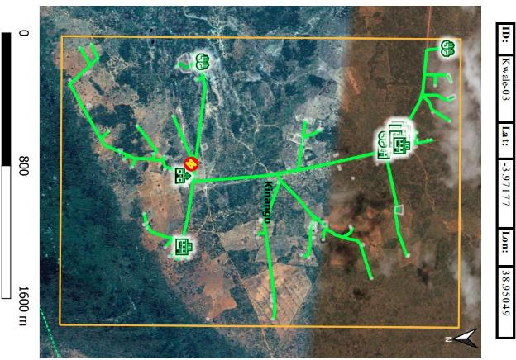
Figure 5: Kilibasi Distribution Line Circuit

Project Phases and Activities
The main project activities include site clearance and leveling, civil works and construction of utilities and structures for the facilities, installation, and connection of the power plant.

2.3.2.1 Pre-Construction/Project Design
As part of the pre-construction stage, the Project is implemented jointly by the Ministry of Energy, Kenya Power and Lighting (KPLC) as well as Rural Electrification and Renewable Energy Corporation (REREC) who have conducted a feasibility study aiming at providing universal access to electricity in Kenya by 2022, universal access to modern energy services for cooking by 2030, as well as the impetus for growth in achieving Vision 2030. A conceptual design has been developed and will be taken forward for detailed design and implementation including the projects described in the previous section. This ESIA report forms part of the feasibility study.

The MOE is currently applying for various permits and licenses including land acquisition for generation assets, wayleaves, contractor facilities and worker’s camps. The procurement of various goods and services and contracting of private sector contractors and other consultants will begin after completion of the EIA process.

2.3.2.2 Construction Procedures
The project will be constructed based on applicable standards of Kenya, environmental guidelines and health and safety measures in line with OSHA Act 2007.
The project inputs will include the following.
- Construction of raw materials will include solar modules, inverter, wires, metals, among others. All these will be obtained from licensed dealers and especially those that have complied with the environmental management guidelines and policies.
- Construction machines will include machinery such as trucks, and other relevant construction equipment. These will be used for the transportation of materials, clearing of resulting construction debris.
- A construction labour force of both skilled and non-skilled workers will be required.
Construction activities will include the following:
- Contractor mobilization.
- Site Preparation.
- Procurement of construction material from approved dealers and transport to the site.
- Storage of PV modules delivery and their installation.
- Laying of internal electrical connections.
- Installation of inverters, Battery Energy storage system.

2.3.2.3Land Tenure
Land ownership in Kwale can be categorized into three main categories namely; community land, public land and private land. Kilibasi site is under Puma Ranch in Kilibasi Village, Kilibasi Sub location in Kinango Sub County in Kwale County. The land is held by the County Government of Kwale on behalf of the community, in line with the Community Land Act 2016. The portion of land identified for the mini-grid by the community is part of the 1.14Ha set aside by the community for public purposes or social service projects.

An abbreviated Resettlement Action Plan (A-RAP) outlining the principles and procedures for land acquisition and compensation is annexed to this ESIA. Is captured under baseline An A-RAP applies where affected persons are not physically displaced, and less than 10% of their productive assets are lost, or fewer than 200 people are displaced. In the case of KOSAP sub-projects, there is no physical displacement of affected persons, and the foreseen impacts on livelihoods such as grazing occasioned by mini-grid construction, wayleaves acquisition, and implementation of community projects are considered minor. A-RAPs will be implemented for sub-project sites on registered and unregistered community land/group ranches.

2.3.2.4 Compensation Details
Compensation for the land for the proposed project will be in kind. In Kilibasi, the community requested:
- Priority 1-Construction of a new Outpatient Department at Kilibasi dispensary
- Priority 2- Improvement of existing water supply source by installing solar powered pumps, dispensing unit and other amenities,
- Priority 3-Supply of electricity to the existing social facilities such as school.

Resource Requirement

Workforce Requirement
Approximately 40 skilled, semi-skilled and unskilled Laboure’s will be required at the construction stage. During the operation phase, the following personnel will be required;2 engineers and 5 technicians. The Kenya Power Company will be conducting the operations and management through the O&M contractors for the first seven years.
Approximately 5 unskilled workers will be involved during operation phase of the project for grass cutting and module cleaning. Also, two trained security guards will be engaged at the operations phase.

Water Requirement and Source

Construction Phase
It has been estimated that approximately 50,000 liters of water will be required per day for civil works during construction stage. Further, water will be required for workers at project site. However, this quantity of water requirement will vary depending upon the mobilization of construction workers at site. The water for the construction phase will be sourced from the local water points, the nearest is located at about 200m to the proposed site next to school and health facility. The available water points within Kilibasi area are sourced from Kinango area.

Operation Phase
The water required during operation phase of the project will be mainly for washing the face of the solar modules, Minimal water will be used for this purpose. Water requirement during operational phase of the project will be met from the water vendors in the area.
Approximately, 10 employees (direct and contractual) will be working during operation phase. For this workforce, approximately between 5,000 Liters of water will be required weekly for domestic consumption.

Raw Material Requirement

Construction Phase
The major raw materials required for the construction phase will be solar modules, fencing materials, construction materials like cement, sand, and aggregate. The fencing materials and the construction materials will be sourced from the local hardware facilities. Solar Modules for the project along with associated structures will be obtained from appropriate sources within or outside the country.

Operation Phase
There will not be major requirement of raw materials during operation phase. Only maintenance spares will be required at this phase.

Power Requirement
Power requirement during the construction phase will be met through Diesel Generators sets. The exact number of Diesel Generator sets to be used, as well as the quantity of fuel, will be ascertained once the project is in the implementation stage.

Fire Safety and Security

Construction Phase
Appropriate firefighting system and equipment shall be provided throughout the construction period. The fire extinguishers will be well distributed according to the fire risks and will be available in areas such as the site office, security area, storage yard etc. A comprehensive emergency response plan with all the emergency numbers will be well displayed at the site and on the fence.
The contractor will make an effort to educate all employees about electrical safety. Increased awareness and communication about the importance of electrical safety will be emphasized throughout the workplace.

Operation Phase
Suitable fire protection and fighting systems that will include portable fire extinguishers, automatic fire detection system and means of fire communication will be made available at the entire PV array area, inverter stations, main control room and switchyard. Installation of short circuit will be done to mitigate against rodents gnawing on the cables or heating up during operation and maintenance. Damaged batteries will be well confined in a non-permeable surface awaiting disposal by a NEMA Licenced waste handler. Fire safety measures will be in place.
The mini-grid grid will have a galvanized Chain link fence to keep off the electrical installation away from access by the public. A gate will be constructed at the entrance to the site which will be locked at all times. The Mini Grid will be lit at night, and a photocell will be used to automatically switch on the lights at a set time each evening. The Mini Grid will also be guarded 24/7 by at least two security guard at any given time.
The systems and equipment’s will align to the Kenyan Fire Reduction Rules of 2007. The Fire protection and fighting systems will be maintained and serviced after every 6 months.

Pollution Streams during Construction Phase

Solid Waste Generation

Construction Phase
The key solid waste that is expected to be generated during construction phase include. Broken solar panels and PV Modules, Hazardous waste like waste oil, lubricants, oil contaminated rags and Domestic soil from the temporary site office.
The hazardous wastes will be stored onsite at separate designated covered area provided with impervious flooring and secondary containment. The storage containers/ bins/ drum will be clearly marked, and color coded for their hazards. The waste will then be collected by a NEMA approved waste handler.
Any broken solar panels or PV Modules will be sent back to the vendor as part of buyback arrangement. Alternatively, the e-waste will be disposed by licensed waste handlers in sites that are licensed by NEMA and local authorities to dump e-waste. All the other domestic solid waste will be disposed at the nearest municipality dumpsite.

Operation Phase
During operation phase, waste generated from the project will include domestic waste at site office, scrap materials like scrap tools, damaged PPEs etc.; hazardous waste like waste oil, lubricants, used transformer oil; damaged batteries; electronic waste like damaged PV modules etc.
The hazardous wastes will be stored onsite at separate designated covered area provided with impervious flooring and secondary containment. The storage containers/ bins/ drum will be clearly marked, and color coded for their hazards. The waste will then be collected by a NEMA approved waste handler.
Any broken solar panels or PV Modules will be sent back to the vendor as part of buyback arrangement. Alternatively, the e-waste will be disposed by licensed waste handlers in sites that are licensed by NEMA and local authorities to dump e-waste. All the other domestic solid waste will be disposed at the nearest municipality dumpsite.
Any solar panels or batteries removed from the array for disposal will first be collected and stored in the covered 10ft container provided by the Contractor before being collected and transported by NEMA licensed waste collector for proper disposal. The Contractor will ensure hazardous items are shipped offshore to a facility licensed to handle hazardous waste.

Air Emissions

Construction Phase
Air quality will be impacted due to onsite construction activities. The likely emissions from construction activities would include the following:
- Dust emissions from the dusty roads leading to the site.
- Increased vehicular emissions due to the high traffic of vehicles transporting construction materials, PV Modules, and accessories.
- Dust emissions from site clearing, material handling, piling and use of the construction machinery.
- Exhaust emissions from the diesel generator.
The high dust emissions arising from various activities such as piling, transportation of material (loading and unloading), vehicular movement (on unpaved roads) should be minimized through sprinkling of water and maintaining vehicular speed to 10-15 km/hr.
All the vehicles and the Diesel generator should be well maintained and serviced to reduce the rate of exhaust emissions.

Operation Phase
It is expected that the normal operations of the site will produce minimal gaseous emissions from all the operating areas. The minimal gaseous and fugitive dust emissions will be attributed to the in and out movement of the maintenance vehicles. It will be ensured that well maintained vehicles are used for maintenance purposes.

Waste Generation

Construction Phase
The liquid effluents generated during the construction phase will include domestic sewage from temporary site offices, kitchen and washing areas. As part of the site preparation stage, septic tank will be constructed for the camp and site office. Sewage disposal trucks should be used to periodically remove the sludge/sewage from the septic tank.

Operation Phase
The operational phase will have negligible wastewater generation at site office. Septic tank and soak pits will be provided at the site office for disposal of sewage.

Noise Emissions

Construction Phase
Noise emissions will be generated from piling, movement of vehicle and other construction machinery and operation of the Diesel Generator. The main noise receptors will be the neighboring settlements and the construction workers. Noise from Diesel Generators will be minimized through provision of acoustic enclosures and occasional maintenance of the generator. Every single noise generating activity will be restricted to Day time only.

Operation Phase
Under normal operations, none of the activities of solar power plant will generate noise. The only noise that can be generated at this phase is during the maintenance works and it will be restricted to daytime only. However, during cloudy periods and when solar energy is low, the backup generator that will be utilized will produce noise. Mufflers and silencers will be installed so as to minimize noise pollution from the backup generator.

Analysis of Alternatives.
This section analyses the project alternatives in terms of site and technology. Solar projects are non -polluting energy generation projects which are site specific and dependent on the availability of solar irradiance resource. The current site selected is a high solar power potential site with high irradiation and consistent sunny days throughout the year.

2.6.1 Site Selection
Solar projects are non-polluting energy generation projects which are site-specific and dependent on the availability of solar irradiance resource. The proponent identified one location for the proposed solar project which located in a school compound. The proposed project is situated south east of Kwale-Taita Taveta county and about 3 km from Kinango Town. The site is located to the north west side of Shimba Hill National reserve. The site soil is primarily sandy loam within the area.
Further details on the other locations identified were not available.
- No settlement presents in the project site;
- The project site land is in Puma ranch;
- The project site has few scattered trees and shrubs and located between school and community settlement area (manyattas);
- The area is in a predominantly pastoral/commercial setting.
- The population density is low, and majority of the surrounding land is grazing land. There is enough grazing land for the community and use of the site to construct the mini grid will not significantly impact grazing land.
- The community is further marginalized with no electricity grid connectivity compared to other regions in the country

PROPOSED PROJECT SITE & PROXIMITY TO CONSUMER SITES
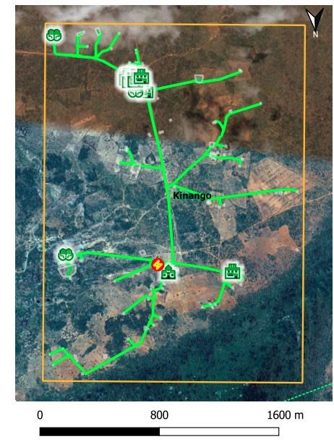
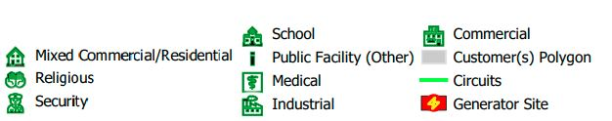

Figure 7: PROPOSED PROJECT SITE, DISTRIBUTION & PROXIMITY TO CONSUMER SITES

2.6.2 Power Scenario at Kilibasi
Mackinnon location has an estimate of 3,000 number of people with approximately 250 households within the area. The proposed solar offgrid project is estimated to cover up to 315 residential and non-residential consumers within the area.
The existing sources of energy at Mackinnon location include solar powered appliances supplied by private enterprises such as D-light. The current energy availability provided by the solar appliances is insufficient and does not meet the objective of the aim of project. Solar energy is mainly utilized for lighting and charging mobile phones. Whereas wood fuel is utilized for cooking, heating water and providing for warmth.
The use of firewood contributes to massive environmental degradation, increased health risks and additional workload for women and girls, and increased emissions of carbon content. Moreover, low enrollment, retention and transition for girls is partly attributed to increased workload related to energy search (firewood).
Failure to construct and operate the minigrid in Kilibasi will lead to the failure of achieving one of the Kenya’s national long-term development policies that aims to transform Kenya into a newly industrializing, middle-income country, by providing a high quality of life to all its citizens by 2030 in a clean and secure environment. Beneficiaries will be households, public and community institutions, enterprises and community facilities that cannot access electricity through the national grid and whose use of electricity will replace kerosene and other fuels for lighting and other activities like pumping water.

2.6.3 Analysis of Alternative
As per IFC Performance Standards, an analysis of probable alternatives for the chosen technology and location of project site along with other similar factors that contribute to the project as a whole has been carried out. The following scenarios have been taken into consideration:
- Alternate Location for Project Site
- Alternate Sources of Energy
- Zero or No Project Alternative

2.6.3.1 Alternative Power Distribution Lines Right of Way
The project requires the distribution of generated power into the settlement points within Kilibasi through optimal access points, therefore all possible options for power distribution have been assessed.

The identified viable option for power distribution within Kilibasi village for the solar mini-grid project is overhead distribution lines. Although other alternatives, such as underground lines and passing the power lines off established community public access routes, may have been considered, they are not feasible for this specific project due to technical and practical reasons. A mini-grid connection with enough capacity and material was recommended due to the anticipated increasing demand for connections. This eliminates the need to overhaul the proposed mini-grid connection when the population increases in Kilibasi.

Underground distribution lines involve the installation of power cables beneath the ground, typically in trenches or conduits. While this option may be visually appealing and minimize the impact on the environment, it presents challenges in terms of cost, maintenance, and accessibility. Excavation for underground lines can be difficult and costly in Kilibasi village due to challenging terrain, and maintenance and repair of underground lines may require specialized equipment and labour. Additionally, accessing underground lines for routine maintenance, fault detection, and repairs can be challenging, especially in remote or inaccessible areas of the area. Furthermore, scalability and flexibility may be limited with underground lines, making future expansions or changes in power demand more complicated and costly.

Passing the power lines off established community public access routes may not be practical in Kilibasi village due to community settlement patterns, existing infrastructure, and environmental considerations. Establishing new routes or modifying existing ones to accommodate power lines may require significant resources, land acquisition, and community consultations, which can be time-consuming and costly.

Additionally, the appropriateness of potential mini-grid site identified by the Proponent was also assessed in terms of various suitability criteria and technical restrictions as outlined below:
Parameter | Comment
Seismicity | According to the Seismic Distribution Map by WHO (2010), generally Kwale county’s seismic hazard is categorized as “Very Low”. It is however recommended that the civil and structural infrastructure for the project should be designed in compliance with the national seismic regulation embedded within the Building Code
Land Use | The parcel of land earmarked for the project is community land with vegetative cover being natural trees and bushes. At present, the land is unutilized.
Terrain | Consideration is given to the topography of potential sites whereby flat or gently sloping topography is preferred. An ideal gradient for the natural ground is 1:100. A gentle slope facilitates surface drainage and movement of vehicles and people on site during construction. A steep slope requires costly leveling (cut and fill) for the construction of the solar mini-grid and increases the potential for environmental impacts during construction as well as operations i.e. steeper slopes have higher surface water flow rates and therefore higher erosive potential. The proposed site is flat and cost-effective during construction.  The proposed site and distribution alignment does not exhibit significant slopes that may impact on the construction/installation activities.
Hydrology | Consideration is given to the proximity of potential sites to adjacent water courses and wetlands where there may be potential impacts in terms of erosion and siltation of water courses, as well as implications associated with storm-water control at the solar mini-grid site. The site is not close to water resources or wetland and so there will be no impact to water sources through siltation.
Geology and soils | Consideration is given to the soil type present within the potential site whereby stable soil and founding conditions are preferable. Less stable soils, i.e. shallow, dispersive soils and soils with poor drainage present an erosion hazard if not managed correctly, and also require the installment of additional, costly foundation infrastructure. The site has sandy soil which drain more readily than other types of soils.
Flora and Fauna | The potential sites need to be assessed in terms of their ecological value at both a macro and micro sale i.e. within the site and the environment surrounding the site to ensure the protection of endemic and red data species and their habitat, should they be present. The proposed site is not of a high ecological value.
Visibility | Highly visible sites i.e. on a ridge / elevated terrain are considered less favorable in that they have a high visual impact on the surrounding landscape. Sites that are hidden or out of site e.g. behind a hill, may be considered more suitable. The proposed site is on flat and may not create sharp visual impact because it is not on an elevated point.
Accessibility | The proposed site is accessible by existing public roads which will avoid the need for construction of new access roads. Access is also important particularly as it relates to the transportation of the solar panels, batteries and generator to the site, which are heavy weights. As such the site should not be located in an area that has excessively steep inclines or declines that could hinder access particularly during periods of heavy rainfall.

Considering these technical and practical challenges, the identified option of overhead distribution lines along Kilibasi access routes is the most feasible for the solar mini-grid project in Kilibasi village. Overhead lines, which involve the installation of power cables on poles, are more cost-effective, easier to maintain, and provide greater flexibility for future expansion. Proper design, installation, and adherence to safety and environmental standards can ensure reliable and efficient power distribution to the consumers on the area, making overhead distribution.

2.6.3.2 Alternate Location for Project Site
In determining the most appropriate site for the establishment of the minigrid, several options were explored. This site selection process considered the following criteria:
- The availability of primary resources required for the operation of the minigrid i.e Sunlight
- Availability of land to locate the site and associated infrastructure.
- The availability and accessibility of infrastructure for the provision of services, manpower and social structure for the construction and operation of the solar minigrid.
- General environmental acceptability in terms of social impacts, water utilization, general ecology, etc.
Kilibasi was identified as the most suitable area for the establishment of the proposed minigrid based on the following factors:
Location: The area is in a predominantly pastoral setting. The population density is low, and majority of the surrounding land is de-vegetated grazing lands and tree cover is currently low at 15%. There is enough grazing land for the community and use of the site to construct the mini grid will not significantly impact grazing land.
Proximity to consumer sites: Mackinnon location has an estimate of 3,000 number of people with approximately 250 households within the area. The proposed solar offgrid project is estimated to cover up to 633 residential and non-residential consumers within the area.

2.6.3.3 Alternate Sources of Energy
Harnessing solar energy is an eco-friendly process, with an inexhaustible solar resource and minimal pollution. There are minimal fuel requirements for operational activities. Solar energy has a short development timeframe, more predictable energy output and low maintenance costs as compared to some other forms of renewable energy sources.
The possible alternatives to solar energy include;
- Wind power: shortfalls associated with wind power includes; lack of time series data of wind, trained human resources to intricate design of wind power etc, providing wind power for Kilibasi residents is technically and financially challenging, expensive to install, dependent on wind pattern (not strong in Kilibasi). However, generation is cheap, low emissions & insignificant pollution levels.
- Thermal power: High fossil consumption, high emissions levels, high water consumption levels (water highly scarce in Kilibasi). Besides coal and petroleum products used in thermal power processing are not readily available within Kilibasi area and may have to be sourced from far locations. Therefore, thermal power option based on coal and petroleum products is not a viable option for Kilibasi. It however has high distribution and large-scale production potential
- Nuclear power: disadvantages include; use of other fuel sources, has hazards associated with radioactive materials, expensive disposal of waste, high cost of project and long gestation period. The mode however does not emit smoke particles, low fuel cost, low emission levels and continuous electricity production.
- Wood fuel/ Firewood: The use of firewood and solid waste for electricity generation using thermal technology is another option. But the issue of air pollution and destruction of vegetative cover through firewood harvesting and charcoal burning already are environmental problems of serious concern which will further aggravate the natural environment. For these reasons, the wood fuel options evaluated above seem inappropriate for Kilibasi on environmental as well as economic grounds
- Fossil fuel
Solar energy was a desirable option because:
- It has low energy-production costs
- The project is environment friendly with minimal greenhouse gas emissions
- Versatile installation
- It is a clean source of energy hence minimal impact on the environment air quality
- Economic savings.

2.6.3.4 Zero or No Project Alternative
The No Project option in respect to the proposed project implies that the status quo is maintained. This option is the most suitable alternative from an extreme environmental perspective as it ensures non-interference with the existing conditions. This option will, however, involve several losses both to Kilibasi area and Kinango as a whole. The village and the surrounding area will continue to have no electricity, and this will not help in maximizing and utilizing the area facilities. The No Project Option is the least preferred from the socio-economic and partly environmental perspective due to the following factors:
- The economic status of the local people would remain unchanged.
- Employment opportunities will not be created.
- Increased poverty in the area.
From the analysis above, it becomes apparent that the No Project alternative is no alternative to the local people, Kenyan Government, and Investors.

2.6.3.5 Analysis of Alternative Construction Materials and Technology
The proposed project will be constructed using modern, locally, and internationally accepted materials to achieve public health, safety, security, and environmental aesthetic requirements. These may not be desirable from a cost and durability perspective. The technology to be adopted will be the most economical and one sensitive to the environment.

2.6.4 Conclusion
The proposed project should be upheld to support the local community.

2.7 Land Requirement and Procurement Process

2.7.1 Land Requirement
The land on which the proposed Kilibasi minigrid will be constructed covers a total 1.14 Ha in size. The distribution power lines will be aligned to already existing access roads within the project area.

The Land Acquisition Strategy under KOSAP has been reviewed to include Compensation in Kind on unregistered and registered community land. Therefore, the community in Kilibasi were given an opportunity to identify projects where one will be selected and implemented by the mini-grid Contractor based on the valuation figure given by NLC.

Kilibasi site will have a distribution line (DL) circuit of 10.55 km in total. Construction of the distribution line will involve the acquisition of land. It is likely that the DL will pass through communal land. Additional information is required on the routing of the DL to enable a proper impact assessment of the wayleave acquisition. At the time of the study, the consultants did not have this information. Additionally, it is recommended that extensive consultations should be carried out with the stakeholders affected by the DL and those who reside near the wayleave.

2.7.2 Land Tenure
Kilibasi site is under Puma Ranch in Kilibasi Village, Kilibasi Sub location in Kinango Sub County in Kwale County. The land is held by the County Government of Kwale on behalf of the community, in line with the Community Land Act 2016. The portion of land identified for the mini-grid by the community is part of the 1.14Ha set aside by the community for public purposes or social service projects.

Compensation Details
Compensation will be done in kind. The main key area for development activities identified by the community in Kilibasi included:
- Priority 1-Construction of a new Outpatient Department at Kilibasi dispensary,
- Priority 2- Improvement of existing water supply source by installing solar powered pumps, dispensing unit and other amenities,
- Priority 3-Supply of electricity to the existing social facilities such as school.

BASELINE SETTINGS- ENVIRONMENT, ECOLOGY AND SOCIAL

Study Area
The project site is located in Kilibasi Village, Kilibasi Sub location, Kinango Sub County in Kwale County. Based on the secondary information of the region, the following baseline information on environment, ecology and social has been discussed under the sections below.

Environment Baseline

Geology and Soil
The soils in the project location were predominantly sandy soil with patches of depressed land of loam soil. The county is generally covered with young sedimentary rocks with loamy soils in the north bordering the Ethiopian highlands. The county has considerable deposits of Limestone and sand.

Topography
Kwale County is a featureless plain and lies between 355 meters and 365 meters above sea level. The topography of the project site is an open area and relatively flat with a general slope southward. The elevation difference of about 10m is observed within the project site. The project site and along latitude 3°58'17.6"S and longitude 39°00'08.2"E. The county is prone to seasonal flooding during the rainy seasons which makes roads impassable.

Hydrogeology and Drainage
Geologically, the County is underlain by the Karoo Sediments also called Duruma Sandstones consisting of the Taru Formation, the Maji-ya-Chumvi Formation, the Mariakani Formation and the Mazeras Formation which cover the middle strip of the county to the foot of Shimba Hills which is at a close proximity to the project site. The project site represents the similar geological formation of sandstones. The sandstone, shale and limestone are of sedimentary origin but are mostly hard and compact due to which the rocks behave similar to consolidated crystalline rocks and the aquifer are formed due to weathering and fracturing.

Water Resources
with regards to water availability in the county, water is sourced from the main sources of water are boreholes, springs, dams, water pans and rock catchments. The average distance to the nearest water points in the County is two (2) Kilometers community also sources water from Makina water pan, in addition to that, some community members buy water from the water bowsers at Kenya shillings 50 per 20 liters jerrican.

Ecological Conditions
The project area located in Puma Ward,Kinango sub county in Kwale County,the area encompasses scarce tree species and several shrubs. Kwale county has a robust ecological system that residents depend on for agriculture, tourism, water and many other benefits. The area’s ecological conditions are influenced by the soil type, altitude, vegetation, rainfall pattern and human activities. The two dominant vegetation types in the area include grasslands and shrubs in the west region of Kwale. Grasslands are suitable for livestock rearing Various plant species were identified during the ESIA study. Thes included; Abutylon fruiticosa, Acalypha indica, Agave sisalana, Amaranthus graecizanzi, Cencharus ciliaris, Comellina begalensis, Cynodon dactylon, Cynodon nlemfuensis, Flavelia trineria, Leersia hexandra, Leucas glabrata, Limnophyton laviflora, Oleracea portulaca, Zehneria scabra, Solanum incanum, Vachellia robusta, Azima tetracantha, Acacia jerradii, Achyranthes aspera. A major threat to the vegetation cover is the destruction caused by human activities including grazing, charcoal burning,mining, extraction of wood fuel and cutting down of trees without replacement resulting in adverse ecological effects.
The Shimba Hills ecosystem which is located about 40km from Kilibasi is a key biodiversity hotspot with Madabara, Mwele, and LongoMwagandi forests within the Shimba Hills National Reserve hosting the highest number of unique and rare species. Mkurumudzi Dam riparian areas are the best amphibian habitat and host three IUCN (Red List) Endangered-EN amphibian species, namely, Boulengerula changamwensis, Hyperolius rubrovermiculatus, and Afrixalus sylvaticus, as well as one snake species Elapsoidea nigra. This ‘hybrid’ species richness pattern is attributable to the hilly topography of the Shimba Hills and their proximity to the Indian Ocean. This has contributed to the Shimba Hills being the richest herpetofauna area in Kenya, with a total of 89 and 38 reptile and amphibian species, respectively.
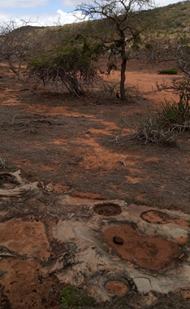
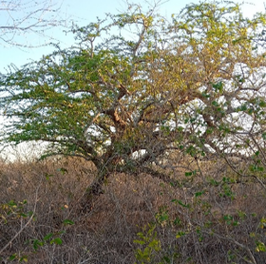
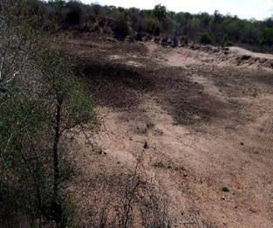
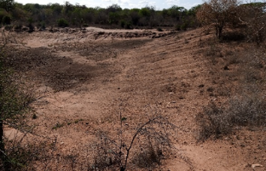

Plate 1: Project area flora presentation

Ambient Noise Quality
In general, the project area is in a village with a trading centre setting where the main source of noise is from motorists and from machines such as the generators used to supply power. Baseline noise data was collected in the project area and the data is shown in the table below:
Table 5: Noise measurement results for Kilibasi Primary School.
Aspect | dB | Time Stamp
Leq | 46.9
LS(max) | 56.2 | 2021/10/01 12:26:01
LS(min) | 38.5 | 2021/10/01 12:40:52
LPeak(max) | 98.0 | 2021/10/01 12:38:56

Table 6 : Noise measurement results for Kilibasi Dispensary
Aspect | dB | Time Stamp
Leq | 41.0
LS(max) | 52.3 | 2021/10/01 11:24:41
LS(min) | 34.1 | 2021/10/01 11:31:11
LPeak(max) | 87.9 | 2021/10/01 11:25:14

Table 7: Noise measurement results for Kilibasi Residence
Aspect | dB | Time Stamp
Leq | 50.2
LS(max) | 65.5 | 2021/10/01 11:59:18
LS(min) | 34.1 | 2021/10/01 11:53:02
LPeak(max) | 98.3 | 2021/10/01 11:59:18

Table 13: Noise measurement results for Kilibasi school for mentally challenged
Aspect | dB | Time Stamp
Leq | 39.8
LS(max) | 56.5 | 2021/10/01 12:07:02
LS(min) | 32.2 | 2021/10/01 12:07:50
LPeak(max) | 91.3 | 2021/10/01 12:13:51

Noise Descriptors used for the survey
Ls(max) A-Weighted Maximum sound pressure level obtained during the measurement period. This index is used to describe short period noise events.
Ls(min) A-Weighted Minimum sound pressure level obtained during the period of measurement. This index is used to describe short period noise events.
Leq Value of A-weighted sound pressure level of a continuous steady sound that, within a specified interval, has the same mean square of sound pressure as the sound under consideration whose level varies with time. This index is used to describe events over the period of the event.
dB Decibels

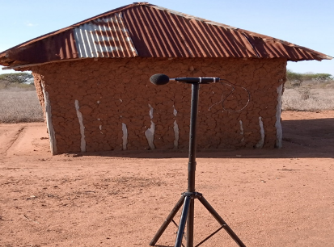

Plate 2: Ongoing baseline noise measurements

Soil Type
The major soil types in Kinango subcounty is sandy loam. Red loamy soil are derived from the country rocks. The major soil type in project area is sandy loamy soil. Sandy loam soils are dominated by sand particles, but contain enough clay and sediment to provide some structure and fertility. The soils have a high concentration of sand quickly drain excess water and cannot hold significant amounts of water or nutrients for plants.
A soil sample was collected from the site and submitted to a NEMA designated Laboratory for for analysis of Petroleum Hydrocarbons. The results obtained and which are presented in table 12 below shows that the pollutants of concern were not detected in the sample. The further indicates that the site has not been impacted by petroleum hydrocarbons.

Table 8: Soil Analysis results
Test | Method | Results | Units | Limit
BTEX
Benzene | PQA/LIM/002 | <0.01 | mg/kg | <0.01
Toluene | PQA/LIM/002 | <0.01 | mg/kg | <0.01
Ethyl benzene | PQA/LIM/002 | <0.01 | mg/kg | <0.01
Xylene | PQA/LIM/002 | <0.01 | mg/kg | <0.01
PAH
Naphthalene | PQA/LIM/004 | <0.01 | mg/kg | <0.01
Acenaphthylene | PQA/LIM/004 | <0.01 | mg/kg | <0.01
Acenaphthene | PQA/LIM/004 | <0.01 | mg/kg | <0.01
Fluorene | PQA/LIM/004 | <0.01 | mg/kg | <0.01
Phenanthrene | PQA/LIM/004 | <0.01 | mg/kg | <0.01
Anthracene | PQA/LIM/004 | <0.01 | mg/kg | <0.01
Fluoranthene | PQA/LIM/004 | <0.01 | mg/kg | <0.01
Pyrene | PQA/LIM/004 | <0.01 | mg/kg | <0.01
Benzo(b)anthracene | PQA/LIM/004 | <0.01 | mg/kg | <0.01
Chrysene | PQA/LIM/004 | <0.01 | mg/kg | <0.01
Benzo(b)fluoranthene | PQA/LIM/004 | <0.01 | mg/kg | <0.01
Benzo(k)fluoranthene | PQA/LIM/004 | <0.01 | mg/kg | <0.01
Benzo(a)pyrene | PQA/LIM/004 | <0.01 | mg/kg | <0.01

Climate and Meteorology
The area is loacted within Kwale county with climatic condition that is strongly influenced by the monsoon season . The average temperature is about 23ºC with maximum temperature of 25ºC being experienced in March during the intermonsoon period and minimum temperature of 21ºC experienced in July a month after the start of the southwest monsoon (also known as Kusi). Kilibasi project site is located within the arid and semi arid area of Kwale County. Rainfall is bi-modal with short rains (Mvua ya Vuli) being experienced from October to December, while the long rains (Mvua ya Masika) are experienced from March/April to July. There is a strong east to west gradient of decreasing precipitation with eastern (coastal) parts of the County receiving greater than 1000 mm of precipitation per year, while a majority of the County central to west around 500-750 mm.Heat stress, dry spells, and drought are hazards that strongly contribute to agricultural risks in the County, especially in the central and western parts of the County. However, flooding due to intense rains has also occurred historically and as such is a risk to the County, especially in the central to eastern parts (including the coast) of the County (Kwale County Integrated Development Plan 2018-2022).

Socio-economic Environment

Community Profile
The demographic profile in terms of total population, number of households, household size and sex -ratio of the selected villages surveyed in study area has been discussed in section below and details are presented below
The project site is located in Kinango Subcounty, Mackinnon ward, the ward has an area of approximately 1,105.60Km2 and Kinango subcounty covering an area of 4,011.70Km2 with a population estimate of about 209,560 people and population density of about 60 people per square kilometer. The project area has an estimated population of 3000 people and 250 households with an estimate of 5 persons per household. The average gender ratio for the population within the project area is estimated to be 60% female and 40% male. Table 13 below presents a summary of demographic profile of Kilibasi.
Table 13 a summary of demographic profile of Kilibasi
Attribute | Magnitude/Number
Approx. population | 3000
Households | 250
Gender. | Male – 40%  Female – 60%
Ave. No. per household | 5 per household
Community composition | Indigenous- 10%  Settlers – 90%
Vulnerable classes | - Community members living with chronic diseases including cancer, HIV/AIDs  - Households with no livestock  - Single mothers (25 households)  - Orphans (3 households)  - Persons Living with Disabilities (3 households)  - The elderly (80 years and above) (5 households)
Dominant ethnic group | watha
Primary religion | Christianity
Other groups | Meru, Kamba,Maasai,Mijikenda
Employment (formal/Informal) | Formal – 2%  Informal – 98%

Socio-economic status of Study Area

Demographic Profile
The information shared on community profile by the area chief (Mackinnon location) showed that Kilibasi has a population of approximately 3,000, and with an estimated number of households to be 250 with an average of 5 people. Kilibasi has a gender ration that is currently estimated to be about 40% male and 60% female.

Educational Infrastructure
As per the observation and information sought from Vigurungani location, the area has one school; Kilibasi primary school (Kilibasi ECD), Kumbulu ECD and Musongoleni ECD.

Occupation and Livelihood Profile
Main livelihood activities undertaken by people in Kilibasi village are pastoralism, charcoal burning, agriculture and doing business in Kilibasi Market which is 1 km from kilibasi primary school. Pastoralism is mainly undertaken at the rural areas of the Ward and to the lager vast grassland of Kilibasi subcounty. Business activities is undertaken at Kilibasi trading center which is about 1km from Kilibasi primary school. The main formal jobs at the area are teaching, Traffic police, Lawyer (1 member) and local administration and other civil servants which accounts to approximately 2% of the population. The other 98% of the population is involved in informal employment.

Land Use
Land area at Kilibasi is considered arable as part of land mass where most agricultural activity take place. The main activities undertaken on available land area at Kilibasi and the greater extents of Kinango subcounty is grazing and growing of maize, beans, cowpeas, sorghum, millet, green grams, watermelon and other fruits. The main animals reared are cows, Chicken, goats and sheep.

Social and Physical Infrastructure
Public and private institutions found in the project area include: schools, health facilities and tertiary college. Public and private institutions found in project area include: schools, health facilities and religious facilities and a market center. The institutions observed in the area during the field visit include: Kilbasi primary school, kilibasi Dispensary, kilibasi church and Kilibasi Market.
Water is sourced from water bowsers at a cost of Kenya shilling fifty (50) for every 20 litters at Kilibasi market/ centres. This was as a result of drying of Makina water pan which is of close proximity to the village, since January 2021.Men in the households are responsible for water collection and inavailability of water lowers the living standards of the community. Roads connectivity within the area is also poor and not regularly maintained.

Vulnerable groups
According to the World Bank document-Vulnerability: A View from Different disciplines by Jeffry Alwang and Paul B. Siegel, a vulnerable group is a population that has some specific characteristics that make it at higher risk of falling into poverty than the others.
The categories of vulnerable groups identified at the project area include:
- Community members living with chronic diseases including cancer, HIV/AIDs
- Households with no livestock
- Single mothers (25 households)
- Orphans (3 Households)
- Persons Living with Disabilities (3 Households)
- The elderly (80 years and above)(5 households)

The vulnerable households can hardly access the basic needs and most of them rely on well-wisher within the community. The project should consider such households for electricity connection. Most of them cannot afford the one thousand shillings’ connection fees.

Gender based vulnerability
The society in the project area is characterized by a patriarchal family structure. Women continue to be rooted in traditional norms of social behavior which include early marriages and child marriage, minimal participation in household or economic decision making, lesser economic freedom and limited opportunity to socialize with other females in the village. During the Focus Group Discussion with women, it was reported that men have more control over household resources such as main assets and equipment and women have control of land only for farming. In a typical household, the head of the household is the eldest male members, while the decision-making authority is the man. In addition to this, men are responsible for ensuring the financial security of the family. The women on the other hand are responsible for household activities such as cooking, cleaning, taking care of the children. Female literacy was reported to be low among women over the age of 18 and higher among the younger girls.

Gender Based Violence
Intimate partner violence is the most common form of GBV in Kilibasi and mainly affects married people. Based on the Focus Group Discussion with women at Kilibasi, intimate partner violence is common in the area is mostly attributed to drunkenness.

Culture and heritage
During the FGD with men it was reported that they would visit Kayas (religious place) which is in Mugundani at approximately 3km from Kilibasi village to pray for rains. The community in the project area are a patriarchal society; men typically speak for women and make decisions in the family. The community practices polygamy and encourages early marriages for young girls

Religion in the project area
The Maasai community members confirmed that their culture is slowly fading away. This is due to community members converting to Christianity in large numbers. Hence the community members are predominantly Christian with churches within the locality

HIV/AIDs prevalence
According to Kwale County AIDs strategic plan, HIV prevalence of 5.7%( National HIV Estimates 2014) Kwale is ranked the medium- epidemic county. With about 21,159 people living with HIV in the county. HIV/AIDS infections in Kilibasi was confirmed by the Nursing Officer in charge at Kilibasi dispensary.

APPLICABLE POLICY AND REGULATORY FRAMEWORK

Introduction
This Chapter outlines the existing national and international environmental and social legislation, policies, and institutions applicable to energy generation that guide the development of the Project.
As Kenya is a signatory to various international conventions and laws, national projects need to be aligned with their requirements; relevant international conventions and laws are therefore presented in this chapter.
Finally, a summary of the World Bank (WB) Environmental and Social operational policies. S relevant to this Project are presented.

Kenya Policy Provisions

Kenya Energy Policy, 2014
The Energy Policy sets out the national policies and strategies for the energy sector that align to the Constitution of Kenya and Kenya’s Vision 2030.
The Energy Policy envisages promoting an energy mix that includes solar energy at both the household/institutional levels as well as large-scale solar energy generation. The Government of Kenya has initiated and has been promoting programmes for the provision of electricity to institutions far from the grid through solar PV systems. The Government has also embarked on a programme to provide solar/diesel and solar/wind hybrid generation capacity to off-grid stations.
The Policy strategizes the need to:
- promote the widespread use of solar energy while enforcing existing regulations and standards.
- provide incentives to promote the local production and use of efficient solar systems.
- provide a framework for connecting electricity generated from solar energy to the national and isolated grids, through direct sale or net metering.
- promote the use of hybrid power generation systems involving solar and other energy sources; and
- facilitate the generation of electricity from solar energy by, among other things, funding, provision of land, fast-tracking issuance of permits and licenses, as well as acquisition of data and information to realize at least 100 MW from solar by 2017, 200 MW by 2022 and 500 MW by 2030.
The Kenya Electricity Supply Industry (ESI) is one of the sub-sectors in the energy sector which the Ministry of Energy and Petroleum oversees on behalf of the Government of Kenya (GoK). Under the Energy Act of 2006, the Ministry is responsible for formulation and articulation of policies to provide an enabling environment for operators and other stakeholders in the energy sector. Relevant stakeholders in the ESI are briefly described below.

Policy paper on Environment and Development (Sessional Paper No. 6 of 1999)
The overall goal of this Sessional Paper is to ensure that environmental concerns are integrated into the national planning and management processes and provide guidelines for environmentally sustainable development. The objectives of the Paper are to conserve and manage the natural resources of Kenya including air, land, flora, and fauna and promote environmental conservation about soil fertility and conservation, biodiversity, to foster afforestation activities, and to protect water catchment areas. More importantly, the Policy emphasizes the enhancement of public awareness and appreciation of the essential linkages between development and environment, involving NGOs, private sector, and local communities in the management of natural resources and their living environment and ensures that an environmental impact assessment report is undertaken for all public and private projects and programmes.
The proposed solar plant facility must ensure that it promotes this integrated approach to environmental management and development, without compromising the livelihoods of the local community.

National Policy on Water Resources Management and Development, 1999
While the National Policy on Water Resources Management and Development enhances a systematic development of water facilities in all sectors for promotion of the country’s socio-economic progress, it also recognizes the by-products of this process as wastewater. The Policy therefore calls for development of appropriate sanitation systems to protect people’s health and water resources from institutional pollution. This implies that industrial and business development activities should be accompanied by corresponding waste management systems to handle the wastewater and other waste emanating therefrom.
During construction, water will be required for concrete works and during the operational period water supply may be necessary for cleaning the PV modules. Appropriate water treatment and waste handling must be incorporated into the Project design to be in alignment with this policy.

Sessional Paper No. 10 of 2014 on the National Environmental Policy, 2014
The overall goal of this Session Paper is to ensure better quality of life for present and future generations through sustainable management and use of the environment and natural resources. This Session Paper calls for the use of environmentally sound technologies based on the best available techniques and policies as a way of minimizing negative impacts to the environment.
Section 5.6 of this Session Paper focusses on infrastructure development and environment and makes explicit policy statements to ensure sustainable management and use of the environment and natural resources during the construction and operation of infrastructure developments. These policy statements require the commitment of the government to:
- Ensure Strategic Environmental Assessment (SEA), Environmental Impact Assessment, Social Impact Assessment and Public participation in the planning and approval of infrastructural projects.
- Develop and implement environmentally friendly national infrastructural development strategy and action plan.
- Ensure that periodic Environmental Audits are carried out for all infrastructural projects
In line with the above policy statements, this ESIA has been conducted for the proposed solar project (including the associated infrastructure) to ensure that environmental and social issues are appropriately addressed.
Once approved by NEMA, the Project Proponent will also need to conduct periodic Environmental Audits to ensure continuous conformity with the overall goal of this Session Paper. In addition, this ESIA has considered analysis of alternatives including alternatives to technology to ensure that the best available and appropriate technology is used.

National Legal Framework

Administrative Framework
In 2001, the Government established the administrative structures to implement the Environmental Management and Co-ordination Act of 1999 (EMCA). The main administrative structures are described in the following sections:
Table 9. Administrative stakeholders and their roles
Stakeholders | Role
NEC | The National Environmental Council is responsible for policy formulation and directions for the purposes of EMCA. The Council also sets national goals and objectives and determines policies and priorities for the protection of the environment.  The proponent should ensure that the project abides by the set goals and objectives of the Council.
NEMA | The responsibility of NEMA is to exercise general supervision and co-ordination over all matters relating to the environment and to be the principal instrument of Government in the implementation of all policies relating to the environment.  This ESIA has been prepared for submission to NEMA for review and approval prior to the commencement of the Project activities, in compliance to the EMCA.
PCC | EMCA has also established a Public Complaints Committee, which provides the administrative mechanism for addressing environmental harm. The Committee has the mandate to investigate complaints relating to environmental damage and degradation. The members of the Public Complaints Committee include representatives from the Law Society of Kenya, NGOs, and the business community.  The proponent should address all issues arising from the Project in accordance with the above requirements, including a clear policy of stakeholder engagement and feedback.
WRA | Water Resources Authority is responsible for regulation of water resources issues such as water allocation, source protection and conservation, water quality management and pollution control and international waters. One of its functions among others is to receive water permit applications for water abstraction, water use and recharge and determine issue, vary water permits; and enforce the conditions of those permits as well as formulate and enforce standards, procedures and Regulations for the management and use of water resources and flood mitigation.  The project area experiences serious water scarcity. The proponent will have to purchase water for use during construction.

Relevant statutes
The current legal provisions for natural resource management in Kenya are contained in over seventy sector-specific statutes. For a long time, the country lacked an umbrella legislative guide for harmonious and holistic environmental management. As such, resources were managed sectoral in accordance with the statutes that were in place.
As these statutes were contradictory at times, in 1999, the Government of Kenya enacted the Environmental Management and Co-ordination Act (EMCA) which is an umbrella legal framework under which the environment is being managed. EMCA establishes the institutional framework under which environmental management is to be coordinated. EMCA prevails over all other Sectoral laws relating to the environment in cases of conflict or contradictions. It also grants the public a locus standi in matters of the environment.

Table 10. Policy and Legislative Framework.
No | Legislation/  Guidelines | Description of the Legislation/Guideline | Relevance of the legislation/regulations in terms of license, permits, and other requirements
 | NATIONAL POLICY FRAMEWORK
 | Vision 2030 | Kenya Vision 2030 is the current national blueprint for development from its inception in 2008 until the milestone year of 2030. This plan is the national long-term development policy that aims to transform Kenya into a newly industrialised, middle-income country by 2030. The Vision is comprised of three key pillars (economic, social, and political), two of which are projected to be positively affected by project implementation. | - Under Vision 2030, Energy is identified as one of the key sectors that form the foundation for socio-political and economic growth. Promoting equal opportunities across the entire Kenyan territory and enhancing access to competitively priced, reliable, quality, safe and sustainable energy is essential to the achievement of this vision.
 | The Poverty Reduction Strategy Paper (PRSP) of 2001 | The PRSP has the twin objectives of poverty reduction and enhancing economic growth. The paper articulates Kenya ‘s commitment and approach to fighting poverty; with the basic rationale that the war against poverty cannot be won without the participation of the poor themselves. | - The proposed project aims at provision and access of renewable electricity geared towards improved economic performance and thus will contribute to poverty alleviation in the project area.
 | National Environmental Action Plan (NEAP) of 1994 | The NEAP for Kenya was prepared in mid 1990s. It was a deliberate policy whose main effort is to integrate environmental considerations into the country ‘s economic and social development. The integration process was to be achieved through multi-sectoral approach to develop a comprehensive framework to ensure that environmental management and the conservation of natural resources forms an integral part of societal decision-making. | - The NEMA does not approve a development project unless the impacts of the proposed project are evaluated and mitigation measures proposed for incorporation in the project ‘s development plan, which is in line with the requirements of the NEAP. The project will be reviewed by NEMA for approval before implementation.
 | Environmental and Development Policy (Session Paper No.6 1999) | As a follow-up to the foregoing, the goal of this policy is to harmonize environmental and developmental goals to ensure sustainability. The paper provides comprehensive guidelines and strategies for government action regarding environment and development. | The proponent:  - Is undertaking an Environmental Impact Assessment, Social Impact Assessment and Public participation as part of the planning and approval of infrastructural projects.  - Will ensure that periodic Environmental Audits are carried out for the project
 | The National Energy and Petroleum Policy 2015 | The overall objective of the energy and petroleum policy is to ensure affordable, competitive, sustainable, and reliable supply of energy to meet national and county development needs at least cost, while protecting and conserving the environment. This policy stipulates the transformation of the Rural Electrification Authority (REA) to Rural Electrification and Renewable Energy Corporation (REREC) to be the lead agency for development of renewable energy resources. | The policy is relevant to the project in the sense that the project will provide sustainable and reliable energy supply and measures will be put in place to protect and conserve the environment during its development. REREC will oversee the development of the mini grid and maintenance.
 | The Gender and Development Policy (Sessional paper no.2 2019) | The overall goal of this policy is to achieve gender equality by creating a just society where women, men, boys, and girls have equal access to opportunities in the political, economic, cultural, and social spheres of life. | - In the absence of appropriate measures, the project can exacerbate gender inequalities and sexual and gender-based violence. In adherence to this policy, measures will be put in place to:  - ensure gender inclusivity in decision making, employment opportunity and access to the energy generated from the Mini-Grid  - mitigate social risks including sexual and gender-based violence, and any form of discriminations
 | The HIV/ AIDS Policy 2009 | In summary, the policy aims at:  - Establishing and promoting programmes to ensure non-discrimination and non- stigmatization of the infected.  - Contributing to national efforts to minimize the spread and mitigate against the impact of HIV and AIDS.  - Ensuring adequate allocation of resources to HIV and AIDS interventions; | - The proposed project is to be implemented in the rural setting at Kilibasi area. The area is not economically empowered hence few HIV/AIDS prevention resources are available. This policy shall provide a framework to both the project proponent and contractor to address issues related to HIV/AIDS during the entire project phase.
 | NATIONAL LAWS
 | The Constitution of Kenya, 2010 | The Constitution of Kenya promulgated in 2010 is the supreme law of the republic and binds all persons and all State organs at all levels of government. The Constitution provides the broad framework regulating all existence and development aspects of interest to the people of Kenya, and along which all national and sectoral legislative documents are drawn. | The proposed project complies with the Constitution by proposing a structure in its ESIA on how to deal with Social, Health, safety and environmental issues for sustainable development.
 | Environmental Management and Coordination Act, 1999 (And the Amendments Of 2015) | The EMCA is a framework environmental law in Kenya. This Act (assented to on January 14, 2000) provides a structured approach to environmental management in Kenya. With the EMCA coming into effect, the environmental provisions within the sectoral laws were not superseded; instead, the environmental provisions within those laws were reinforced to better manage Kenya’s ailing environment. | The proposed project will be undertaken in accordance with relevant sections of the EMCA, specifically Clauses 58 – 63. These sections of the Act are operationalised by subsidiary legislation promulgated under the Act and specifically Legal Notice (L.N.) 101: Environment (Impact Assessment and Audit) Regulations, 2003.
 | L.N. 101: EIA/EA Regulations, 2003 And 2016 Amendments | These regulations provide the framework for undertaking EIAs and EAs in Kenya by NEMA licensed Lead Experts and Firms of Experts. An EIA or EA Study in Kenya is to be undertaken by a firm duly licensed by the NEMA. The EIA/EA Regulations also provide information to project proponents on the requirements of either an EIA or EA as required by the EMCA. | - The proposed project is subject to relevant provisions of these regulations and subsequently, the ESIA has been undertaken in accordance with the requirements.
 | L.N. 120: Water Quality Regulations, 2006 | This regulation provides for the sustainable management of water used for various purposes in Kenya. The regulation contains discharge limits for various environmental parameters into public sewers and the environment. | - The contractor will be required to properly manage the effluent from construction activities in accordance with the above regulations prior to discharge into the environment.
 | L.N. 121: Waste Management Regulations, 2006 | Generally, it is a requirement under the regulations that a waste generator segregates waste (hazardous and non-hazardous) by type and then disposes them in an environmentally acceptable manner. | - Waste to be disposed in accordance with these regulations.
 | L.N. 61: Noise and Excessive Vibration Control Regulations, 2009 | The general prohibition of these regulations states that no person shall make or cause to be made any loud, unreasonable, unnecessary, or unusual noise which annoys, disturbs, injures, or endangers the comfort, repose, health, or safety of others and the environment. | - Rules 13 and 14 of the regulations define the permissible noise levels for construction sites. These noise limits will be applicable to the proposed project.
 | Licenses and Permits Required Under The EMCA | The subsidiary legislations under the EMCA are partially monitored using permits and licenses. Subsequently all licenses and permits required during the construction phase shall be the responsibility of the individual contractors and their agents. During the operational phase, all permits, and licenses required to operate the project will be the responsibility of the proponent. | The following permits to be available for inspection during the construction and operational phases of the project:  - Waste Transport License under Legal Notice 121: The Environment Management and Coordination (Waste Management) Regulations 2006 for disposal of all types of wastes; and  - Noise Permit under Legal Notice 61: The Environment Management and Coordination (Noise and Excessive Vibration Control) Regulations, 2009.
 | Occupational Health and Safety Act, 2007 | The Occupational Safety and Health Act (OSHA) was enacted to provide for the health, safety and welfare of persons employed in workplaces, and for matters incidental thereto and connected therewith. | The contractors will be required to fully comply with  Legal Notice 40 titled: Building Operations and Works of Engineering Construction Rules, 1984 (BOWEC). Each contractor will develop and implement a formal construction health and safety plan.
 | L.N. 31: The Safety and Health Committee Rules, 2004 | These rules came into effect on April 28, 2004, and require that an Occupier formalise a S&H Committee if there is a minimum of 20 persons employed in the workplace. The size of the S&H Committee will depend on the number of workers employed at the place of work | The contractor will be required to constitute Health and Safety Committee to oversee safety and health at the construction site
 | L.N. 24: Medical Examination Rules, 2005 | These rules provide for Occupiers to mandatorily undertake pre-employment, periodic, and termination medical evaluations of workers whose occupations are stipulated in the Eighth Schedule to the OSHA and the First Schedule to this Rules. Workers that fall under the above two schedules are required to undergo medical evaluations by a registered medical health practitioner duly registered by the DOSHS. | The contractor should ensure that the workers exposed to hazards and or accidents undergo requisite medical examinations as required by these rules
 | L.N. 25: Noise Prevention and Control Rules, 2005 | The rules set the permissible level for occupational noise in any workplace (which includes construction sites)  The Proponent is to ensure that  - any equipment brought to the site for use shall be designed or have built-in noise reduction devices that do not exceed 90 dB(A).  - those employees that may be exposed to continuous noise levels of 85 dB(A) are medically examined as indicated in Regulation 16. If found unfit, the occupational hearing loss to the worker will be compensated as an occupational disease. | The contractor to ensure that equipment is serviced properly and/or use equipment that complies with the threshold noise values provided in the act. Alternatively, each contractor will be required to develop and implement a written hearing conservation programme during the construction phase.
 | L.N. 59: Fire Risk Reduction Rules, 2007 | Several sections of the rules apply to the proposed project as enumerated below.  - Regulation 16 requires Proponents to ensure that electrical equipment is installed in accordance with the respective hazardous area classification system. It is also a requirement that all electrical equipment is inspected every six months by a competent person and the Proponent is required to keep records of such inspections.  - Regulation 22 provides a description of the functions of a fire-fighting team.  - Regulation 23 requires Proponents to mandatorily undertake fire drills at least once a year.  - Regulation 34 requires Proponents to develop and implement a comprehensive written Fire Safety Policy  - Regulation 35 requires a Proponent to notify the nearest Occupational S&H area office of a fire incident within 24 hours of its occurrence and a written report sent to the Director of DOSHS within 7 days. | The proponent is expected to comply with the requirements of L.N. 59: Fire Risk Reduction Rules, 2007 by  - Carrying out, and record, a fire risk assessment identifying any possible dangers and risks.  - Reducing, or where possible remove, the risk of fire and take precautions to deal with the remaining risks.  - Developing an emergency plan should a fire occur which includes evacuation procedures etc
 | The Energy Act, 2019 | The Energy Act of 2019 deals with all matters relating to all forms of energy including the generation, transmission, distribution, supply and use of electrical energy as well as the legal basis for establishing the systems associated with these purposes. The Act also established the Energy and Petroleum Regulatory Authority (EPRA). | The proponent is in line with the Energy act regulations in the following ways.  - The proponent has identified an available site  - alignment of the Mini-Grid Project to County development plans.  - the Mini-Grid proponent has the technical and financial capability to conduct the project  - The proponent has conducted the necessary engagement with the community.
 | The Energy (Solar Photovoltaic Systems) Regulations, 2012 | These regulations shall apply to a solar PV system manufacturer, importer, vendor, technician, contractor, system owner, a solar PV system installation and consumer devices. The Regulations prohibits any person from designing or installing any solar PV system unless he/she is licensed by EPRA. | - The Regulations regulates the design and installation of PV systems. The persons engaged in the designing and installation of the Mini-Grid shall be licensed by EPRA
 | The Public Health Act (Cap. 242) | The Act prohibits the proponents from engaging in activities that cause environmental nuisance or those that cause danger, discomfort or annoyance to inhabitants or is hazardous to human and environmental health and safety. | - The proponent will be in line with the regulations of this act and will ensure suppression of infectious diseases and maintain proper sanitation during all the phases of the project.
 | The Land Act, 2012 | An Act of Parliament to give effect to Article 68 of the Constitution, to revise, consolidate and rationalize land laws; to provide for the sustainable administration and management of land and land- based resources, and for connected purposes  Forms of Tenure. 5. (1) There shall be the following forms of land tenure- (a) freehold; (b) leasehold; (c) such forms of partial interest as may be defined under this Act and other law, including but not limited to easements; and (d) customary land rights, where consistent with the Constitution.  Methods of acquisition of title to land. 7. Title to land may be acquired through— (a) allocation; (b) land adjudication process; (c) compulsory acquisition; (d) prescription; (e) settlement programs; (f) transmissions; (g) transfers; (h) long term leases exceeding twenty-one years created out of private land; or (i) any other manner prescribed in an Act of Parliament.  Conversion of land. 9. (1) Any land may be converted from one category to another in accordance with the provisions of this Act or any other written law.  (d) Community land may be converted to either private or public land in accordance with the law relating to community land enacted pursuant to Article 63(5) of the Constitution. | Land in Kilibasi is community land whose tenure falls under customary land rights. KPLC will observe all the relevant provisions of the Act. The proponent shall compensate the community land through a ‘compensation in kind’ approach
 | Community Land Act, 2016 | This Act is critical for the proposed project is within community land. Section 6(1) of the Act provides that ‘county governments shall hold in trust all unregistered community land on behalf of the communities for which it is held’. Furthermore, Section 6(2) maintains that ‘the respective county government shall hold in trust for a community any monies payable as compensation for compulsory acquisition of any unregistered community land’.  Section 30(1) states that ‘Every member of the community has a right to equal benefit from community land’. Section 26(1) provides that ‘a community may set aside part of the registered community land for public purposes and Sub-section (2) holds that ‘where land is set aside for public purposes under Sub-section (1), the (Land) Commission shall gazette such parcel of land as public land’. These provisions offer a window for the proposed project to acquire land for project works legally for communities as necessary and to convert the same into public land. This is useful for the project as once done powerful groups will not have opportunity to exclude them on account of their socio - economic statuses. In any event, Section 35 holds that, ‘subject to any other law, natural resources found in community land shall be used and managed-  (a) Sustainably and productively.  (b) For the benefit of the whole community including future generations.  (c) With transparency and accountability; and  (d) On the basis of equitable sharing of accruing benefits.  The concept of community land has been defined broadly enough to include VMGs. Women, children, old people, and future generations have been thought of as beneficiaries and thus their rights secured in this Act | - The proposed project site falls on unregistered community land. The community has since offered to the land in kind for project use.  - The proponent should adhere to the provision of this legislation
 | Land Registration Act, 2012 | Section 27 (2) provides that a transfer without valuable consideration shall have the same effect as a transfer for valuable consideration when registered. | Once the KOSAP PIU finalizes stakeholder engagements in all the identified counties, the transfer process shall be commenced to ensure that the land  - rights are secured. This gives the project the required land security to allow project implementation, which is in compliance with this legal requirement.
 | Land value amendment Act 2019 | It aims at standardizing the value of land in Kenya for the primary purpose of enhancing efficiency and expediting the compulsory land acquisition process for public projects.  It introduces Section 107A into the Land Act, which provides the criteria for the valuation of freehold and community land that is the subject of compulsory acquisition. Community Land, like freehold land, shall be valued based on the criteria outlined in Section 107A and the Land Value Index which will be jointly developed by the national government and county government. Section 5 introduces a list of the forms in which compensation can be made. | Land in Kilibasi is community land and shall be allocated by the community for the proposed mini-grid will be acquired for the project. The MOE will pay compensation in kind through implementation of projects based on the community preferences; Health project.
 | The Physical and Land Use Planning Act, 2019 | This Act of Parliament makes provision for the planning, use, regulation, and development of land and for connected purposes. | The proposed site is not in contravention of any Zoning regulations. The project site is within unregistered community land; necessary county approvals will be sought by the proponent e.g., Project design approval and change of use. The approvals shall be issued by the Physical planner in the department of Lands, Housing and Urban Development – Kwale County.
 | The Employment Act No 11 of 2007 | This Act is important since it provides for employer – employee relationship that is important for the activities that would promote management of the environment within the energy sector. | With the Contractor and the Project Proponent being primary employers during the construction and operational phases of the Project, respectively, they are bound by this law to abide to its stipulations on employee management and relations
 | The Children Act, 2012 | Part 2 of the Act denotes the rights of the children and their welfare shall be protected from child labor and armed conflict i.e. Every child shall be protected from economic exploitation and any work that is likely to be hazardous or to interfere with the child’s education, or to be harmful to the child’s health or physical, mental, spiritual, moral or social development.  The Act also notes that a shall be protected from sexual exploitation and use in prostitution, inducement or coercion to engage in any sexual activity, and exposure to obscene materials. | Sensitization to the community on the need to ensure the protection of children has been done and will continue throughout the project cycle. In addition, the contractor will sensitize workers against abuse and exploitation of children.
 | The Sexual Offenses Act 2006 | This is a comprehensive law that criminalizes a wide range of behaviors including rape, sexual assault, defilement, compelled or induced indecent acts with child imbeciles or adults, gang rape, child pornography, child trafficking, child sex tourism, child prostitution, exploitation of prostitution, incest by male and female persons, sexual harassment, deliberate transmission of HIV or other life threatening sexually transmitted disease, stupefying with sexual intent, forced sexual acts for cultural or religious reasons among others. The Act also has orders for medical treatment for victims including free HIV prophylaxis, emergency pregnancy pill and counselling. The Act provides stiff penalties in which most of the crimes attract minimum of ten years imprisonment which can be enhanced to life imprisonment. | Implementation of a project creates changes in a community in which it is implemented and is has potential to can cause shifts in power dynamics between community members and within households. For instance, male drunkness is a key driver of Gender Based Violence (GBV) which can be triggered by labor influx on a project when workers are believed to be interacting . Hence, abusive behavior can occur not only between project-related staff and those living in and around the project site, but also within the homes of those affected by the project.
 | Persons with Disability Act, Chapter 133 | This Act provides for the protection of the rights of people with disabilities ensuring they are not marginalized and that they enjoy all the necessities of life without discrimination. The Act guarantees that (1) No person shall deny a person with a disability access to opportunities for suitable employment. (2) A qualified employee with a disability shall be subject to the same terms and conditions of employment and the same compensation, privileges, benefits, fringe benefits, incentives or allowances as qualified able-bodied employees. (3) An employee with a disability shall be entitled to exemption from tax on all income accruing from his employment. | The Act will be adhered to in order to ensure that persons with disability are included in all decision making that affects their lives. This will be monitored to make sure they are not excluded from project benefits and exposed to negative impact from the project that could adversely affect them.
 | The Work Injury Benefit Act, 2007 | This is an Act of Parliament to provide for compensation to employees for work related injuries and diseases contracted in the course of their employment | The Proponent and Contractor will maintain an insurance policy cover for its employees, record of accident, carryout proper accident investigations; organize for pre-employment and regular medical examinations for staff.
 | Air Quality Regulations (2014) | Regulation 3 stipulates that the objective of these Regulations is to provide for the prevention, control, and abatement of air pollution to ensure clean and healthy ambient air. | The Proponent and contractor will implement mitigation during construction to ensure neighboring properties are not impacted by nuisance dust

National Administrative Requirements
A brief description of the relevant enforcement agencies with respect to the institutional framework is described in the table below.
Table 11: Relevant Enforcement agencies
Main Actors | Key Functions
Ministry of Energy | Under the leadership of a Cabinet Secretary, the ministry is responsible for formulation and articulation of energy policies through which it provides an enabling environment for all stakeholders. Its tasks include national energy planning, training of manpower and mobilization of financial resources.
Energy and Petroleum Regulatory Authority (EPRA) | The Energy Act establishes the EPRA to, among other functions: regulate production, conversion, distribution, supply, marketing and use of renewable energy; collect and maintain energy data; ensure, in collaboration with the Kenya Bureau of Standards, that only energy-efficient and cost-effective appliances and equipment are imported into the country; and co-ordinate the development and implementation of a national energy efficiency and conservation action plan.  The powers of the Authority include, but are not limited to, the power to: issue and renew licenses and permits for all undertakings and activities in the energy sector; manage electric power tariffs and tariff structures; investigate tariff charges; formulate, set, enforce and review environmental, health, safety and quality standards for the energy sector; approve electric power purchase and network service contracts for all persons engaging in electric power undertakings; investigate and determine complaints or disputes between parties over any matter relating to licenses and license conditions under the Energy Act; and impose such sanctions and fines as may be appropriate for violation.
Energy and Petroleum Tribunal | The Energy Act establishes the Tribunal to hear and determine civil disputes and appeals from the EPRA and any other licensing authority relating to the energy and petroleum sector. The Tribunal has powers to grant equitable reliefs including, but not limited to injunctions, penalties, damages, specific performance, and the power to, on its own motion or upon application by an aggrieved party, review its judgments and orders.
Rural Electrification and Renewable Energy Corporation (REREC) | The main purposes of the RERC are to spearhead development of renewable energy resources in Kenya and to accelerate the pace of rural electrification in the country. The REREC is mandated under The Petroleum Act to undertake feasibility studies and maintain data with a view to availing the same to developers of renewable energy resources and provide an enabling framework for the efficient and sustainable production, conversion, distribution, marketing, and utilization of renewable sources in Kenya.
Renewable Energy Resource Advisory Committee | The Committee is intended to play an advisory role to the Cabinet Secretary for the Ministry of Energy and Petroleum on the criteria for allocation of renewable energy resource, licensing of renewable energy resource areas, management of water towers and catchment areas, development of multi-purpose projects such as dams and reservoirs for power generation and management and development of renewable energy resources.

International Safeguard Requirements
The table below shows the applicability of World Bank Operational Safeguards as it applies to the proposed project in Kilibasi site.
Table 12. World Bank Operations and Safeguards
OP | TITLE | APPLICABILITY | COMMENTS
4.01 | Environmental and Social Impact | Applicable | OP 4.01 has been triggered. The main potential environmental impacts anticipated are civil works that would be limited to construction of the site in the remote Kilibasi area and the construction of distribution lines to connect the area residents.
4.04 | Natural Habitats | Applicable | OP 4.10 will be triggered due to the known presence of indigenous peoples (IPs)/vulnerable and marginalized groups (VMGs) at the project area. Kilibasi area is overwhelmingly IP/VMG area and is inhabited mainly by the agro-pastrolist community. The watha are the inhabitant of kilibasi area
4.12 | Land Acquisition and Involuntary Resettlement | Applicable | The Kilibasi site does not envisage major physical or economic displacement of people. Kilibasi community members have given land for project development, hence the OP 4.12 is not triggered
4.10 | Indigenous People | Applicable. | The proposed project will be operating in Kilibasi where the beneficiaries are classified as Indigenous Peoples (IPs).

Comparison between the World Bank and Kenyan Laws to this Project
A comparison between the WB policies and the Kenyan law is presented in this section. The objective is to find out any gaps and propose a recommendation.
Table 13: Comparison between the WB safeguard policies and the Kenya Legislation
World Bank safeguard Policies | Kenyan laws | Comparison | Recommendation
O.P 4.01 requires screening to determine level of environmental and social assessment to be done  An ESIA is prepared before project implementation | EMCA requires screening of project to determine level of environmental and social assessment to be done  An ESIA is required once determination is done | Similar both require screening | Screening has been done and the project is established as medium risk which requires and ESIA
ESIA is needed once determination had been established and should be prepared identifying all environmental and social impacts and mitigation measures proposed to address the impacts | ESIA is needed once determination had been established and should be prepared identifying all environmental and social impacts and mitigation measures proposed to address the impacts | Similar-both require ESIA depending on the project impacts | ESIA is prepared in line with EMCA /EIA regulations and makes reference to WB safeguard policies
O.P 4.04 is a comprehensive set of standards that aim to promote sustainable development and protect the environment and communities from the adverse impacts of development projects. The ESIA must consider the impacts of the project on natural habitats, including wetlands, forests, and other sensitive ecosystems, as well as the impacts on biodiversity and wildlife. | Under EMCA, an ESIA must be conducted before the implementation of any development project that is likely to have significant adverse impacts on the environment. | Similar-Both focus on protection of natural habitats and the assessment impacts of development projects on these habitats. However, OP/BP 4.04 provides more detailed guidance on the specific steps and considerations that must be taken into account when conducting an ESIA, while EMCA provides the legal framework for ESIA in Kenya | The World Bank policy is more detailed, and the two are used in a complementary manner
O.P 4.12 Land Acquisition and Involuntary resettlement should be avoided wherever possible or minimized and exploring all alternatives | The Government and any other organization shall prevent internal displacement linked to development projects to the extent possible by exploring other alternatives. | Similar- displacement in projects should be avoided to the extent possible by exploring alternatives. | WB policy is more elaborate than the Kenyan Law.
O.P 4.10 on indigenous people seeks to promote the inclusion of these group in development project and especially through consultation to ensure they also share in the project benefits and ensure negative impacts do not disproportionately fall on them  The policy requires these groups to be consulted separately to enhance their participation | The Constitution of Kenya 2010 article 56 provides for the right of marginalized communities and the importance of their input in decision making that regards them.  National Gender and Equality Act and the Children’s Act and Persons with disability Act seeks to promote the inclusion of these persons in all issues as they are often overlooked and left out.  Emphasis is also on consulting with them | Similar-both seek to promote inclusion of these group so that they do can share the projects benefits and ensure that negative impacts of the project do not fall on them disproportionately  WB needs a social assessment to be conducted | WB policy more elaborate and the two are being used to compliment
Project affected persons should be meaningfully consulted and be given opportunities to participate in planning and implementing of projects and especially where there is resettlement | EMCA requires that the project owner seeks the views of the people who are affected and explain the project information to them and especially the impacts of project and also obtain their opinions or comments | Both are similar | Consultation has been done and will be progressed in line with the two WB policy and Kenya legislation

STAKEHOLDER ENGAGEMENT
This section profiles the key stakeholders for the Kilibasi site solar project and assesses their potential concerns and levels of influence. The process of stakeholder engagement involved.
- Stakeholder identification and analysis
- Planning how the engagement with stakeholders will take place.
- Disclosure of information.
- Consultation with stakeholders
- Addressing and responding to grievances; and
- Reporting to stakeholders

Stakeholder Consultation and Disclosure Requirement for the Project
The World Bank Environmental and Social Safeguards ops 4.01 emphasizes on engagement in meaningful consultations with all stakeholders. The stakeholders with timely, relevant, understandable, and accessible information, and consult with them in a culturally appropriate manner, which is free of manipulation, interference, coercion, discrimination, and intimidation.
A documented record of stakeholder engagement, including a description of the stakeholders consulted, a summary of the feedback received, and a brief explanation of how the feedback was considered is in place.
The respective minutes and list of participants for the public consultation undertaken at Kilibasi baraza park is enclosed under appendices in page 11-2 of this report. Further, an initial communication was shared with the county commissioner Kwale and Chief for Mackinnon location at Kilibasi baraza park in Kilibasi shopping centre. Background information document (BID) with project details was posted clearly on one of the regular shops at Kilibasi shopping center.

Stakeholder Characterization and Identification
A stakeholder is “a person, group, or organization that has a direct or indirect stake in a project/organization because it can affect or be affected by the Project/organization's actions, objectives, and policies” Stakeholders thus vary in terms of degree of interest, influence and control they have over the project.
Stakeholders are classified in the following two categories.
- Primary Stakeholders- Stakeholders who have a direct impact on or are directly impacted by the project.
- Secondary Stakeholders- Stakeholders who have an indirect impact or are indirectly impacted by the project.
In line with the nature of the project and its setting in Kilibasi the stakeholders have been identified and listed in the table given below.
Table 14. Identified Stakeholders
Stakeholder Category | Stakeholder Groups |  |  | Consultation Tool
Project Affected Persons | Local Community | Households | Local Laboure’s  Local Community  Pastoralists | Public Meeting  - 1 public meeting was held in Kilibasi shopping Centre on 1st February 2022.  - The meeting was held with attendance of 60 people.  Focus Group Discussions (FGD)  - The FGDs were conducted with the men, women, youth.  Key Informant Interviews (KII)  - The KIIs for Kilibasi Primary school.  The chief was also interviewed on the Community Profile of Kilibasi
 |  | Individuals | VMG’s
 | Institutions |  | Community & Faith Based Organizations  Education & Healthcare institutions
Interested Parties | Government Bodies |  | District and local administration | - Key informant interview  - Administering questionnaires  - Physical Meeting
NEMA
County Government

Stakeholder Mapping
Stakeholder mapping is a process of examining the relative influence that different individuals and groups have over a project as well as the influence of the project over them. The purpose of a stakeholder mapping is to:
- Identify each stakeholder group.
- Study their profile and the nature of the stakes.
- Understand each group’s specific issues, concerns as well as expectations from the project
- Gauge their influence on the Project.
The significance of a stakeholder group is categorized considering the magnitude of impact (type, extent, duration, scale, and frequency) or degree of influence (power and proximity) of a stakeholder group and urgency/likelihood of the impact/influence associated with the stakeholder group in the project context. The magnitude of stakeholder impact/influence is assessed taking the power/responsibility and proximity of the stakeholder group and the group is consequently categorized as negligible, small, medium, or large. The urgency or likelihood of the impact on/influence by the stakeholder is assessed in a scale of low, medium, and high. The overall significance of the stakeholder group is assessed as per the matrix provided in Table below.
Table 15: Stakeholder Significance and Engagement Requirement
 |  | Likelihood of Influence on/ by Stakeholder
 |  | Low | Medium | High
Magnitude of impact | Negligible | Negligible | Negligible | Negligible
 | Small | Negligible | Minor | Moderate
 | Medium | Minor | Moderate | Major
 | Large | Moderate | Major | Major

Stakeholder Analysis
The table below has been used to classify the identified stakeholders (directly or indirectly impacting
the project) in accordance with their levels of influence on the project. The influence and priority have
both been primarily rated as:
- High Influence: This implies a high degree of influence of the stakeholder on the project in terms of participation and decision making or high priority to engage with the stakeholder.
- Medium Influence: Which implies a moderate level of influence and participation of the stakeholder in the project as well as a priority level to engage the stakeholder which is neither highly critical nor are insignificant in terms of influence; and
- Low Influence: This implies a low degree of influence of the stakeholder on the project in terms of participation and decision making or low priority to engage that stakeholder.

The intermediary categories s of low to medium or medium to high primarily imply that their influence
and importance could vary in that range subject to context specific conditions or also based on the responses of the project towards the community.

The coverage of stakeholders as stated above includes any person, group, institution, or organization that is likely to be impacted (directly or indirectly) or may have interest/influence over project. Keeping this wide scope of inclusion in stakeholder category and the long life of project, it is difficult to identify all potential stakeholders and gauge their level of influence over project at the outset of the project. Therefore, the project proponent is advised to consider this stakeholder mapping as a live document which should be revised in a timely manner to make it comprehensive for any given period.

Summary of Community Consultation Meeting Leading to Land Identification and GRC Constitution-(screening level)
Project: Proposed Kilibasi Solar Mini-grid
Venue of meeting; Kilibasi primary school in Kilibasi village, Kilibasi sub location in Mackinnon location, Kinango sub county of Kwale County
Date: 3/11/2020

The meeting was called to order by the Assistant Chief (Mr. Ndolo) of Kilibasi location at 11.05 a.m.
Dr Kasomi explained that the national government is implementing KOSAP in partnership with County Government in 14 Counties in areas that are far away from the national grid. He said the proposed project is called KOSAP-(Kenya Off-grid Solar Access Project) is being implemented jointly by the Ministry of Energy, the Kenya Power and Lighting Company (KPLC) and the Rural Electrification and Renewable Energy Corporation (REREC) in partnership with the World Bank as a development partner, County Government as a partner and the communities in Off-grid areas being the beneficiaries.

He further noted that the agenda of the visit was to undertake
- Undertake an environmental and social screening of the proposed sites to check suitability in terms of environmental, technical, social and health requirements.
- Undertake community engagement to sensitize the community on the project.
- Explain the land requirements for the project and sensitize the community on their rights in regard to land so that they can make an informed decision.
- Need to set up Grievance Redress Mechanism for the project.

The environmentalist (Koech) explained the benefits and negative impacts and their proposed mitigation measures of the project.

Land for the Project
Ms. Nancy (REREC) informed the community that among the agendas of the visit was to guide and advice the community on the land acquisition process for the proposed mini-grid. She explained to the public forum that the proposed project will require about 2-3 acres of land. The community stated that the land is community owned and they have one title deed for the same. The community were ready and willing to donate the land adjacent to kilibasi Primary School. She further informed them that for voluntary land donation, there is a criteria which must be fulfilled to allow for voluntary donation to be acceptable. The surveyor (Nancy) explained to the community that once agreed the surveyor will need to pick exact GPS points of the agreed area so that the process of land acquisition may start leading to titling of the land.

Plenary Session
Rebecca (MOE) made a brief summary of what had been discussed and invited the community members to ask questions or seek clarifications on the information shared. The questions raised are presented in the table below

 | Name | Questions/suggestions | Response | Response by agency on how feedback will be used or acted upon
1. | Jonathan Malabu | -thank for your coming.  -thank for educating us on various issues of the project. |  | -
 |  | How much land is needed for the project | We need 2-3 acres of land | N/A
2 | Ward Admin | We have heard that the people will be paying through token. How shall you ensure that they work because we hear in other places once buys tokens for so much money before getting power | Prepaid meters will be used. This work in the same way like the phones. The way you buy credit and feed to your phone. In prepaid meters you buy the electricity token/units before you consume. The units are fed into a consumer interface unit which will be issued during meter installations. Once the units are depleted then the power supply goes off. You then have to buy more units before you get power supply.  Those who had to buy many units before they got supply are those customers who had abandoned their postpaid meters and got prepaid meters without following due process. | N/A
3 | Hannah Katuro | We have heard about safety of the electric infrastructure of lines and in our houses. Repeat your explanation on the safety of our cattle and children from the solar Mini-grid | The solar Mini-grid will be fenced off to keep off the public and any livestock from access for safety purposes | N/A
4 | Gideon Ndambuki | What about households of people who are far away (beyond the 3km radius of the Mini-grid). what will happen to them | Those outside the 3km radius will not benefit from this proposed Mini-grid. | The matter will be communicated to the project coordinator
5 | Bernard Mutavi | In case I want to connect my house and also some business premise what is the payment | These are two different premises and they will need two meters so you will pay Ksh 2000. | N/A
6 | Asst chief | We have other villages that will not be reached by this Kilibasi proposed Mini-grid. Are there plans currently to put up other Mini-grids in those areas | Those outside the 3km radius will not benefit from this proposed Mini-grid. As at now we do not have a proposed project for them. | The matter will be communicated to the project coordinator
7 | Jonathan | Apart from the Ksh 1000 what is the other payment we are expected to pay. | You will be expected to pay for electricity consumed. | N/A
8 | Hildah Mwababa | We as parents of Kilibasi primary school. Who will pay for consumption of power at the school | This will be paid by the school | N/A
9 |  | What happens in case of an electric accident | In case of an accident, you should report through the technicians who will be operating the Mini-grid, Kwale office or even the chief. An investigation is done to establish the cause of the accident. Whoever is found liable pays for the damages | N/A
10 | Grace | Now that we have donated the land, whose ownership will it be | The ministry proposes that the ownership will be vested in KPLC who will be operating and maintaining the Mini-grid. | N/A

Photo of the community Meeting

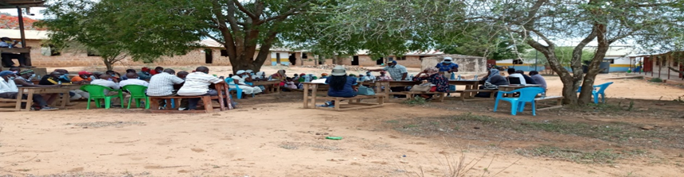

Project Grievance Redress Mechanism
Dorothy explained to the community that it is important to put in place a project grievance redress mechanism (GRM). She noted that the GRM to be set should borrow heavily from the existing conflict resolution structures in the community. She explained that the need for a GRM is to provide the community and other stakeholder’s opportunity to share project information and raise questions and grievances about the project. She told the community that they are free to raise any complain or request information about the project. She explained that the project will have a three-tier grievance redress mechanism as follows.
- Locational grievance redress committee. This is the lowest level (forum) where the community will get project information and also ask questions. At this level you the community will choose project committee members who will also double as grievance redress committee. The membership will comprise; elders/men representatives, representatives from women, youth, special needs (persons with disability), and the office of the chief as Ex-officials. This will be the first stop for receiving information and raising grievances.
- County Grievance Redress committee. This shall consist members of the county working group. This committee is at the county level and will resolve complains or issues that are unable to be resolved at the locational/project level. The chairman of the project grievance redress committee at the community will forward issues/ complains to the county grievance redress committee through CREO who will also be responsible for giving feed back to the local committee
- National Grievance Redress Committee This will comprise, KOSAP Project Implementation Unit at the Ministry of Energy and the implementing agencies. Matters that could not be resolved at the county level will be escalated to this National GRC by the CEC-Energy
- The last level of the GRM for the community or project affected persons will be arbitration or legal redress in a court of law once all the three levels have been exhausted.

She explained further that members of the project/ grievance redress committee will be chosen by the community members themselves. The committee chosen will be in charge of giving project information to the community and be a focal point for reporting project related issues of concern or grievances.

The members chosen to the grievance redress committee for Kilibasi are as follows;
Project Committee Members/grievance redress committee.
S/No | Name | Identification No. | Telephone No. | Category
1 | Bernard Mistavi | 11872439 | 0705228023 | Elder
2 | Bekwekwe Kassim | 20598024 | 0757620912 | Elder
3 | Loiskare k Roine | 21631040 | 0727576893 | Elder
4 | Munali N Munazi | 10955720 | 0769359735 | Elder
5 | Pen Mwanchanze | 25038942 | 0740919603 | Women
6 | Salim Badipha | - | - | Youth

    - Focus Group Discussions
The community members were told of the need to have focus group discussions to discuss the project further and allow the people more opportunities to ask questions or give suggestions regarding the project. Therefore, three separate meetings for men, women and youth were held. In these meetings the message on the project was echoed again especially on benefits and impacts (both positive and Negative) of the project to the community, rights of the community in regard to land and the need to have a grievance redress committee with representation from all groups in the community. Each group was told elect their representatives to the GRC.

a) Focus Group Discussion with the Women
The women were allowed time to ask questions, give suggestions and or seek clarifications.
Table 5-3: Question, Suggestions, Feedback and Response for the Focus Group Discussion with Women
Name of Person making the contribution (e.g. comment or question) | Question, Comment, Suggestion | Feedback/Responses by project team | Response by agency on how feedback will be used or acted upon
Pen Mwadzale | Some people e border one side of people on private land will they be connected to power | -yes they have a right to be connected if they are within the 3km radius of the Mini-grid.  In addition it will depend on way leave issues because we shall have to consult the private owner to grant us way leave consent without compensation so that we can supply them. | N/A
Photo of the focus group discussion with the women
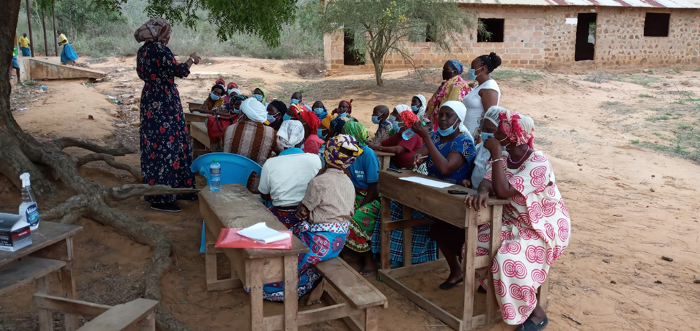

Focus Group Discussion with the Youth
Mr. Steve ( REREC) LED the youth group in the focus group discussion in regards to happenings in their community. The youth said they support the project. The youth were then allowed to ask questions.
Question, Suggestions, feedback and response for focus group discussion with Youth
Name of Person making the contribution (e.g. comment or question) | Question, Comment, Suggestion | Feedback/Responses by project team | Response by agency on how feedback will be used or acted upon
Haruni Dowani | This project is important and it will assist us and the community. I feel we should support it | Noted | N/A

Photo of the youth in focus group discussion
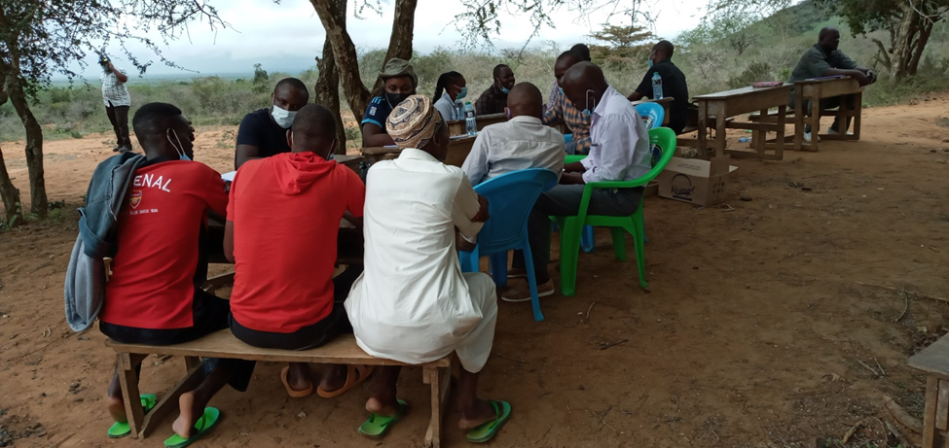

Elders/Men Discussions
Dr. Kasomi lead the men in holding focus group discussion. The elders said they welcome the project and that they had already agreed on the portion of land where the project would be implemented in an earlier meeting. The elders noted they had identified a portion of land within the Kilibasi primary school for the project.
The discussion was then opened up for questions.
Name of Person making the contribution (e.g. comment or question) | Question, Comment, Suggestion | Feedback/Responses by project team | Response by agency on how feedback will be used or acted upon
Peter Githeka | Will the solar for the individual household give the same power as the one for the Mini-grid | No because the one at the individual household has no back-up generator so in the days of poor/low sun light the quality of power may be different | N/A
 | Will the power lines be overhead or underground | Overhead lines | N/A
Gideon Ndambuki | If I have five sons, can we use one meter | If your sons are married and everyone has their houses it will be good to have each their meter. This is also good so as to avoid conflicts in regard to tokens purchase since different household may have different uses. | N/A

Photo of men in focus group discussion
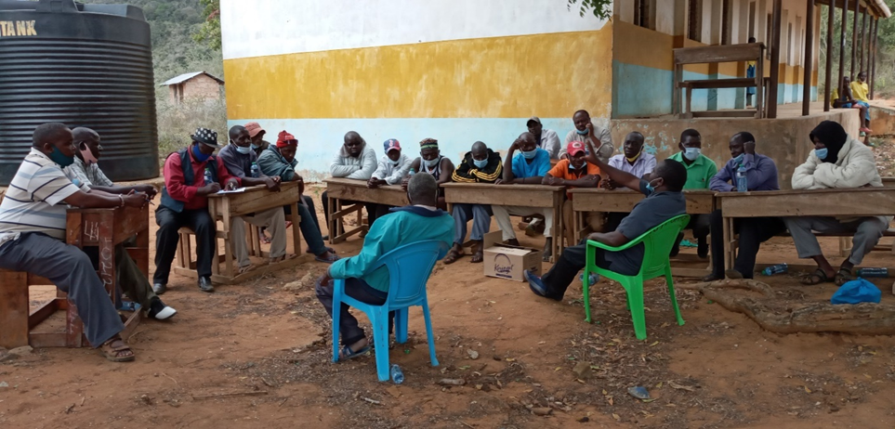

Summary of Community Consultation Meeting during the ESIA

A Consultative Public Participation (CPPs) session is conducted to provide project information and facts to the local community and other stakeholders especially local government administrator thus giving them a platform to enable them to express their appreciation, concerns and fears as well as contribute ideas and opinions towards the project sustainability.
A detailed CPP and community engagement for Kilibasi Solar Mini Grid was held in Kilibasi village, at Kilibasi Baraza park on 1st October 2021 chaired by the area chief.
The general stakeholder consultation was done in a public meeting (Baraza) organized at Kilibasi community baraza point where 36 males and 40 women were in attendance. The meeting was chaired by the area ward administrator assisted by the chief and the “Nyumba Kumi” leaders. The feedback received during the stakeholder consultation process have been summarized below
Table 17: Feedback received during public participation process

No | Issue | Comments | Response
1. | Wildlife protection | Concerns on whether the site would be protected from wild animals, livestock and children | The consultant explained that the site will be well fenced to avoid accidents and also for security purpose, it will be in appropriate surveillance everyday by members from KPLC.
2. | Employment opportunities | Concerns on how employment opportunities will be distributed for the skilled and unskilled personnel | The consultant expounded and informed the community that the available opportunities will always be advertised and information provided on basic requirements and qualifications. He informed them that those who will be eligible will be considered, local capacity is encouraged. He further informed that during project implementation, the contractor will be encouraged to source locally available materials from within so as to create more opportunities for the community
3. | Compensation | Concerns on whether there would be compensation in case of injuries as a result of construction | The consultant informed the youth that the project was being undertaken by qualified and experienced power distribution firm (KPLC/REREC) and is being implemented in conjunction with the Ministry of Energy. He further noted that the implementation will follow set out guidelines and Kenyan law during construction and implementation.
4. | Water quality and scarcity | Concerns on whether the project would affect the local water pan in terms of its capacity and the quality of water pan- Kilibasi location | The consultant informed that the Ministry of Energy and consultants will collect samples of water and soil from the site and it’s surroundings and conduct lab test/ analysis to avoid or mitigate any anticipated environmental impacts of the project.
5. | Power distribution | Concerns on how power will be distributed around the area. | The consultant informed that power will be generated from the project site and distributed to an average distance of 1.5km radius around the area.  He further informed that the project has an additional component for installation of standalone solar systems which will be used to electrify institutions and areas outside the 3km diameter zones. He also clarified that this will be provided at a later stage
6. | Women inclusion in employment | Concerns on whether women will be engaged on available job opportunities for the project | The consultant informed that the project will ensure that opportunities are available for everyone irrespective of their gender. The consultant further informed that women will be considered and integrated into the project.

Positive Comments about the Project from the Participants
Some of the positive impacts that were identified by the participants include the following.
- Learning will improve due to availability of lighting
- improve their livelihood and enhance their living standards
- provide them with energy for domestic use in addition to helping them to improve their business.
- Improve the security within the village

The identified negative impacts of the project
Some of the positive impacts that were identified by the participants include the following.
- Accidents: some of the members raised concerns of possible accidents from falling poles, electrocution especially the children as well as possible accidents from falling of the electric poles. The community suggested extra care when, protection of appliances and reinforcement of electric poles to mitigate these accidents.
- Employment Disputes: There was a concern over the possibility of disputes arising between the local community with people of different cultures in the construction sites. The community suggested that proponent should consider employing local construction workers.
- Dust Generation: The participants expressed concern over possibility of generation of large amounts of dust within the project site and surrounding areas because of demolition, excavation works and transportation of building materials.
The proponent will ensure that dust levels at the site are minimized through sprinkling water in areas being excavated and along the tracks used by the transport trucks within the site. Additional mitigation measures presented in this report will be fully implemented to minimize the impacts of dust generation.
- Environmental Aesthetics It was seen that the aesthetics of the area would be affected negatively during construction. It was suggested that the proponent should ensure landscaping is conducted after construction.
- Noise Pollution: The neighboring school and neighbors will be affected by possible noise and exhaust fumes from the site.
Other concerns
- Some of the members asked whether they be required to pay the cost of connection or only the daily usage
- Questions were also raised on whether the labor and raw materials will be sourced from the community.
- A youth felt that the proposed site was an individual’s plot and suggested that an alternative site be considered

Additional Responses from the Consultant
The consultant while addressing the community’s issues raised, gave the following response.
- Every resident, business or public facility will be connected to the electricity at an affordable cost
- That the Contractor/KOSAP will rehabilitate and plant trees after the construction phase of the project
- All non-skilled labor will be sourced from the Kilibasi Community and not from outside
- He assured the community that the project will commence soon after ESIA
- That noise form the Machinery will be minimized.

Consent
The Community members present accepted the Project Proposal.

Community Presentation

Adult to youth Representation
During the stakeholder’s consultation adults were more represented than the youth as shown in the table below.

Gender Representation
Table 18. The consultative meeting had a wide representation
Category | Male | Female
Youth | 8 | 3
Adult | 26 | 37
TOTAL | 36 | 40

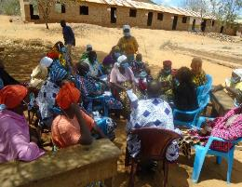 | 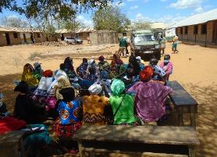
Focused Group Discussion with Women

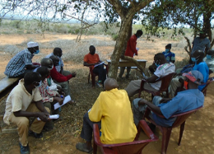 | 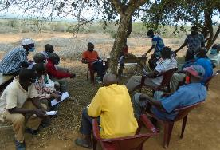
Focused Group Discussion with the Men

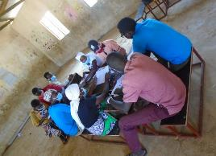 | 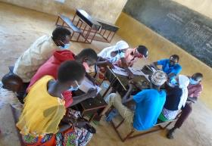
Focused Group discussion with the Youths

- IMPACT ASSESSMENT AND MITIGATION MEASURES
  - Identification of Impacts
This Section identifies and discusses both negative and positive impacts associated with the proposed construction of solar Mini-grid. The impacts are identified across all the phases namely: Pre-construction Phase, Construction Phase, Operational Phase and Decommissioning Phase.

Identification of project’s positive and negative environmental impacts was done through observations, literature review, consultations and use of experts’ analysis. The positive impacts are presented first then the negative impacts and their mitigation measures.
  - Impact Assessment Methodology
An impact is essentially any change to a resource or receptor brought about by the presence of the Project component or by the execution of a Project related activity. In general, the assessment of impacts will proceed through an iterative process considering four key elements:
- Prediction of potential impacts and their magnitude (i.e., the consequences of the development on the natural and social environment);
- Evaluation of the importance (or significance) of potential impacts taking the sensitivity of the environmental resources or human receptors into account;
- Development of mitigation measures to avoid, reduce or manage the potential impacts or enhancement measures to increase positive impacts; and
- Assessment of residual significant impacts after the application of mitigation and enhancement measures.
Where significant residual impacts remain, further options for mitigation may be considered and impacts re-assessed until they are as low as reasonably practicable for the Project and would be deemed to be within acceptable levels:

Defining Impact
Impacts will be defined in a number of ways, including:
- Nature of impact: positive or negative;
- Type of impact: direct, indirect, or cumulative;
- Duration of impact: temporary, short-term, national, international
- Scale of impact: onsite, local, regional, national, international.

Assessment of Significance
Criteria for assessing the significance of impacts will stem from the following key elements:
- Status of compliance with relevant Kenyan legislation, policies and plans and any relevant Kenyan or industry policies, standards or guidelines, as well as international best practice standards and guidelines;
- The magnitude (including nature, scale and duration) of the change to the natural or socioeconomic environment (e.g. an increase in coastal erosion, or an increase in employment opportunities), expressed, wherever practicable, in quantitative terms. The magnitude of all impacts is viewed from the perspective of those affected by considering the likely perceived importance as understood through stakeholder engagement;
- The nature and sensitivity of the impact receptor (physical, biological, or human). Where the receptor is physical, the assessment considers the quality, sensitivity to change and importance of the receptor. For a human receptor, the sensitivity of the household, community or wider societal group is considered along with their ability to adapt to and manage the effects of the impact; and
- The likelihood (probability) that the identified impact will occur. This is estimated based upon experience or evidence that such an outcome has previously occurred.
It is generally accepted that significance is a function of the magnitude of the impact and the likelihood of the impact occurring.
For this assessment, significance has been defined in Table 8-1 based on five levels described in table below;
Table 5-6: Categories of Significance
Category | Significance
Positive impacts | Positive impacts provide resources or receptors, most often people, with positive benefits. It is noted that concepts of equity need to be considered in assessing the overall positive nature of some impacts such as economic benefits, or opportunities for employment
Negligible impacts (or Insignificant impacts) | Negligible impacts (or Insignificant impacts) are where a resource or receptor (including people) will not be affected in any way by a particular activity or the predicted effect is deemed to be ‘negligible’ or ‘imperceptible’ or is indistinguishable from natural background variations.
Minor | An impact of minor significance (‘Minor impact’) is one where an effect will be experienced, but the impact magnitude is sufficiently small (with or without mitigation) and well within accepted standards, and/or the receptor is of low sensitivity/value.
Moderate | An impact of moderate significance (‘Moderate impact’) is one within accepted limits and standards. Moderate impacts may cover a broad range, from a threshold below which the impact is minor, up to a level that might be just short of breaching a legal limit. Clearly to design an activity so that its effects only just avoid breaking a law and/or cause a major impact is not best practice. The emphasis for moderate impacts is therefore on demonstrating that the impact has been reduced to a level that is ALARP (as-low-as-reasonably-possible). This does not necessarily mean that ‘Moderate’ impacts have to be reduced to ‘Minor’ impacts, but that moderate impacts are being managed effectively and efficiently.
Major | An impact of major significance (‘Major impact’) is one where an accepted limit or standard may be exceeded, or large magnitude impacts occur to highly valued/sensitive resource/receptors. An aim of EIA is to get to a position where the Project does not have any major residual impacts, certainly not ones that would endure into the long-term or extend over a large area. However, for some aspects there may be major residual impacts after all practicable mitigation options have been exhausted (i.e., ALARP has been applied). It is then the function of regulators and stakeholders to weigh such negative factors against the positive ones in coming to a decision on the Project.

For environmental impacts the significance criteria used in this ESIA is shown in Table 8-2:
Table 5-7: Overall Significance Criteria for Environmental Impacts
Receptor sensitivity | Impact Magnitude
 | Low | Medium | High
Low | Minor | Minor | Moderate
Medium | Minor | Moderate | Major
High | Moderate | Major | Major

For the social impact assessment, the perceptions of stakeholders, expressed as opinions around certain issues, can be as important as actual impacts. Consequently, the concept of perception is explicitly brought into the evaluation of significance after an impact is evaluated. When an impact is of significant stakeholder concern, this may be causing to raise the significance rating. This prompts the formulation of more rigorous and appropriate mitigation measures which focus on the source of the impact and also address stakeholder perceptions. The risk of not addressing stakeholder perceptions is that reputational damage could arise, resulting in the loss of a ‘social license to operate.

Magnitude of Impact
The impact assessment describes what will happen by predicting the magnitude of impacts and quantifying these to the extent practical. The term ‘magnitude’ covers all the dimensions of the predicted impact to the natural and social environment including:
- the nature of the change (what resource or receptor is affected and how);
- the spatial extent of the area impacted, or proportion of the population or community affected;
- its temporal extent (i.e., duration, frequency, reversibility); and
- where relevant (accidental or unplanned events), the probability of the impact occurring.
For social impacts, the magnitude considers the perspective of those affected by taking into account the likely perceived importance of the impact, the ability of people to manage and adapt to change and the extent to which a human receptor gains or loses access to, or control over, socio-economic resources resulting in a positive or negative effect on their well-being (a concept combining an individual's health, prosperity, their quality of life, and their satisfaction).

Sensitivity of Resources and Receptors
Sensitivities are defined as aspects of the natural or social environment which support and sustain people and the physical environment. Once affected, their disruption could lead to a disturbance of the stability or the integrity of that environment. For ecological impacts, sensitivity can be assigned as low, medium or high based on the conservation importance of habitats and species. For habitats, these are based on naturalness, extent, rarity, fragility, diversity and importance as a community resource.
For socio-economic impacts, the degree of sensitivity of a receptor is defined as ‘a stakeholder’s (or groups of stakeholders’) resilience or capacity to cope with sudden changes or economic shocks. The sensitivity of a resource is based on its quality and value/importance, for example, by its local, regional, national or international designation, its importance to the local or wider community, or its economic value.

Likelihood
Terms used to define likelihood of occurrence of an impact are explained in Table 8-3 below.
Table 5-8: Explanation of Terms Used for Likelihood of Occurrence
An impact with a
High probability | Refers to a very likely impact | Refers to very frequent impacts
Medium probability | Refers to a likely impact | Refers to occasional impacts
Low probability | Refers to rare impacts | Refers to rare impacts
 | As far as one-time events (e.g., air emissions) or slowly developing effects  are concerned (e.g., impacts on local life  style) | As far as possibly recurring impacts are  concerned, such as accident or unplanned events (e.g., traffic accident,  fire)

Definition of Mitigation Measures
Mitigation measures are developed to avoid, reduce, remedy or compensate for significant potential negative impacts, and to create or enhance potential positive impacts, such as environmental and social benefits. In this context, the term “mitigation measures” includes operational controls as well as management actions. These measures are often established through industry standards and may include:
- Changes to the design of the project during the design process (e.g., changing the development approach);
- Engineering controls and other physical measures applied (e.g., wastewater treatment facilities);
- Operational plans and procedures (e.g., waste management plans); and
- The provision of like-for-like replacement, restoration or compensation.
For potential impacts that are assessed to be of major significance, a change in design is sometimes required to avoid or reduce the significance. For potential impacts assessed to be of moderate significance, specific mitigation measures such as engineering controls are often sufficient to reduce these impacts to ALARP (‘as-low-as-reasonably-possible’) levels. This approach takes into account the technical and financial feasibility of mitigation measures. Potential impacts assessed to be of minor significance are usually sufficiently managed through good industry practice, operational plans and procedures.
In developing mitigation measures, the first focus is on measures that will prevent or minimize potential impacts through the design and management of the Project rather than on reinstatement and compensation measures.

Positive Impacts - Pre-Construction
- Employment opportunities arising from recruitment of workers
- Skill acquisition and enhancements to locals and future workforce
- Improvement in quality of life for from the in-kind compensation agreed by the community member

Positive Impacts During Construction Phase
This section enumerates and discusses the positive impacts associated with the proposed project during construction phase of the project.

Creation of Employment Opportunities
Various employment opportunities will be available during construction. The opportunities will be both skilled and unskilled. Majority of the unskilled and semi-skilled jobs will be taken up by the local community. Employment of the locals will increase skill transfer from the contractors.
The approximate number of workers to be employed by the proposed project is not yet known, however, this will contribute to easing unemployment level in the area. There will be a trickledown effect to the economy at large resulting from new income revenues as well as services provided through this project.

The impact significance is low as it will employ few people over a short period

Enhancement Measures
- Contractor should ensure that they prioritise the local community in allocating job opportunities.
- Contractor should ensure that job opportunities are not discriminatory
- Equal opportunities should be given to both men and women

Improving local economy
During this phase, the project will require supply of building materials most of which will be sourced locally at the nearest trading centre and its environs to the extent possible. Therefore, the project will provide ready market for local enterprises with such materials and boosts the local economy.

The businesses that will benefit during this phase are such as hotel, shops, artisan industries and food vending who will be benefit directly from the construction, as people working there will need commodities from them. This will promote the informal sector in securing some temporary revenues and hence improved livelihoods.
One of the responsibilities of the PAPs of the proposed Solar Mini-grid is to undertake wiring of their premises before there are connected and payment of a connection fee of Ksh 1000. The MOE through its implementing agency KPLC should consider supporting at least 50 households that are very poor through installation of ready boards to offset the cost of wiring so that they can also access electricity.
The impact significance is low as it will buy few materials over a short period of time

- KPLC should ensure that their contractors/suppliers remit taxes and have a tax compliance certificate
- Prioritise local purchases over imports.
- Remit taxes on behalf of employees
- Contractor should prioritise local purchases over imports;
- Contractor should give preference to the local labourers which increases the local’s ability to spend

Positive Impacts during Operation Phase

Quality, Reliable Power Supply
There is no electricity in Kilibasi. This is a maiden project with an aim of supplying power through solar because the area is far away from the national power grid. Once operational, household and public institutions (dispensary, primary school) and shopping centre in the area will greatly benefit from the stable power supply.

The impact significance is high as it will provide power where it wasn’t for a long period

Enhancement Measures
- KPLC should ensure that they have a functional customer support team and a field response team;
- KPLC should ensure that they communicate power outages early to consumers

Employment Creation
Employment opportunities will also be created during the operation phase of the project. Opportunities that will be created include unskilled, semi-skilled to skilled jobs. These will involve security personnel, and staff to operate and maintain the Mini-grid. Employment will increase skill transfers.

The impact significance is low.

Enhancement Measures
- KPLC should ensure that they prioritise the local community in allocating job opportunities.
- KPLC should ensure that job opportunities are not discriminatory
- Equal opportunities should be given to both men and women

Reduction of Pollution Associated with Thermal Power Generation, Kerosene and Wood Fuel Usage:
Residents in the area use different sources of energy. Electricity supply will imply that as many as are willing can apply for connection and get connected. This will result in reduced individuals and organizations using diesel generators, less reliance on kerosene, wood fuel and charcoal. This would mean less carbon dioxide is released to the environment and destruction of forests will be reduced hence decreasing greenhouse gases.

The impact significance is high as it will provide cleaner energy over a long [period of time for many households

Enhancement Measures
- KPLC should ensure that the power provided cost is competitive to discourage the locals from using unclean source of power.
- KPLC should ensure that they communicate power outages early to consumers

Improvement of Local and National Economy
The mini-grid project will ensure supply of a stable power that will reduce damage to the electronics and this will result in promotion of businesses both in the formal and informal sectors. Availability of power will enable businessmen to scale up their businesses while making it is possible to set up businesses such as salons, barber shops, photocopying machines, cyber cafes, welding, refrigeration of drinks among others. This will result in income improvements at the individual level and for the national economy. More customers will be connected and retail of reliable electricity by the power utility firm will attract increased tax revenues to the government.

The impact significance is low as it will buy few materials over a long period of time

Enhancement measures
- KPLC should ensure that their contractors/suppliers remit taxes and have a tax compliance certificate
- Prioritise local purchases over imports.
- Remit taxes on behalf of employees

Education
Access to electricity at the household level and schools will create opportunities for children be able to study even for longer hours. Additionally, children in households can also access education programs being aired through different radio and T.V. channels. Schools will be able to take advantage of information technology and communication that are becoming a way of life in education sector and learning in general.’
The impact significance is high as it will provide power to schools over a long period for additional study time in the night and morning

Enhancement Measures
- KPLC should consider having the transmission lines are closer to schools for them to benefit from the power supply;
- KPLC should consider partnering with the county government in providing street lighting to improve security for children and teachers leaving for school early or leaving late for home

Health Benefits of the Project
Solar energy for lighting is better than kerosene lamps that are in use currently. This is because kerosene lamps emit particles that cause air pollution. The health risks posed by this indoor air pollution mainly include acute lower respiratory infections. Additionally, insufficient illumination (low light) conditions can cause some degree of eye strain and reading in these conditions over long periods of time may have the potential to increase the development of near-sightedness in children and adults. The project will result in many families replacing kerosene lamps for lighting with electricity there-by reducing chances of the afore mentioned disease incidences.

Improved Standard of Living
Availability of power will result in lifestyle changes through improved night lighting, pumping of water instead of manual pumping and refrigeration to maintain food safety and quality.

Security
The area will benefit from improved security since houses, businesses and public institutions will be well lit using electricity. This is as a result of more security flood lights bulbs which helps keep off opportunistic crimes including gender-based violence.

Communications
Access to electricity will lead to improved communication. This will be enabled by the fact that charging of mobile phones will be easier and cheaper. Access to mass media like radio and T.V will provide opportunity for the households to access a wide range of information which is useful for decision making.

Positive Impacts during Decommissioning Phase

Employment Opportunities
Once the project has served its purpose it will then be decommissioned. This will involve demolition and removal of the facility. During demolition, unskilled, semi-skilled and skilled employment opportunities will be available to the public.

Site Rehabilitation
After demolition of the proposed project, rehabilitation of the project site will be carried out to restore it to its original status or to a better state than it was. This will include replacement of topsoil and re-vegetation which will lead to restoration of the visual, vegetative and aesthetic state of the site.

Negative Impacts during Pre-construction Phase

Land Take
The identified site for the proposed Mini-grid is part of a 1.214 Ha of land owned by the Kilibasi community that they set aside for construction of public facilities. The assessment found that;
- No residential houses or businesses premises were on the piece of land
- No socio-economic activity was taking place on the land
- No physical relocation will take place.

Way Leaves
Supply of electricity will involve passing of low voltage (LV) lines to connect the customers to power. It is estimated that a total of 11 km of LV circuit will be constructed mainly along the road reserve and along the boundaries to supply power.

The impact significance for this impact is assessed minor considering the community willingly allocated the land for project construction.

Mitigation Measures
- Land for mini-grids will be acquired by NLC compulsorily and affected communities compensated in-kind.
- The contractor will sign and adhere to the agreement for use of community land for contractor facilities and worker’s camps, and restoration of the site after use.
- The construction activities will be restricted to within the allocated land and the immediate surroundings only.
- After construction work, any land taken for a temporary basis for storage of material will be restored to their original form.
- Consultations with the community during construction of the low voltage lines

Negative Impacts During Construction Phase
Despite the positive impacts identified, the project will also have negative impacts. However, adverse impacts are not anticipated due to its size and nature and most of the impacts will be experienced during construction phase of the project. The negative impacts and their mitigation are discussed below.

Vegetation Clearance
The construction process of the proposed Mini-grid and other associated facilities and structures will involve clearing of the existing vegetation cover (mainly grass) and trees. The project site is located in open area with minimal settlement around besides the dispensary and residential homes. Both the magnitude and sensitivity of this impact will be low. The impact will be direct, permanent and minor.
Mitigation Measures
- Clear only the necessary areas
- Ensure proper demarcation and delineation of the project area to be affected by construction works.
- Specify locations for vehicles and equipment, and areas of the site which should be kept free of traffic, equipment, and storage.
- Designate access routes and parking areas
- Re-vegetation including planting of trees around the plant/facility

Soil Erosion Impact
During clearing of the area to pave way for groundbreaking soil erosion may take place. This will be due to surface run off or blowing away by the wind if not properly managed. This is bound to happen because the soil will be loose. The area is gently slopy on the lower side and surface run off can also result to soil erosion. The impact significance will be minor due to the nature of the works and the fact that construction activities will be confined in the small project area.
Mitigation Measures
- The contractor shall avoid groundbreaking during the seasons of high rainfall to avoid erosion.
- Monitoring of areas of exposed soil during rainy seasons to ensure that any incidents of erosion are quickly controlled.
- The contractor should ensure that construction related impacts like erosion and cut slope destabilizing should be addressed through landscaping and grassing, carting away and proper disposal of construction materials
- Use silt traps where necessary
- Cover soil stockpiles.
- Landscaping with grass on areas without electrical installation (lower areas)
- The contractor should ensure recovery of exposed soils with grass and other ground cover as soon as possible.
- The contractor should put up proper drainage to avoid unnecessary erosion and do compaction of spoil areas to avoid land instability in form of soil subsidence, slip and mass movement.
- Areas compacted by vehicles during site preparation and construction should be scarified (ripped) by the contractor in order to allow penetration of plant roots and the re growth of the natural vegetation

Contamination of Soil from Fossil Fuels
The potential sources of soil contamination during construction phase are oil /fuel leaks or spills from machinery used in site preparation and trucks used in transporting construction materials. Depending on the size and source of the spill, liquid and gaseous state, petroleum hydrocarbons may remain mobile for long periods of time, threatening to contaminate the soil. The significance of the impact to the soil will be minor due to the nature of the works and the fact that construction activities will be confined in the small project area.
Mitigation Measures
- Construction vehicles must be maintained in good state and proper servicing to ensure no oils are likely to leak
- Care must be exercised not to spill any fossil fuels
- Any contaminated soil shall be scooped and disposed-off appropriately.

Dust Emissions
Initial activities such as site clearing, excavation if done in dry weather conditions will result in dust pollution. Dust emission from construction machinery is regarded as a nuisance when it reduces visibility and is aesthetically displeasing. This is expected during construction works. Dust will be generated from construction earthworks, transportation activities and aggregate mixing.
The receptors were noted to be mainly residential and a health facility. The distances from a source that dust impacts can occur is highly site specific and will depend on the extent and nature of incorporated mitigation measures, prevailing wind conditions, rainfall and the presence of natural screening. Due to the variability of the weather, it is impossible to predict what the weather conditions will be when specific construction activities are being undertaken. Therefore, the assessment of construction dust impacts is typically qualitative.
Mitigation Measures
- The construction area should be fenced off to reduce dust to the public
- Sprinkle loose surface earth areas with water to keep dust levels down.
- Construction trucks moving materials to site, delivering sand and cement to the site should be covered to prevent material dust emissions into the surrounding areas;
- Masks should be provided to all personnel in areas prone to dust emissions during construction
- Stockpiles of excavated soil should be enclosed/covered/watered during dry or windy conditions to reduce dust emissions.
- Drivers of construction vehicles must be sensitized so that they limit their speeds so that dust levels are lowered.
- Trees can be planted around the plant provided they do not cast shadows to the solar panels to act as wind breakers and hence decrease dust pollution

Vehicle Exhaust Emissions
Exhaust emissions are likely to be generated by the construction vehicles and equipment. Motor vehicles that will be used to ferry construction materials would cause air quality impact by emitting pollutants through exhaust emissions. There are few Receptors (settlements) within 500 m of the project site and the impact magnitude will be medium and sensitivity medium hence the impact significance will be moderate.
Mitigation Measures
- Drivers of construction vehicles must be sensitized so that they do not leave vehicles idling so that exhaust emissions are lowered.
- Maintain all machinery and equipment in good working order to ensure minimum emissions of carbon monoxide, NO_{X}, SO_{X} and suspended particulate matter;

Pollution from Solid Waste Generation
It is expected that solid waste will be generated during construction phase of the project. Solid waste is anticipated to be produced during site preparation, civil works, spoil from excavations and will include; mortar, wood, paper, waste paper wrappings, conductor off cuts, masonry chips and left-over food stuffs. Effects of mismanaged waste include:
- Public nuisance due to littering or smell in case of rotting
- Contamination of soils and water courses
- Creation of breeding grounds for vermin like rodents and cockroaches
The significance of this impact will be minor due to the nature of the works and the fact that construction activities will be confined in the small project area.
Mitigation Measures
- Ensure spoil from excavations is arranged according to the various soil layers. This soil can then be returned during landscaping and then rehabilitation, in the correct order which they were removed that is top soil last;
- Segregate waste and dispose of appropriately using a licensed waste handler
- Provide litter collection facilities such as bins and create awareness campaigns to segregate as early as possible, using the appropriate bins
- Contractor to put in place and comply with a site waste management plan
- The contractor should comply with the requirement of OSHA ACT 2007 and Building rules on storage of construction materials
- Use of durable, long-lasting materials that will not need to be replaced as often, thereby reducing the amount of waste generated over time
- Recovery of materials remains and return to stores
- Re-use of materials where possible
- Proper budgeting to avoid waste generation

Impacts on Water Resources and Water Quality
During construction, excavation activities will involve soil exposure which results in soil erosion due to wind and surface runoff due to rains. Seepage from spilled fuels and oils and leaking machinery can also negatively impact groundwater water which could lead to potential contamination. Generally, due to the localized area of impact, the overall significance of the related impacts on water quality is considered to be minor, provided the necessary mitigation/ management measures are implemented.

Mitigation Measures
Measures shall be put in place to minimize erosion and sediment mobility, especially during construction. These measures include:
- Clear the necessary areas only.
- Appropriate remedial measures shall be implemented by the contractor in the event of erosion.
- Infrastructure shall be designed to ensure that contaminated run-off does not reach watercourses.
- In the event of an oil spill the procedures contained in the emergency response plan of the contractor will come into effect.
- No vehicle maintenance and service shall be done at project site but in approved garages or service stations to avoid any possible oil and fuel spills that could contaminate soils and possibly ground water quality.
- Ensure that potential sources of petro-chemical pollution are handled in such a way to reduce chances of spills and leaks.
- Construction activities to avoid any unchanneled flow of water at the site
- Storage areas that contain hazardous substances should be bundled with an approved impermeable liner and provision for a pit to be made in case of oil spill.
- The excavation and use of rubbish pits during construction should be strictly prohibited.
- A waste disposal area should be designated within the active construction area and this should be equipped with suitable containers i.e., skips or bins of sufficient capacity and designed to contain and prevent refuse from being blown by wind,
- Areas contaminated by spilled concrete and/or fuels and oils leaking from vehicles and machinery should be cleaned immediately.
- The contractor to source for alternative source of water for construction purposes to avoid potential conflict with the community

Noise and vibration
During construction activities noise pollution will occur and is bound to be a nuisance and a disturbance to neighboring communities. This noise is from construction equipment, excavation works, concrete mixing and vehicles coming to site but will be temporary. From the prediction of the specialist study on ambient noise quality measurements, the traffic noise that will be emitted by traffic accessing the proposed project site during construction is expected to have an adverse impact on ambient noise. The level of traffic noise will increase depending on the traffic volume. General guideline indicates that an increase of 20% in traffic volume approximates to a noise level increase of around 1 dB, while a doubling of traffic volume results in a noise level increase of about 3 dB. It is however, worth noting that the level of noise is attenuated with increase in distance from the source and thus the sites/objects in close proximity to the source will receive more noise in comparison to those at remote location. The impact significance has therefore been assessed minor. This due to the fact that the impact magnitude is low and the receptor sensitivity is medium.

Mitigation Measures for Noise and Vibration
These proposed mitigation measures aim to ensure that noise generated during construction is kept to minimum and adheres to relevant noise standards. They include:
- Fencing off the construction site with iron sheet during construction
- Install portable barriers to shield compactors thereby reducing noise levels.
- Use of noise-suppression techniques to minimize the impact of construction noise at the project site.
- Use equipment designed with noise control elements.
- Co-ordinate with relevant agencies regarding all construction activities.
- Limit vehicles to minimum idling time and observe a common-sense approach to vehicle use, and encourage drivers to switch off vehicle engines whenever possible.
- Set and observe speed limits and avoid raving of engines
- The Contractor shall ensure that construction activities are limited to working hours (i.e., between 8am and 5pm daily) from Monday to Saturday, or as required in terms of legislation.
- Compliance with Noise and Vibration Regulations of 2009 is expected

Impacts from Hazardous Materials
Some hazardous materials will be used during construction phase of the project. They include insulating oil, paints, solvents and oils. Spilled chemicals can contaminate soil as well as pollute water resources. Additionally, hazardous and flammable substances if improperly stored and handled on site become potential health hazard for construction workers and the public. The amount of hazardous waste generated will be minimal. The significance of the impact will be minor due to a low magnitude and medium sensitivity.

Mitigation Measures
- Maintenance of construction vehicles will not be done on site
- All hazardous products and waste should be labeled and handled properly to avoid contact with the ground
- Material handling to be done by trained and qualified staff
- The contractor site should have designated area (concrete bunded) for storing hazards materials

Accidental Oil Spills or Leaks
There is possibility of oil leaks from construction vehicles. The construction machines on the proposed site have moving parts which will require continuous oiling to minimize the usual corrosion or wear and tear. These processes may lead to oil spill to the ground. The impact significance will be minor due to the nature of the works and the fact that construction activities will be confined in the small project area.

Mitigation Measures
- In the event of accidental leaks, contaminated top soil should be scooped and disposed of appropriately.
- It is proposed that the refuelling and maintenance of vehicles will not take place at the construction site.
- Contractor to create awareness for the employees on site on procedures of dealing with spills and leaks from oil for the construction machinery
- Vehicles and equipment must be serviced regularly and kept in good state to avoid leaks.
- In case of spillage the contractor should isolate the source of oil spill and contain the spillage using sandbags, sawdust, absorbent materials and/or other materials approved by materials.
- Proper training for the handling and use of fuels and hazardous material for construction workers.
- All chemicals should be stored within the bunded areas and clearly labelled detailing the nature and quantity of chemicals within individual containers.

Fire Hazards
During construction of the project, fire hazards are likely to occur especially when precaution measures are not taken to account. Smoking is one of causes of fires and this can happen if cigarette butts are left carelessly. Additionally, keeping of fuels onsite during construction can be a potential cause of fire. This impact is evaluated to be of moderate significance. All the construction activities will be confined at the project site hence high sensitivity and low magnitude.
Mitigation Measures
The following measures should be put in place to prevent fire hazards:
- Create awareness to the construction workers on potential fire hazards
- Provision of firefighting equipment (extinguishers) on site during construction.
- No smoking shall be done on construction site
- ‘No smoking’ signs shall be posted at the construction site
- A fire evacuation plan must be posted in various points of the construction site including procedures to take when a fire is reported.

Impacts of construction material sourcing (e.g., quarrying)
The construction of the project will utilize materials such as; stone, ballast, sand and hardcore. It is anticipated that they will be obtained from quarry and mining operations. Conscious or unwitting purchase of these materials from unlicensed operations indirectly supports, encourages and promotes environmental degradation at the illegal quarry sites and causes medium to long term negative impacts at source, including landslides. The significance of this impact will be moderate due to high sensitivity and low magnitude.

Mitigation Measures
- The contractor should source all building materials such as stone, sand, ballast and hard core from NEMA approved sites.
- Ensure accurate budgeting and estimation of actual construction materials to avoid wastage.
- Reuse of construction materials where possible.

Increased Water Demand
During the construction of the project there will be increased demand for water by the construction workers and the construction works. Water will be mostly used in the construction works and for wetting surfaces or cleaning completed structures. It will also be used by the construction workers to wash themselves and even drink. Although the sensitivity of the receptor (surface water) in the project area is high owing to unavailability of feasible alternative source of water for the local community, the overall significance of impacts is assessed to be negligible due to negligible magnitude of the impact.
Mitigation Measures
- Prudent use of available water
- Consultations with the project local committee on use of water in the community to avoid conflicts with the community
- Contractor to make own arrangements to provide water for construction works different from the community dam to avoid any conflicts with community.

Energy Consumption
The construction works will consume fossil fuels (mainly diesel) to run transport vehicles and construction machinery. Fossil energy is non-renewable and its excessive use may have serious environmental implications on its availability, price and sustainability. This impact will be negligible owing to the size of the project that will require very few trucks during the construction phase.

Mitigation Measures
Proper planning of transportation of materials will ensure that fossil fuels (diesel, petrol) are not consumed in excessive amounts. Complementary to these measures, the contractor shall monitor energy use during construction and set targets for reduction of energy use.
- Regular maintenance of vehicles to ensure efficient consumption of fuels.

Occupational Health and Safety Impacts
There are several activities involved during construction. These activities can pose potential health and safety risks to the workers. The activities include excavation, backfilling, civil works, pole erection, stringing of conductors. Risk of accidents and incidents are likely during construction activities. As already noted during construction, the safety and health of employees may be exposed to risk as a result of the use of tools and other machinery to construct the Mini-grid. Occupation safety and health risks includes accidents, fall from heights, pricks by sharp objects etc. The impact on occupational health and safety during the construction phase is evaluated to be of moderate significance. All the construction activities will be confined at the project site hence high sensitivity and low magnitude.
Mitigation Measures
- The contractor should use skilled personnel for activities that demand that.
- Awareness creation/Tool box talks on safety to workers while at construction site and documentation kept
- Workers coming to the site should be knowledgeable on safety precautions to take
- Appropriate PPE (helmet, safety harness, gloves, safety shoes, masks, climbing irons among others)
- Proper housekeeping and maintain good hygiene
- Close supervision of workers
- Engagement of trained first aider on site
- Provide safe drinking water for workers
- Availability of equipped first aid box on site
- Risk assessment by contractor of the construction activities and implement mitigation measures appropriately
- Adherence to occupational Safety and Health Act 2007
- Establish Safety committees
- The contractor must acquire insurance for the workers-WIBA cover

Community Safety -Access to Site by General Public
If access to the Mini-grid site is not controlled then it can lead to people entering the site including animals. This can result to accidents. Impact significate is rated as moderate considering the high impact magnitude and low receptor sensitivity.
Mitigation Measures
- Proper barricading
- Awareness creation to community
- Hazard communication.
- Controlled access to the site by designated personnel
- Maintain records of any person who comes to site

Spread of HIV/AIDS and STIs
HIV and AIDS remain a major challenge in Kenya as well as Kwale County. The epidemic continues to adversely impact on all spheres of the County; economic, social and health sectors.

The project construction will improve the economic status of some of the people employed thus increasing the disposable income with the probability of indulgence in substance abuse and using the money to solicit for sex. Researchers have indicated that HIV prevalence rates are higher in areas where there is high disposable income as might be the case during construction of the project
Mitigation measures include:

- Develop and implement at HIV/AIDS Policy to promote awareness of HIV/AIDS and access to treatment.
- Employees contractors and subcontractors will be required to follow, and will be trained in, the Worker Code of Conduct which includes context specific guidelines on worker-community interactions, worker-worker interactions and alcohol and drug use.
- Employees, contractors, and subcontractors will be trained and educated to improve awareness of transmission routes and methods of prevention of sexually transmitted infections, communicable diseases and vector borne diseases, notably malaria, prior to working on the Project site. Other diseases will be covered as appropriate.
- Provide access to free condoms at all worker sites and accommodation.
- Work with NGOs or the Ministry of Health to develop and implement a community sensitisation programme on HIV/AIDs and communicable diseases.
- Continue to implement a programme of stakeholder engagement including a grievance mechanism in communities in the Project Area.
- Monitor health trends during Project construction (and operations) in order to be aware of and respond appropriately to any negative health trends that may be linked to the Project and its workers.

Increase in competition for scarce resources and strain on public utilities

The influx of workers in the area is expected to lead to increase in demand for public amenities such as hospitals, transport, schools water resources etc. This could lead to a loss of access to these services by locals especially those who could be among the vulnerable categories. Due an increase in demand, cost of housing near the sites will disadvantage the locals.
The nature of the project will require technical skills that might not be available in the community. This might require movement of construction workers into the community. It is expected that technically skilled personnel might be sourced from outside the community while the unskilled labour is expected to be sourced locally. It is therefore a possibility that the neighbouring communities might go out looking for opportunities in project area thus creating competition. The significance of this impact is considered to be minor because the receptor sensitivity will be medium, and the impact magnitude is low.
Mitigation Measures
- Reduction of labour influx by tapping into the local workforce to the extent possible
- Recruitment of local workforce to the extent possible especially unskilled and semi-skilled jobs
- Consultations with and involvement of local community in project planning and other phases of the project
- Awareness-raising among local community and workers on the need to have a good /cordial working relation
- Sensitization/awareness to workers regarding engagement with local community.
- Contactor shall make provision to provide resources needed by the workers if the need for such resources may result to competition e.g., water
- Establishment and operationalization of an effective Grievance Redress Mechanism accessible to community members
- The contractor and the project/community grievance redress committee to work closely address complains raised on time.
- Gender considerations in employment opportunities
- Appropriate compensation for work done
- Respect for community values/culture
- Prompt payments as per the contractual agreements/terms

Child Labor
Implementation of the project could lead to increased opportunities for the host community to sell goods and services to the incoming workers. This can lead to child labour to produce and deliver these goods and services, which in turn can lead to school truancy. The impact significance is rated minor, based on low sensitivity of the receptor and medium magnitude of the impact.
Mitigation Measures
  - Awareness creation to the community that child labour is illegal and that children have a right to education.
  - Communication to the contractor that child labour is illegal and adherence to employment act is required.

Gender Based Violence- SEA and SH
Gender-based violence (GBV) is an umbrella term for any harmful act that is perpetrated against a person’s will and that is based on socially ascribed (i.e., gender) differences between males and females. It includes acts that inflict physical, sexual or mental harm or suffering, threats of such acts, coercion, and other deprivations of liberty. GBV in project may manifest in terms of sexual exploitation and abuse (SEA) and workplace sexual harassment (SH).

Sexual Exploitation and Abuse (SEA) is any actual or attempted abuse of a position of vulnerability, differential power, or trust, for sexual purposes, including but not limited to, profiting monetarily and socially from the sexual exploitation of another. Sexual abuse is further defined as “the actual or threatened physical intrusion of a sexual nature, whether by force or under unequal or coercive conditions.” Women, girls, boys and men can experience SEA.

Workplace sexual harassment (SH) includes unwanted sexual advances, request for sexual favors and sexual physical contact.

Sexual exploitation and abuse (SEA) of community members by project workers and sexual harassment (SH) among project workers are forms of GBV that are a potential risk and impacts to this proposed project. GBV has serious and far-reaching negative effects including physical injuries resulting in death or disfigurement, psychological trauma, infection with HIV/AIDS, unwanted pregnancies, social stigmatization and exclusion and economic deprivation among others. Consequently, it is incumbent that preventive measures be mooted to prevent occurrence of such cases.

There are few but rare incidents of gender-based violence in as identified during FGD with Men, women and youths. However, it cannot be ruled out during project implementation. Thus, the significance of this impact is considered to be Minor considering low sensitivity of the receptor and low magnitude of the impact.
Mitigation Measures
To manage GBV risks, the contractor will prepare a SEA/SH Prevention and Response Action Plan that will include a GRM that ensures confidentiality. The plan should have an Accountability and Response Framework. The plan will include the necessary measures for prevention and response. The contractor can make reference to World Bank’s Good Practice Note for Addressing Gender-based Violence in Investment Project Financing involving Major Civil Works (Sept 2020) for further guidance.
It should be noted that the decision to report a GBV case lies with the survivor or the guardians if the survivor (in case of a minor) and such a decision must be respected. Therefore, the contractor or project will only refer the survivor of guardian to the established referral pathway, including the nearest police station with a gender desk for handling GBV cases. Also, should a survivor choose legal redress, the project will similarly facilitate him/her by referring him/her to the nearest established legal support facility that offers legal support to GBV survivors.

Key tasks will include:
- Community engagement to create awareness on SEA/SH risk/ issues
- Creating awareness to workers on the need to refrain from SEA/SH incidences
- Mandatory awareness creation for workers on required lawful conduct in the community and legal consequences for failure to comply with laws
- Mandatory signing and implementation of code of conduct for the workers
- Creation of partnership or liaison with specialized actors in GBV who can respond appropriately in case of any incidence (provide contacts to community)
- Ensure a survivor centered approach in responding to SEA/SH incidences i.e., decision to report lies with the survivor or the guardian in case of a minor.
- Contractor to provide established referral pathway including police station with a gender desk for handling SEA/SH cases and also free toll numbers/hot lines for reporting GBV
- The contractor will also facilitate any survivor who decides to take legal action by referring them to the nearest established legal support facility that offers legal support to GBV survivors.
- Ensure Confidential reporting and responding to SEA/SH cases if reported;
- Encourage reporting of all SEA/SH incidences to the chief or the grievance redress committee members or community elders; and
- Ensure all complaints on SEA/SH or harassment are reported directly through CREO - county renewable energy officer.

    - Exclusion of VMGs, Vulnerable Individuals and Households
A significant risk associated with this project is the potential for the exclusion of Vulnerable and Marginalized Groups (VMGs), vulnerable individuals and households including the elderly, PLWDs, widows, widowers, orphan-led households, minority clans/sub-clans from participating and or benefiting from the mini-grids project. VMGs participation and inclusion could be disadvantaged based on social identity, which may be across dimensions of gender, age, location, occupation, race, ethnicity, disability, sexual orientation and religion. There is potential risk of lack of intentional actions by the mini-grids contractor(s) and implementing agencies for the inclusion of VMGs in the project activities and benefits. This potentially leads to the exclusion of VMGS from the benefits and opportunities derived from the proposed mini-grid facilities.

The activities of component 1 envisages upon completion of the MG, that the relevant Implementing Agencies will connect customers from community facilities, enterprises and households to the electricity grid on a commercial basis under a market driven approach. There is a high likelihood that the targeted beneficiaries of the new electricity connections to the mini-grids network will be dominated by the local elites. This may lead to the exclusion of those without the financial resources to connect to the mini-grid electricity distribution network. This could result in a situation where a majority persons or households with adequate financial resources in the project area will be able to take advantage of the provision to connect to the electricity grid. This will negate a key objective of the project of overcoming energy poverty.

During the ESIA study the community identified the people and households considered vulnerable in the community as:
- Women headed households
- Orphans
- Persons Living with Disabilities - Albinos
- The elderly (80 years and above)
      - Significance of Impact
Considering the high sensitivity of the VMGs and the vulnerable individuals and households identified in the project and high magnitude, the impact significance is considered to be major. However, it is important to put into account the project site inhabitants are predominantly the Somali community.

      - Mitigation measures
- Participation will be through meetings with the different groups of the vulnerable people identified primarily to ensure that;
    - The VMGs and the vulnerable individuals and households are aware of the project and its impacts
    - The VMGs and the vulnerable individuals and households are Aware of any restrictions and negative impacts
    - Provide support to VMG and the vulnerable individuals and households participation arrangements in the project
- Confer with the VMGs and the vulnerable individuals and households at the outset on how they wish to be engaged
- Understand and respect local entry protocols as they relate to permission to enter a community and access traditional lands
- Commit to open and transparent communication and engagement from the beginning and have a considered approach in place
- Ensure that all representatives of the contractor and Proponent staff carrying out the specific sub project investment including third party subcontractors and agents are well briefed on local customs, history and legal status, and understand the need for cultural sensitivity
- Regularly monitor performance in engagement
- Enlist the services of reputable advisers with good local knowledge
- Implement the existing grievance redress mechanism Early identification and inclusion of VMGs and disadvantaged groups.
- Meaningful consultation to effectively participate in the project.
- Timely and prior disclosure of relevant project information to VMGs and disadvantaged groups.
- Adequate and ongoing consultations with VMGs and disadvantaged groups in line with the SEP.
- All concerns or grievances raised are fully resolved in a timely manner.
- Access to culturally appropriate project benefits and opportunities.

Public Health Impacts
Construction works/activities will bring people together and new interactions between people are likely to happen. These interactions are likely to pose risks to the social fabric of the community. Such risks include public health related issues such as (COVID-19 infections and spread, HIV/AIDS, communicable and sexually transmitted diseases (STDs). The receptor sensitivity is medium and low magnitude, hence Minor significance.
Proposed Mitigation Measures
- Sensitize workers and the community on prevention and mitigation of HIV/AIDS and other sexually transmitted diseases, through staff training, awareness campaigns and community Barazas.
- Awareness creation and consultations with local communities prior and during construction on the dangers of these diseases
- Informing workers on local cultural values and health matters.
- Provision of condoms to workers
- Allowing migrant workers time to be with their families
- The contractor is impressed upon not to set a construction camp on site.
- The contractor will provide public education/information about HIV/AIDS transmission and prevention measures.
- Ensure equal treatment of workers
- Provide all appropriate COVID-19 preventive measures including campaign to maintain individual measures at the work place.

w) Public Health Impacts Sanitary Waste
Currently at the site there is not sanitary waste system (toilet) except one that is being constructed for the dispensary. There is need to dispose sanitary waste in manner that will not pose health hazards to the workers and the community. The receptor sensitivity is medium and low magnitude, hence Minor significance.

Mitigation Measures
- Construct/ install pit latrines for both genders clearly labelled

Forced Labour
During construction of the mini-grid the risk of forced labour is likely to occur and precaution is need to safe guard the community from being subjected to forced labour. The impact significance is rated minor, based on low sensitivity of the receptor and medium magnitude of the impact.

Mitigation Measures
- Contractor must adhere to the employment Act which outlaws any form of forced labour
- Community to report any form of forced labour at the site
- Contractor to ensure that all workers have a national ID card or documentation to show they are adults (above 18 years).

Risks related to Inadequate Stakeholder Engagement
Lack of timely and adequate stakeholder engagement during construction is a recipe for dissatisfaction among stakeholders affected and can result to grievances which may turn to conflicts and delays in project construction. With the implementation of the mitigation measures the impact significance is minor.

Mitigation measures;
- The contractor will design and implement a stakeholder engagement schedule to ensure various stakeholders are engaged at and informed about the project on a timely basis and respond to issues that the stakeholders may require.
- The contractor will also prepare and implement a grievance redress mechanism to deal with grievances. The grievance redress mechanism committee of this GRM should also include representatives from the community.

Negative impacts during Operation phase of the project
NOTE: According to the MOE the proposed project will be constructed by a third party (contractor) who will also operate and maintain the solar mini-grid for a period of ten years and then hand over the plant to Kenya Power who is the implementing agency of the plant on behalf of the MOE. Therefore, mitigation measures against negative impacts during the first ten years will be the responsibility of the contractor after which KPLC will take over.

Solid Waste Generation
The proposed Mini-grid is expected to generate some amounts of solid waste during its operation phase. The type of the solid waste generated during the operation of the project will consist of paper, drums, plastic, cables, meters, panels. Such wastes can be injurious to the environment. Some of these waste materials especially the plastic, cables, metals, polythene among others are not biodegradable hence may cause long-term injurious effects to the environment. The overall impact significance on land due to waste disposal during O&M phase has been assessed as minor due to medium sensitivity and low magnitude.
Mitigation measures
The contractor will be responsible for efficient management of solid waste generated by the project during its operation. In this regard, the contractor;
- Will provide waste handling facilities such as labelled waste bins for temporarily holding solid waste generated at the site.
- He shall put in place an emphasis on prudent waste generation and will give priority to reduction at source. This option will demand a solid waste management awareness among the employees.
- Separation of hazardous waste from non-hazardous waste is required
- Use long-lasting materials that will not need to be replaced as often, thereby reducing the amount of waste generated.
- He will ensure that waste is disposed of regularly and appropriately.
- Waste should then be handled, collected, transported and disposed according to the Environmental Management and coordination (waste management) regulations of 2006.

Liquid Waste/Oils Generation
The solar Mini-grid will have a small diesel backup generator which will operate in the event that the solar energy is limited for example during rainy and cloudy seasons. From its operations there will be waste oil. There is also potential for oil spills and accidents during oil loading to the generator, storage and operations. These oil spills can pollute the soil and even ground water. The liquid waste to be generated is hazardous hence may cause long-term injurious effects to the environment. The overall impact significance on land due to liquid waste disposal has been assessed as minor due to medium sensitivity and low magnitude.
Proposed mitigation measures
- Proper storage of the oil is required to ensure no leakages/ spills to the ground
- Frequent inspection and maintenance of the generator to minimize leakages.
- No vehicles should be serviced or maintained at the Mini-grid area.
- The waste oil or used oil must be disposed-off using NEMA approved waste handlers
- Proper training for the handling and use of fuels for the operators of the Mini-grid.
- In the event of accidental leaks, contaminated top soil should be scooped and disposed of in accordance to the law

Increased oil Consumption
The proposed Mini-grid shall consume fuel/oil in the process of backing up the solar energy required. The fuel is produced mainly through non-renewable resources, implying this will have adverse impacts on these non-renewable resources base and their sustainability. The impact will be of minor significance.
Mitigation Measures
To ensure efficient energy consumption during the operation phase of the project, the contractor to install an energy-efficient lighting system at the project site facilities. This will contribute immensely to energy saving during the operational phase of the project. In addition, the plant operators will be sensitized to ensure energy efficiently in their daily operations.

Increased Storm Water Flow
The panels, building roofs and pavements of the proposed Mini-grid will lead to increased volume and velocity of storm water or run-off flowing across the area covered by the solar panels during operation phase. This will lead to increased amounts of storm water entering the drainage systems. The impact will be of minor significance.
Mitigation Measures
- Construct the drainage system in a way to follow natural drain of the water
- Concrete only the required area and leave the rest of the land with vegetation like grass
- Construct rain harvesting system on the control buildings/office and harness into storage tanks for use

Fire Outbreaks
Carelessness and negligence both at the solar mini-grid and by the PAPs of electricity may cause fires. With the mitigation measures in place the impact is evaluated to be of moderate significance due to high sensitivity and low magnitude.
Mitigation Measures
- The power plant must contain firefighting equipment (Portable fire extinguishers) of recommended standards and in key strategic points
- Detection/alarm systems that can detect fire should be considered and installed
- A fire risk assessment and evacuation plan should be prepared and posted at strategic points and should include procedures to take when a fire is reported.
- Workers especially operators of the plant must be trained on fire fighting and management
- ‘No smoking’ signs shall be posted within the Mini-grid area
- A fire Assembly point should be identified and marked

Visual Impacts
Once complete the Mini-grid will present visual impacts, both by its physical presence and by visual impacts of its associated structures. Visual intrusion caused by the Mini-grid may cause alteration to the natural scenery of the project area. Some people however, do not notice structures or do not find them objectionable from an aesthetic perspective. To some, the Mini-grid and its utilities may be viewed as part of the infrastructure necessary to enhance everyday lives and activities while to other it represents economic development. The project and its surrounding area are new for such developmental project and will have visual impacts during initial period of Project and the same will disappear over a period of time. Based on the above, significance of visual impact on landscape during operation phase of the project has been assessed as minor due to low receptor sensitivity and impact magnitude being medium.
Mitigation Measures
- The visual negative impacts can be mitigated through putting up a fence round to keep off/screen the solar panels.
- Planting of short trees along the fence

Water demand
During this period the demand for water will be lesser than that used in construction. However, some amounts of water will be needed in wiping of the panels and use at the solar plant facility. Therefore, caution need to be exercised to ensure prudent use of water. The impact is assessed to be negligible due to very low magnitude of the impact.
Mitigation Measures
- There is need to source for a sustainable water source for use
- Install water-conserving automatic taps
- Encourage water harvesting from rooftops and storage for cleaning purposes (washing the panels off dust)
- Any water leaks through damaged pipes and faulty taps should be fixed promptly.

Sanitary waste
Although there are few people who will be running the Mini-grid during operation phase provision for disposal of sanitary waste must be put in place through septic tanks. The impact is assessed to be negligible due to very low magnitude of the impact.
Mitigation Measures
The area is not served by a sewer system and sanitary waste will be drained through use of septic tanks.

Flooding
Flooding may occur and cause damage to the plant and other associated infrastructure but the risk of occurrence is low since the area is not known for regular flooding. The impact is assessed to be negligible due to very low magnitude of the impact.

Mitigation measures
- Ensure drainage channels are free of any obstruction at all times i.e., not blocked
- Construct more channels and or expand existing ones
- Raise foundations of the solar panels and ensure a proper and firm concrete base
- Create flooding diversions and or spill ways to divert water from getting into the solar power facility

Workers Occupation Health and Safety
Working within the Mini-grid can poses potential health hazards and accidents to workers. Therefore, caution must be taken to ensure that the Mini-grid does not pose a health and safety risks to workers. Because the maintenance activities will be conducted less frequently, the impact magnitude on occupational Safety and Health will be low. Considering that the accidents may result in injuries and death, the sensitivity is considered to be High. Therefore, the significance is Moderate.
Mitigation Measures
- Ensure only qualified staff are employed to work in the facility
- All workers operating the Mini-grid must be equipped with appropriate and adequate person protective equipment (PPE) such as; safety footwear, helmet among others.
- Operators must be skilled on firefighting management
- Annual environmental audits should be done
- WIBA cover for staff is mandatory

Hazardous waste
The amount of hazardous waste generated will be very low and possibly originate from maintenance works and would include; used up batteries, damaged panes, waste oil, and their containers, used rags and spent clean-up rags. This impact is assessed as minor due to medium sensitivity and low magnitude.
Mitigation Measures
- These waste wastes should not be mixed with other non-hazardous waste
- Operator to have a designated waste storage area for absolute lead-acid batteries awaiting disposal
- These wastes should be disposed by NEMA approved handlers

Noise and Vibration
Negligible noise and vibration will be produced during operation phase of the project and would be from the backup generator.
Mitigation Measures
The generator room should be made sound proof to ensure no noise of a nuisance level will be produced. The contractor should also monitor noise levels by taking tests and putting in appropriate measures.

Electric and magnetic fields (EMFs)
Electric magnetic fields are only anticipated during operation period, but these are negligible. The exposure to would be little EMFs is highly negligible because the EMFs produced by the electrical installation are low. Consequently, the study does not anticipate impacts of EMFs.

Shocks and electrocutions to the PAPs
Majority of the PAPs who will be customers and users of the power have not used electricity before. Failure to take appropriate precaution while interacting with electricity can result in electric shocks, fires and even electrocution/death. Impact significate is rated as moderate considering the high impact magnitude and low receptor sensitivity.
Mitigation Measures
The following precaution/preventive measures need to be observed in order to prevent risk of electric shocks, fires and electrocutions.
- Inspect the wiring of the houses before connecting power
- Safety awareness campaigns to the community before connection of power on safety precautions such as
  - Require community to engage a certified technician to do wiring in the premises
  - Use of quality materials while wiring
  - Refraining from individual illegal extensions of power lines to other houses
  - Observing safety measures while using electricity such as not touching sockets and switches with wet hands or wiping with wet cloths
  - Keeping off all electricity infrastructure e.g., not tying livestock on electric poles, no cutting earth wires that run along some electric poles, not interfering with sockets or switches
  - Reporting any electric wire/conductors if found fallen on the ground
  - Report any incident regarding electricity at the local office –staff in charge of operating the Mini-grid

Community safety -Access to the facility by general public
Once operational the facility/plant will need controlled access from the public to avoid any safety risks. The contractor will put the following measures to ensure the public will not access the site without permission. Impact significance is rated as moderate considering the high impact magnitude and low receptor sensitivity.

Mitigation Measures
- Fencing off the facility to keep of community members, children and livestock from entering into the facility
- Controlled access to the site only with prior approval
- Maintain records of any person who comes to site

Risks related to poor or inadequate stakeholder engagement (Conflict)
During operation of the project there are grievances that may arise from community and other stakeholders related to poor or inadequate engagement of stakeholders and other need for information or challenges in using power by the community. Therefore, the contractor will design and implement a grievance redress mechanism to deal with grievances. The grievance redress mechanism committee should also include representatives from the community. With the implementation of the mitigation measures the impact significance is minor to negligible.

Mitigation measures
- Employ from the community to the extent possible
- Engage the community members and other stakeholders in a timely manner
- Work closely with the GRM committee members in solving the conflicts
- Solve all conflicts/grievances at the earliest time possible
- Ensure all grievances are logged and closed
- Monitoring the pattern of grievances to come up will long term measures

Gender Based Violence- SEA/ SH
Gender based violence risk is also possible during operation phase although the labor force will be smaller. the impact is assessed as minor due to the low magnitude and medium receptor sensitivity. Therefore, measures must be put in place to address GBV risks.

Mitigation Measures
To manage GBV risks, the contractor will prepare a SEA/SH Prevention and Response Action Plan that will include a GRM that ensures confidentiality. The plan will include the necessary measures for prevention and response.

Key tasks will include
- Community engagement to create awareness on GBV risk/ issues
- Creating awareness to workers on the need to refrain from GBV incidences
- Mandatory awareness creation for workers on required lawful conduct in the community and legal consequences for failure to comply with laws
- Mandatory signing and implementation of code of conduct for the workers
- Creation of partnership or liaison with specialized actors in GBV who can respond appropriately in case of any incidence (provide contacts to community)
- Ensure a survivor centered approach in responding to GBV incidences i.e., decision to report lies with the survivor or the guardian in case of a minor.
- Contractor to provide established referral pathway including police station with a gender desk for handling GBV cases and also free toll numbers/hot lines for reporting GBV
- The contractor will also facilitate any survivor who decides to take legal action by referring them to the nearest established legal support facility that offers legal support to GBV survivors.
- Ensure Confidential reporting and responding to GBV cases if reported;
- Encourage reporting of all GBV incidences to the chief or the grievance redress committee members or community elders; and
- Ensure all complaints on GBV or harassment are reported directly through CREO - county renewable energy officer.

Public Health Impacts –HIV/AIDs
There is potential for HIV/AIDs risks during operation phase. Therefore, the contractor need to put measures to prevent the same. Based on the fact that the receptor sensitivity will be medium and the impact magnitude low, the impact significance will be Minor.
Mitigation Measures
- Sensitize workers and the community on prevention and mitigation of HIV/AIDS and other sexually transmitted diseases, through staff awareness and awareness campaigns for the community
- The contractor will provide public education/information about HIV/AIDS transmission and prevention measures.
- Provision of condoms to workers
- Allowing migrant workers time to be with their families

Public health Impacts -Covid 19 disease
It is likely that the project will be implemented during the Covid 19 pandemic and so preventive measures must be put in place to prevent the disease from spreading. The receptor sensitivity will be medium and the impact magnitude low, therefore, the impact significance will be Minor.

Mitigation Measures
- Social distance must be observed
- Provision of hand wash facilities before access
- Provide thermal guards for temperature check and monitoring for workers and any other person coming to site
- Enforce wearing of masks
- Make provision for testing and treating especially of workers
- Display Ministry of Health guidelines on COVID 19 at strategic points and ensure adherence
- Create awareness on COVID 19 preventive measures
- Provision of contact numbers for the nearest health facility for testing and treatment
- Adhering to any other measures from the ministry of health which may be issued from time to time

Dust emissions
During operation phase not much dust will be generated from the facility but wind and dust storms are potential impacts. This impact will be negligible because there will be no activities on site that will have the potential to generate dust.

Mitigation Measures
- Trees can be planted around the plant/facility provided they do not cast shadows to the solar panels to act as wind breakers and hence decrease dust pollution
- Ensure planting of grass around and within the facility compound

Vehicle exhaust emissions
Exhaust emissions are likely to be generated by the vehicles coming to the facility though on a low risk. Due to the low magnitude of the impact and the low sensitivity, the significance will be minor.
Mitigation Measures
- Drivers of the vehicles must be sensitized so that they do not leave vehicles idling so that exhaust emissions are lowered.
- Company vehicles should be well maintained

Negative impacts during decommissioning phase
Preparation for decommissioning
The solar power plant may be decommissioned due to various reasons and there are impacts that will need to be mitigated. Once KPLC makes the decision for decommissioning the following will be required;
- Prepare a Decommissioning Plan and submit to NEMA and the County Governments of Kwale to obtain approval for implementation.
- Implement the decommissioning plan including backfilling, revegetation, disposal of waste material, recycling of recyclable material among others
Some of the negative impacts associated with the proposed project during its decommissioning phase include;

Noise and Vibration
The demolition works will lead to significant deterioration of the acoustic environment within the project site and the surrounding areas. This will be as a result of the noise from demolition works. The impact significance has been assessed minor due to the fact that the impact magnitude is low and the receptor sensitivity is medium.
Mitigation Measures
Significant impacts on the acoustic environment will be mitigated by the KPLC who will put in place several measures that will mitigate noise pollution. The following noise-suppression techniques will be employed to minimize the impact of temporary noise at the project site.
- Install portable barriers to shield compressors and other small stationary equipment where necessary.
- Use quiet equipment (i.e., equipment designed with noise control elements).
- Co-ordinate with relevant agencies in case the noise produced will require a license.
- Limit pickup trucks and other small equipment to a minimum idling time and observe a common-sense approach to vehicle use and encourage workers to shut off vehicle engines whenever possible.
- Demolish mainly during the day when most of the neighbours are out working.

Solid Waste Generation
Demolition of the Mini-grid and related infrastructure will result in generation of solid waste. The waste will contain the materials used in construction including concrete, metal, wood, glass, paints, adhesives, sealants and fasteners, conductors, poles solar panels and batteries. Although demolition waste is generally considered as less harmful to the environment since they are composed of inert materials, there is growing evidence that large quantities of such waste may lead to release of certain hazardous chemicals into the environment. The impact will be of major significance due to high magnitude and medium receptor sensitivity. The batteries and panels need to be disposed in a specific way, in accordance to the manufacturer’s guidelines and relevant regulations (both National and Kwale County Government regulations).
Mitigation Measures
- Demolition contractor to adhere to the various manufacturer’s guidelines and requirements regarding demolition and disposal
- Segregation of waste in order to separate hazardous waste from non-hazardous waste and other streams of waste
- Provision of facilities for proper handling and storage of demolition materials to reduce the amount of waste caused by damage or exposure to the elements
- Adequate collection and storage of waste on site
- Safe transportation to the disposal sites / designated area
- Hazardous waste must be disposed by NEMA approved waste handler

Dust Emissions
Some dust will be generated during demolition works. This will affect demolition staff as well as the neighbours. The impact will be of minor significance.
Mitigation Measures
High levels of dust concentration resulting from demolition or dismantling works will be minimized as follows:
- Watering all active demolition areas to kill dust.
- Cover all trucks hauling soil, sand and other loose materials or require all trucks to maintain at least two feet of freeboard.

HIV/AIDs awareness and prevention
Interactions during the decommissioning phase will be for a very limited time. The project will sensitize workers and the surrounding communities on prevention and mitigation of HIV/AIDS and other sexually transmitted diseases, through staff training and awareness campaigns/ to the community. This impact is assessed to be Minor due to the low magnitude and medium receptor sensitivity.

Social Protection
There will adequate mechanisms in place to protect local vulnerable population especially women and minors from risks associated with influx of workers (harassment, underage sex). This system will ensure having security on site provided by the contractor as well as sensitization and enforcement by the contractor. There will also be a code of conduct established for contractor employees and contract workers acknowledging a zero-tolerance policy towards child labor and child sexual exploitation. Additionally, the contractor will employ their skilled staff and apply unskilled construction labor from the local population as far as possible to minimize on influx of foreigners into the community.

Social Inclusion
Gender Mainstreaming
Projects usually affect women and men differently, and their roles are highly delineated. The project shall ensure that both men and women are equally consulted about the project and benefit from employment and other opportunities the project will present.
In addition, among communities, some groups are faced with barriers that prevent them from fully participating in political, economic, and social life. Disadvantage is often based on social identity, which may be derived from gender, age, economic status, ethnicity, disability, among other factors. These factors make some groups of people more vulnerable to project impacts than others alongside posing barriers to accessing project benefits. Thus, development projects affect people differently but vulnerable groups are more severely affected than those that are better off. In this project, some groups of the society that can be categorized as the vulnerable. These include the very poor, poor female headed households, poor children headed households, the poor elderly and the special needs persons (disabled). To ensure social inclusion and social sustainability, deliberate effort must be made to ensure the vulnerable take advantage of the project benefits as well as shielding them adverse impacts of the project.

ENVIRONMENTAL AND SOCIAL MANAGEMENT AND MONITORING PLAN

A detailed Environmental and social management and monitoring plan for pre-construction, construction, operation and decommissioning phase is well illustrated in the table below:

Table 7-1: Pre-construction Phase ESMMP
Potential Impacts | Recommended Mitigation Measures | Project phase | Responsibility | Monitoring Indicator | Frequency | Estimated Cost (Ksh)
Social Impacts
Local employment | -Prioritize hire of locals for all unskilled labour.  -Implement a local recruitment plan that is fair and transparent (including recruitment processes that ensure inclusivity of both men and women, vulnerable individuals, minority clans, ethnic groups and VMGs.  -Adhere to labour laws, and labour management practices (timely renumeration, equitable compensation for both genders for equal work etc.)  -Create awareness to workers and the community on worker and project grievance redress mechanisms. | Construction  Operations  Decommissioning | Contractor/  Proponent | -Fair and transparent local recruitment plan in place.  -Recruitment processes (job adverts, interviews, selection etc.).  -Number of locals employed based on gender, vulnerability, ethnic group, clan etc.  -Type of employment (skilled, semi-skilled and unskilled).  -Grievances raised, those aggrieved, status of resolution. | Quarterly | Contractor’s cost
Local Sourcing | -Source materials from local businesses/communities, and where necessary give opportunities to businesses owned or operated by vulnerable individuals. | Construction  Decommissioning |  | -Number and types of businesses sourced from, businesses owned and operated by vulnerable individuals, types and quantities of materials etc. | Quarterly | No additional cost
Land acquisition and compensation for land and assets on land | In line with the RPF provisions;  -Implement the prepared Abbreviated Resettlement Action Plan (A-RAP) as a guide land acquisition for the mini-grid, wayleaves for power distribution. Further, the proponent will fast-track A-RAP preparation to ensure that land acquisition and contractor mobilization to the site is undertaken after the A-RAP is finalized, cleared, and disclosed.  -The contractor will implement and adhere to agreements for temporal use of land and restoration of land after use.  -Compensate affected communities in-kind (priority project) for the loss of land.  -The construction activities will be restricted to within the allocated land and the immediate surroundings only.  -After construction work, any land taken for a temporary basis for storage of material will be restored to their original form.  -Consultations with the community on the low voltage lines.  -The design of the distribution line will utilize the existing road reserves. However, any damage to structures, crops, trees, community facilities and other assets will be compensated in line with the RPF provisions | Pre- Construction | Contractor-  Proponent- (project land for generation assets) | -Land Acquisition and consultation report (consultation (minutes and lists of participants).  -Type and amount of compensation paid to affected persons.  - Priority community project implemented and handed over to affected communities.  -Signed agreements with communities on the use and restoration of their land. | Quarterly | Value of compensation in kind project will be equivalent to the value of land acquired as per NLC
Labor Influx and related impacts (SEA/SH, HIV/AIDs and other STIs) | -Tap into the local workforce to the extent possible to reduce labor influx.  -Recruit local workforce to the extent possible especially for unskilled and semi-skilled jobs.  -Consult with and involve local community in project planning and other phases of the project.  -Raise awareness among local community and workers on the need to have a good /cordial working relation  -Sensitize workers regarding engagement with local community.  -Make provision to provide resources needed by the workers if the need for such resources may result to competition e.g., water.  -Establish and operationalize an effective Grievance Redress Mechanism accessible to community members.  -The contractor and the project/community grievance redress committee to work closely address complains raised on time.  -Include gender considerations in employment opportunities.  -Provide appropriate compensation for work done.  -Respect for community values/culture.  -Prompt payment of workers as per the contractual agreements/terms. | Construction  Decommissioning | Proponent, Contractor | -Records of employees/updated employee register.  -Number of local community employees and external employees/ updated employee register. | Quarterly | 50,000.00
Child labor | -Employ workers who are 18 years and above, and with a valid national ID at the time of hire.  -Implement and monitor the employment register regularly. Compliance with the national labor laws and labour management practices.  -Put visible signage on site “No Jobs for children”  -Do not allow children at the project site. | Construction  Decomissioning | Contractor, Proponent | -Updated employment register indicating locals employed, their ages, national identification numbers etc.  -Grievances raised, aggrieved persons and status on resolution etc. | Quarterly | 20,000.00
GBV- SEA and SH | -Prepare an SEA/SH Prevention and Response Action Plan, to manage the SEA/SH risks.  -The Action Plan to be proportionate to potential SEA/SH risks, and to include measures such as awareness creation for communities and workers; identification of referral services for survivors and a GRM that ensures confidential reporting of GBV cases.  -Implement a code of conduct signed by all those with physical presence on site. | Construction  Operations  Decomissioning | Contractor  Proponent | -Minutes of awareness creation sessions for the community and workers on GBV-SEA/SH.  -Code of conduct signed by all those with physical presence on site.  -GRM that ensures confidentiality of GBV cases in place.  Documented referral services for survivors.  -Grievances raised, aggrieved persons and status on resolution etc | Quarterly | 50,000.00
Forced Labor | -Adhere to the Employment Act which outlaws any form of forced labor.  -Report any form of forced labor at the site.  -Ensure that all workers have a national ID card or documentation to show they are adults (above 18 years). | Construction  Decomissioning | Contractor  Proponent | -Number of reported cases of forced labor. | Quarterly | 20,000.00
Risks related to Inadequate stakeholder engagement | -Prepare a stakeholder engagement/consultation plan (SEP) that is proportionate to the subproject and the identified stakeholders.  -Timely and prior disclosure of project all project information, including project instruments, the full rights and entitlements of project affected persons, sub-project positive and negative impacts and opportunities, proposed subproject budget.  -In line with the SEP, undertake adequate consultations prior to construction and throughout the project cycle with all segments of the community and other relevant stakeholders.  -Prepare and implement a grievance redress mechanism to deal with grievances.  -The grievance redress committee to include representatives from the community.  -Sensitize stakeholders on SEP and GRM. | Construction  Operations  Decomissioning | Contractor | -Availabiliy of and implementation of the Stakeholder Engagement Plan.  -# of stakeholder consultations held  -Record of stakeholder consultations held (minutes of meetings and list of participants).  -Information disclosed, to whom it was disclosed  (men women, PWD, youth, vulnerable individuals and households etc., methods and languages used in the disclosure (culturally appropriate and accessible), grievances raised and status on resolution etc.  -Concerns raised andactons raised. | Quarterly | 30,000.00
Exclusion of VMGs and vulnerable individuals and households | In line with the provisions of the ESMF, VMGF and Social Assessment ensure the following.  - Early identification and inclusion of VMGs and disadvantaged groups.  - Meaningful consultation to effectively participate in the project.  - Timely and prior disclosure of relevant project information to VMGs and disadvantaged groups.  - Adequate and ongoing consultations with VMGs and disadvantaged groups in line with the SEP.  - All concerns or grievances raised are fully resolved in a timely manner.  - Access to culturally appropriate project benefits and opportunities. | Pre-construction  Construction  Operations  Decomissioning | Contractor  Proponent | Minutes of consultative meetings with all community segments including VMGs and vulnerable individuals and households, grievances raised and status on resolution etc. | Quarterly | No additional cost
Inaccessibility of project benefits to VMGs and other vulnerable individuals due to affordability challenges | -Consult VMGs and Vulnerable individuals and households on charges for sub project services, and put in place specific interventions to ensure the vulnerable equally access project benefits. | Operations | Proponent | -Interventions to enable those vulnerable access project benefits.  -Number of complaints raised by VMGs/vulnerable individuals regarding access to project services.  -GRM that is culturally appropriate and accessible.  Grievances raised and status on resolution etc | Quarterly | No additional cost
Inadequate grievances management | -Constitute a Local Grievances Committee is in consultation with all community segments, and incorporates the existing local dispute resolution mechanism.  -Implement a workers grievances mechanism.  -Awareness on the culturally appropriate and accessible GRM to all community segments  including VMGs, vulnerable individuals and households and CSOs  -All reported grievances are logged, dated, processed, resolved and closed out in a timely manner.  -Proportionate representation of VMGs and vulnerable individuals in the local grievances committee.  -GRM provides for confidential reporting of particularly sensitive social aspects such as GBV, as well as anonymity. | Construction  Operations  Decomissioning | Contractor  Proponent | -Local Grievances Committee in place, composition of committee, awareness of community and workers on project and worker GRMs, updated GRM logs, types of grievances  -Availability of grievance redress process  -Number of grievances reported  -Number of grievances resolved in a timely manner  -Number of grievances escalated to national courts and the World Bank Grievances Redress Service and Inspection Panel. | Quarterly | No additional cost
Environmental Impacts
Vegetation clearance | - Clear only the necessary areas  - Ensure proper demarcation and delineation of the project area to be affected by construction works.  - Specify locations for vehicles and equipment, and areas of the site which should be kept free of traffic, equipment, and storage.  - Designate access routes and parking areas  - Re-vegetation including planting of trees around the plant/facility | Construction | Contractor | -Number of trees cleared  -Planted trees | Once off | 50,000.00
Soil erosion | - Avoid groundbreaking during the seasons of high rainfall to avoid erosion.  - Monitoring of areas of exposed soil during rainy seasons to ensure that any incidents of erosion are quickly controlled.  - Construction related impacts like erosion and cut slope destabilizing should be addressed through landscaping and grassing, carting away and proper disposal of construction materials  - Use silt traps where necessary  - Cover soil stock piles  - Landscaping with grass on areas without electrical installation (lower areas)  - Monitoring of areas of exposed soil during rainy seasons to ensure that any incidents of erosion are quickly controlled. | Construction | Contractor | Assess size of rills or Gulleys forming from accelerated run off from compacted areas | Quarterly | Part of contractor’s fee
Contamination of soil from fossil fuels | - Ensure waste water generated is discharged or drained into approved drainage facilities  - Construction vehicles must be maintained in good state and proper servicing to ensure no oils are likely to leak  - Care must be exercised not to spill any fossil fuels  - Any contaminated soil shall be scooped and disposed-off appropriately.  - No servicing vehicles on site | Construction | Contractor | Records of any leakages from construction equipment/ vehicles. | Quarterly | 50,000.00
Dust emissions | - The construction area should be fenced off to reduce dust to the public  - Suppress dust during dry periods by use of water sprays;  - Stockpiles of excavated soil should be enclosed/covered/watered during dry or windy conditions to reduce dust emissions.  - Burning of woody debris & construction waste to be prohibited  - Use of personnel protective equipment (PPE) -masks should be provided to all personnel in areas prone to dust emissions  - Restrict speed on loose surface roads during dry or dusty conditions  - Keep stockpiles and exposed soils compacted and re-vegetate as soon as possible.  - Construction trucks moving materials to site, delivering sand and cement to the site should be covered to prevent material dust emissions into the surrounding areas  - Plant short trees to break speed of wind | Construction | Contractor | -Visual Observation of dust  -Provision of PPEs especially masks | Daily | 100,000.00
Vehicle exhaust and emissions from Generator | - Drivers of construction vehicles must be sensitized so that they do not leave vehicles idling so that exhaust emissions are lowered.  - Maintain all machinery and equipment in good working order to ensure minimum emissions of carbon monoxide, NO_{X}, SO_{X} and suspended particulate matter  - Maintain equipment in good running condition – no vehicles to be used that generate excessive black smoke  - Use of diesel which is Sulphur- free to run the power producing generators to be encouraged  - The stack chimney of the generators will be increased from its normal height of 3 meters to 6 meters | Construction | Contractor | -Engine maintenance records  - inspection of stacks | Quarterly | 100,000.00
Solid waste generation | - Ensure spoil from excavations is arranged according to the various soil layers. This soil can then be returned during landscaping and then rehabilitation, in the correct order which they were removed that is top soil last;  - Segregate waste  - Provide litter collection facilities such as bins  - Contractor to put in place and comply with a site waste management plan  - The contractor should comply with the requirement of OSHA ACT 2007 and Building rules on storage of construction materials  - Use of durable, long-lasting materials that will not need to be replaced as often, thereby reducing the amount of waste generated over time  - Recovery of materials remains and return to stores  - Re-use of materials where possible  - Proper budgeting to avoid waste generation  - Proper disposal of waste in line with solid waste regulation  - Construction wastes to be managed in accordance with construction standards in Kenya | Construction | Contractor | Presence of well-maintained receptacles and centralized collection points | Quarterly | 100,000.00
Impacts on Water Resources and Water Quality | - Clear the necessary areas only.  - Appropriate remedial measures shall be implemented by the contractor in the event of erosion.  - Infrastructure shall be designed to ensure that contaminated run-off does not reach water source i.e., earth dam.  - Contractor to develop an oil-spill containment plan as part of the emergency response plan. In the event of an oil spill the procedures contained in the emergency response plan of the contractor will come into effect.  - No vehicle maintenance and service shall be done at project site  - Ensure that potential sources of petro-chemical pollution are handled in such a way to reduce chances of spills and leaks. | Construction | Contractor | -Oil spill containment plan.  -Provision of fuel/oil drip and spill trays | Quarterly | 150,000
Noise & vibration | - Construction activities to avoid any unchanneled flow of water at the site  - Storage areas that contain hazardous substances should be bunded with an approved impermeable liner and provision for a pit to be made in case of oil spill.  - The excavation and use of rubbish pits during construction should be strictly prohibited.  - A waste disposal area should be designated within the active construction area and this should be equipped with suitable containers i.e., skips or bins of sufficient capacity and designed to contain and prevent refuse from being blown by wind,  - Areas contaminated by spilled concrete and/or fuels and oils leaking from vehicles and machinery should be cleaned immediately | Construction | Contractor | Noise levels-Records of noise measurements done by contractor within the project area and at distances of 30m from the Solar mini-grid | Quarterly | 150,000.00
Impacts from Hazardous materials - | - Maintenance of construction vehicles will not be done on site  - All hazardous products and waste should be labeled and handled properly to avoid contact with the ground  - Dispose hazardous waste through a NEMA approved waste handler | Construction | Contractor | Presence of well-maintained receptacles and centralized collection points | Quarterly | 100,000.00
Accidental Oil Spills or Leaks | - In the event of accidental leaks, contaminated top soil should be scooped and disposed of appropriately.  - Refueling and maintenance of vehicles will not take place at the construction site.  - Create awareness for the employees on site on procedures of dealing with spills and leaks  - Vehicles and equipment must be serviced regularly and kept in good state to avoid leaks.  - In case of spillage the contractor should isolate the source of oil spill and contain the spillage using sandbags, sawdust, absorbent materials and/or other materials approved by materials.  - All chemicals should be stored within the bunded areas and clearly labeled detailing the nature and quantity of chemicals within individual containers. | Construction | Contractor | Records of all accidental spills and number of liters | Quarterly | 150,000.00
Fire Hazards | - Create awareness to the construction workers on potential fire hazards  - Provision of firefighting equipment on site during construction.  - No smoking shall be done on construction site  - ‘No smoking’ signs shall be posted at the construction site  - A fire risk assessment and evacuation plan should be prepared and must be posted in various points of the construction site including procedures to take when a fire is reported.  - Designate an assembly point | Construction | Contractor | -Records of any Fire incidences  -Fire equipment and evacuation plan | Quarterly | 100,000.00
Impacts of construction material sourcing (e.g., quarrying) | - Source all building materials such as stone, sand, ballast and hard core from NEMA approved sites.  - Ensure accurate budgeting and estimation of actual construction materials to avoid wastage.  - Reuse of construction materials where possible. | Construction | Contractor | Sources of raw materials (from local community) | Quarterly | Part of contractor’s cost
Increased water demand | - Prudent use of available water  - Consultations with the project local committee on use of water in the community to avoid conflicts with the community  - Source and utilize a sustainable and reliable water supply for both construction and operation phase. | Construction | Contractor | Water usage records | Quarterly | Part of contractor’s cost
Energy Consumption | - Ensure responsible electricity use at the construction site through sensitization of staff to conserve electricity by switching off electrical equipment or appliances when they are not being used.  - Proper planning of transportation of materials will ensure that fossil fuels (diesel, petrol) are not consumed in excessive amounts.  - Complementary to these measures, they monitor energy use during construction and set targets for reduction of energy use. | Construction | Contractor | Energy consumption records | Quarterly | No additional cost
Occupational Health and safety Impacts | - Use skilled personnel for activities which demand skills/technical tasks  - Awareness creation/Tool box talks on safety to workers while at construction site  - Workers coming to the site should be knowledgeable on safety precautions to take  - Appropriate PPE (helmet, safety harness, boots, masks, climbing irons)  - Proper general house keeping  - Close supervision of workers  - Risk assessment by contractor of the construction activities and implement mitigation measures appropriately  - Adherence to occupational Safety and Health Act 2007  - Availability of equipped first aid box on site  - Provide safe drinking water for workers  - Engagement of trained first aider on site  - Ensure the WIBA cover is taken for the staff  - Establish safety committees | Construction | Contractor | Records of any near misses, incident, and accidents.  Records of corrective actions implemented if there was an accident. | Quarterly | 1,000,000.00
Community safety –access | - Proper barricading  - Hazard communication.  - Controlled access to the site by designated personnel  - Maintain records of any person who comes to site | Construction | Contractor | Presence of a controlled access and records of every person accessing the site | Daily | 20,000.00
Public Health Impacts | - Sensitize workers and the community on prevention and mitigation of HIV/AIDS and other sexually transmitted diseases, through staff training, awareness campaigns and community Barazas.  - Awareness creation and consultations with local communities prior and during construction on the dangers of these diseases  - Informing workers on local cultural values and health matters.  - Provision of condoms to workers  - Allowing migrant workers time to be with their families  - The contractor is impressed upon not to set a construction camp on site.  - The contractor will provide public education/information about HIV/AIDS transmission and prevention measures.  - Ensure equal treatment of workers  - Provide all appropriate COVID-19 preventive measures including campaign to maintain individual measures at the workplace. | Construction | Contractor | Number of awareness creation sessions conducted.  -Availability of and distribution of condoms | Quarterly | 20,000.00
Sanitary waste | - Construct/ install pit latrines for both genders clearly labelled | Construction | Contractor | Presence of separate and clean washrooms for both the gents and ladies | Quarterly | 300,000.00
Solid Waste Generation | - Provide waste handling facilities such as labeled waste bins  - Emphasis on prudent waste generation and give priority to reduction at source  - Solid waste management awareness to operators  - Operator to contract a NEMA licensed waste handler to collect and dispose solid waste | Operation | O&M Contractor | Presence of well-maintained receptacles and centralized collection points | Quarterly | 50,000.00
Liquid Waste/Oils Generation | - Proper storage of the oil is required to ensure no leakages  - Frequent inspection and maintenance of the generator to minimize leakages.  - No vehicles should be serviced or maintained at the Mini-grid area.  - The waste oil or used oil must be disposed-off appropriately.  - Proper training for the handling and use of fuels for the operators of the Mini-grid.  - In the event of accidental leaks, contaminated top soil should be scooped and disposed of appropriately. | Operation | O&M Contractor | -Engine maintenance records  -Oil spill containment plan | Quarterly | 200,000.00
Increased oil Consumption | - Efficient energy consumption  - Install an energy-efficient lighting system | Operation | O&M Contractor | Energy consumption records | Quarterly | No additional cost
Increased storm water flow | - Construct the drainage system in a way to follow natural drain of the water  - Concrete only the required area and leave the rest of the land with vegetation like grass  - Construct rain water harvesting system on the control buildings/office and harness into storage tanks for use | Operation | O&M Contractor | Provision of a drainage system and a rain water harvesting system | Quarterly inspections | 200,000.00
Fire Outbreaks | - The power plant must contain firefighting equipment (Portable fire extinguishers) of recommended standards and in key strategic points  - Detection/alarm systems that can detect fire should be and installed  - A fire evacuation plan should be prepared and posted at strategic points and should include procedures to take when a fire is reported.  - Workers especially operators of the plant must be trained on fire management  - ‘No smoking’ signs shall be posted within the Mini-grid area  - A fire Assembly point should be identified and marked | Operation | O&M Contractor | -Provision of serviced fire equipment, evacuation plan and safety signages  -Records of fire safety training | Quarterly | 50,000.00
Visual Impacts | - Fence round the solar Mini-grid to keep off/screen the solar panels. | Operation | O&M Contractor | Presence of a perimeter fence | Quarterly inspections | No additional cost
Water demand | - Ensure prudent use of water.  - Install water-conserving automatic taps.  - Any water leaks through damaged pipes and faulty taps should be fixed promptly. | Operation | O&M Contractor | Water usage records | Quarterly | 20,000.00
Sanitary waste | - Provide sanitary waste facilities for both genders clearly marked  - Disposal of waste through septic tanks | Operation | O&M Contractor | Presence of separate and clean washrooms for both the gents and ladies | Quarterly | No additional cost
Flooding | - Ensure drainage channels are free of any obstruction at all times i.e., not blocked  - Construct more channels and or expand existing ones  - Raise foundations of the solar panels and ensure a proper and from concrete base  - Create flooding diversions and or spill ways to divert water from getting into the solar power facility | Operation | O&M Contractor | -Provision of drainage system  -Raised foundations for the structures | Quarterly | 100,000.00
Occupation health and Safety | - Ensure only qualified staff are employed to work in the facility  - All workers operating the Mini-grid must be equipped with appropriate and adequate person protective equipment (PPE) such as; safety footwear, helmet among others.  - Operators must be skilled on firefighting management  - Annual environmental audits should be done  - WIBA cover for staff is mandatory | Operation | O&M Contractor | -Provision of PPEs and WIBA cover  -Environmental audit reports | Quarterly | 100,000.00
Hazardous waste-damaged panels | - Segregation from other waste streams  - Proper disposal through a NEMA approved/licensed handler | Operation | O&M Contractor | Presence of well-maintained receptacles and centralized collection | Quarterly | 200,000.00
Noise and Vibration | - Generator room should be sound proof to ensure no noise of a nuisance level will be produced.  - Monitor noise levels | Operation | O&M Contractor | Noise levels-Records of noise measurements done by contractor within the project area and at distances of 30m from the Solar mini-grid | Quarterly | Part of contractor’s cost
Shocks and electrocutions | - Inspect the wiring of the houses before connecting power  - Safety awareness campaigns to the community before connection of power on safety precautions such as:  - Require community to engage a certified technician to do wiring in the premises  - Use of quality materials while wiring  - Refraining from individual illegal extensions of power lines to other houses  - Observing safety measures while using electricity such as not touching sockets and switches with wet hands or wiping with wet cloths  - Keeping off all electricity infrastructure e.g., not tying livestock on electric poles, no cutting earth wires that run along some electric poles, not interfering with sockets or switches  - Reporting any electric wire/conductors if found fallen on the ground  - Report any incident regarding electricity at the local office –staff in charge of operating the Mini-grid | Operation | O&M Contractor, Consumer | -Records of awareness sessions conducted  -Incidences report | Quarterly | No additional cost
Community Safety- Access to site by general public | - Fencing off the facility to keep of community members, children and livestock from entering into the facility  - Controlled access to the site only with prior approval  - Maintain records of any person who comes to site | Operation | O&M  Contractor | Presence of a controlled access and records of every person accessing the site | Daily | Part of contractor’s cost
Risks related to poor or inadequate stakeholder engagement (Conflict) | - Employ from the community to the extent possible  - Engage the community members and other stakeholders in a timely manner  - Work closely with the GRM committee members in solving the conflicts  - Solve all conflicts/grievances at the earliest time possible  - Ensure all grievances are logged and closed  - Monitoring the pattern of grievances to come up will long term measures | Operation | O&M Contractor, Proponent | Grievance records | Quarterly | 20,000.00
Gender Based Violence –SEA and SH | To manage GBV risks, the contractor will prepare a SEA/SH Prevention and Response Action Plan that will include a GRM that ensures confidentiality. The plan will include the necessary measures for prevention and response and must ensure survivor-based approach | Operation | O&M Contractor | -SEA/SH Prevention and Response Action Plan  -Grievance records | Quarterly | 20,000.00
Public Health Impacts –HIV/AIDs | - Sensitize workers and the community on prevention and mitigation of HIV/AIDS and other sexually transmitted diseases, through staff awareness and awareness campaigns for the community  - Provision of condoms to workers  - Allowing migrant workers time to be with their families | Operation | O&M Contractor | Number of awareness creation sessions conducted.  -Availability of and distribution of condoms |  | 20,000.00
Public health Impacts -Covid 19 disease | - Social distance must be observed  - Provision of hand wash facilities before access  - Temperature check and monitoring of the temperature of workers and any other person coming to site  - Enforce wearing of masks  - Make provision for testing and treating especially of workers  - Provision of contact numbers for the nearest health facility for testing and treatment  - Adhering to any other measures from the ministry of health which may be issued from time to time | Operation | O&M Contractor | Availability of hand washing facilities  Utilization of hand washing facilities  Number of Covid-19 cases reported | Quarterly | 30,000.00
Dust Emission | - Trees can be planted around the plant/facility provided they do not cast shadows to the solar panels to act as wind breakers and hence decrease dust pollution  - Ensure planting of grass around and within the facility compound | Operation | O&M Contractor | Visual inspection | Quarterly | 50,000.00
Vehicle Exhaust Emissions | - Drivers of the vehicles must be sensitized so that they do not leave vehicles idling so that exhaust emissions are lowered.  - Company vehicles should be well maintained | Operation | O&M Contractor | Engine maintenance records | Quarterly | No additional cost
Noise and Vibration | - Install portable barriers to shield compressors and other small stationary equipment where necessary.  - Use quiet equipment (i.e., equipment designed with noise control elements).  - Co-ordinate with relevant agencies in case the noise produced will require a license.  - Limit pickup trucks and other small equipment to a minimum idling time and observe a common-sense approach to vehicle use and encourage workers to shut off vehicle engines whenever possible.  - Demolish mainly during the day when most of the neighbors are out working. | Decommissioning | Contractor | Noise levels-Records of noise measurements done by contractor within the project area and at distances of 30m from the Solar mini-grid | Once off | 20,000.00
Solid Waste Generation | - Demolition contractor to adhere to the various manufacturer’s guidelines and requirements regarding demolition and disposal  - Segregation of waste in order to separate hazardous waste from nonhazardous waste and other streams of waste  - Provision of facilities for proper handling and storage of demolition materials to reduce the amount of waste caused by damage or exposure to the elements  - Adequate collection and storage of waste on site  - Safe transportation to the disposal sites / designated area  - Hazardous waste must be disposed by NEMA approved waste handler | Decommissioning | Contractor | Presence of well-maintained receptacles and centralized collection points | Daily | 700,000.00
Dust Emissions | - Cover all trucks hauling soil, sand and other loose materials or require all trucks to maintain at least two feet of freeboard | Decommissioning | Contractor | Visual inspection | Daily | 20,000.00
Public Health- HIV/AIDS | The project will sensitize workers and the surrounding communities on prevention and mitigation of HIV/AIDS and other sexually transmitted diseases, through staff training and awareness campaigns/ to the community. | Decommissioning | Contractor | Records of awareness creation sessions conducted.  -Availability of and distribution of condoms | Once off | 20,000.00
 | Total |  |  |  |  | 4,380,000.00

Table 7-2: Institutional Framework and Compliance/Implementation of the ESIA/ESMMP
No | Institution | Role/Function
 | The National Environment Management Authority (NEMA) | NEMA:  - Approves the ESIA Report;  - Issues EIA License for project implementation; and  - Carries out independent Audit to determine compliance with ESMMP.
 | Directorate of Occupational Safety and Health Services (DOSHS) | DOSHS:  - Provides OSH permits for workplace of the project including campsites and quarries; and  - Conducts inspections to ensure conformance to OSHA.
 | Water Resources Authority (WRA) | WRA:  - Provides necessary water abstraction permits for boreholes and surface water sources (rivers, streams etc.); and  - Monitors water use in the region and provide guidance water use.
 | National Land Commission (NLC) | NLC:  - Verifies the identified land for the purposes of ascertaining land ownership; and  - Transfer of land ownership details to the proponent.
 | National Gender and Equality Commission | The Commission:  - Ensures that there is gender equality and equity throughout the implementation of the project; and  - Representatives will monitor and evaluate gender quality and equity with regards to job provision and harassment cases on site to ensure compliance with the law
 | County Government of Kwale | County Governments will:  - Provide approval for the project & project site;  - Approval of community land consent & verification; and  - Provide support.
 | Supervision Consultant | Supervising Consultant:  - Will engage the following dedicated full-time safeguards staff to support risk management:  - Supervising Engineer (RE)  - Social Safeguards Specialist  - Environmental Safeguards Specialist  - Review and approval of the ESMMPs and other plans;  - Day to day supervision of Contractor implementation of the ESMMPs and other plans;  - Regular reporting on the ESMMP implementation; and  - Has full time Environmental, Health and Safety and Social Specialists
 | Contractor | Contractor:  - Will engage the following dedicated full-time safeguards staff;  - Environmental Safeguards Specialist  - Social Safeguards Specialist  - Registered Occupational Health and Safety (OHS) Expert  - Community Liaison officer to act as link between the community and contractor and to support the social specialist.  - Will Prepare the C-ESMPs informed by the proponent’s ESMMP and other plans before commencing construction;  - Will Operationalize and implement the C-ESMPs;  - Carries out day to day management of ES, H& S risks; and  - Reports on incidents and accidents to the Resident Engineer and regulators.

Management Plan during Construction Phase
The contractor will prepare targeted management plans to deal with specific environmental and social aspects guided by the ESMMP and any other emerging issues on the ground. The contractor shall prepare these plans and have them approved by both the proponent and the Bank before they mobilize to the site:
- Construction management plan
- Rehabilitation and site closure plan
- Local recruitment plan
- Workplace health and safety plan
- Community safety plan
- Emergency management and response plan
- SEA/SH Prevention and Response plan
- Stakeholder Engagement plan
- Grievance Redress mechanism
- Labor influx management plan

Construction Management Plan
The construction management plan for the proposed project shall include the following:
- Management of Fuels and other Hazardous Materials
- The Contractor shall comply with all applicable laws, regulations, permit and approval conditions and requirements relevant to the storage, use, and proper disposal of hazardous materials.
- Management of the Construction Site
- The contractor shall prevent littering and the random discard of any solid waste on or around the construction site
- The contractor shall manage other solid and liquid waste
- Fire Prevention and Management
- The Contractor shall take all necessary precautions to prevent fires caused either deliberately or accidentally during construction process.
- The Contractor shall prepare a fire prevention and fire emergency plan as a part of the plans to be submitted to KPC.
- Management of Air Quality
- The Contractor shall institute appropriate measures to minimize or avoid air quality impacts. This can be achieved through formulation of air quality management plan.
- Neighbouring Land Owner and Occupier Relations
- The Contractor shall respect the property and rights of neighbouring landowners and occupiers at all times and shall treat all persons with deliberate courtesy.
- The contractor shall respect any special agreements between the KPC and the neighbours e.g., the wayleaves agreements signed between Kenya power and landowners will need to be respected by the contractors.
- Complaints Register
The contractor shall establish and maintain a register for periodic review by the KPC that logs all the complaints raised by the neighbours or the general public about construction activities. The register shall be regularly updated, and records maintained including the name of the complainant, his/her domicile and contact details, the nature of the complaint and any action taken to rectify the problem.
- Construction Control
The construction control for the proposed project shall cover the following:

Control of Access
The contractor shall ensure that the construction site is accessed by authorized persons only and up-to-date records kept

Control of material supply and burrow areas
- The contractor shall, as far as possible, source all material needed to construct the proposed project from the licensed quarries
- In instances where materials are to be obtained from a new burrow area; the contractor shall comply with relevant legislations.
- The contractor shall prepare a method statement including plans, detailing the expected quantity of excavation, temporary and permanent drainage control, the final contouring of the burrow pit and the proposed method of rehabilitation.

Rehabilitation and Site Closure Plan
- After completion of construction activities, the contractor shall clear the site of construction materials and dispose wastes in appropriate disposal sites.
- The contractor shall remove all temporary works on the construction site and grow grass on areas that are not covered by the installations to control erosion.

Local Recruitment Plan
The contractor will prepare a local recruitment plan to guide on recruitment of locals. The plan shall pay attention or adhere to Employment Act.
In designing the local recruitment plan contractor shall:
- Comply with the provisions of Employment Act, 2007
- Wherever possible, give priority to qualified local people when hiring employees.
The mitigation measure is:
- Prepare a local recruitment strategy that is fair and transparent to ensure all community segments - men, women, vulnerable individuals, minority clans, and VMGs who meet OP 4.10 criteria) - can access subproject benefits during construction and that prioritizes hire of locals for skilled, semi-skilled and unskilled labour.

Workplace Health and Safety Plan
The workplace health and safety plan to be implemented by the contractor and KPC shall include the following key measures:
- The contractor shall comply with all relevant legislative requirements governing worker health and safety at the work place (e.g., OSHA 2007 and its subsidiary legislations).
- The contractor shall prepare and implement measures to minimize diseases likely to be contracted by the construction workers as a result of the proposed project such as HIV &AIDs and other communicable diseases
- The contractor shall have obligations of managing the safety of its employees by;
  - Provision of appropriate PPEs to employee
  - Training employees on competence
  - Employing competence and qualified staff
  - Provision of First Aid Kits onsite
  - Should have a trained first aider
  - Document and create awareness on safe work procedures and work instruction
- The contractor will manage accidents by having an emergence response plan which will include contacts for emergency service providers e.g., ambulances, fire brigade and nearest hospitals
- Health and safety performance will be continuously monitored, and procedures reviewed with the aim of eliminating risk as far as reasonably practicable.

Community Health and Safety Plan
The community health and safety plan to be implemented by the contractor shall include:
- Adherence to OSHA 2007 Act and its subsidiary legislations to ensure that health and safety of immediate neighbours and the public is not threatened.
- The contractor to ensure that construction work is undertaken in manner not likely pose risks to community health and safety.
- The contractor shall undertake an independent risk assessment prior to construction. The findings of this assessment will inform the development of a community safety plan and create awareness to the community on the same.

Emergency Preparedness Plan
The Contractor shall develop an emergency plan that will enable rapid and effective response to all types of environmental emergencies in accordance with recognized national and international standards.
The emergency plan shall include establishment of a network of communication between the Contractor and emergency services including police, ambulance services, and fire brigades among others.

SEA/SH Prevention and Response Action Plan
The contractor will prepare a SEA/SH Prevention and Response Action Plan that will include a GM that ensures confidentiality. The plan should have an Accountability and Response Framework. The plan will include the necessary measures for prevention and response of GBV impacts.
The mitigation measures shall include:
- Ensure that local employment opportunities are equitably accessible to all segments of the community,
- Ensure equal pay for equal work
- Prepare and implement GBV (SEA/SH management) plan that includes sensitisation of community members and subproject workers on the potential of the subproject giving rise to, exacerbating and/or mitigating SEA and SH, and the appropriate mitigation measures
- Map all GBV service providers and document referral services for survivors, and, sensitize community members and subproject workers on the referral pathways.
- Prepare and implementing a functional and accessible contractor GBV GM for use by workers and community members (as appropriate).
- The GBV GM should allow for anonymous incident reporting and should be GBV survivor-centric
- Sensitize community members and workers on contractor GMs
- Prepare and sensitise Code of Conduct (CoC) for SEA and SH, and their responsibilities for the same, to demystify the stigma associated with SEA and SH

Stakeholder Engagement Plan
A Stakeholder Engagement Plan is a formal approach to communicate with project stakeholders to achieve their support for the project. The plan prepared shall specifies the frequency and type of communications, media, contact persons, and locations of communication events. The SEP is a useful tool for managing communications between the contractor and other stakeholder. The plan should meet the following objective of a SEP.
- To help improve project design and implementation
- To inform third parties about changes that affect them
- To take their views into account in the implementation of projects
- To identify adverse impacts and mechanisms to enhance project benefits
- To identify risks from and to a project
- To increase project ownership and sustainability
- To comply with Bank policies that require consultations
The plan shall put this measure in to consideration:
- In consultation with the identified stakeholders, prepare a stakeholder engagement plan (SEP) that is based on their locations (maps) and their information needs at the various subproject phases

Labor Influx Management Plan
The purpose of this plan is to provide a clear set of actions and responsibilities for the control of impacts linked to in-migration within the Project’s area of influence. This plan will be regularly reviewed and updated to reflect revised Project design, socio-economic changes and learning experienced during its implementation.
The objectives of this plan are as follows:
- Monitor the scale of project induced in-migration into the project area and specific in-migration ‘hotspots’;
- Support local government and communities to manage both internal and external immigration into the project area; and
- Mitigate and manage any negative impacts and enhance and promote any positive impact related to labor influx.
The plan shall consider these measures:
- Prepare and Implement a Labour Management Plan (LMP) with policies and measures for ensuring that:
- Subproject managers and workers are sensitised on:
  - County/National Labour laws
  - County/National Child Labour laws
  - National/International Forced Labour laws
- Enforce:
  - The Code of conduct
  - County/National Labour laws
  - County/National Child Labour laws
  - National/International Forced Labour laws

Grievance Redress Mechanism

Introduction
Grievance mechanisms should receive and facilitate resolution of the affected institutional or communities’ concerns and grievances. Community concerns should be addressed promptly using an understandable and transparent process that is culturally appropriate and readily acceptable to all segments of affected communities, at no cost and without retribution. Mechanisms should be appropriate to the scale of impacts and risks presented by a project. Grievances can be an indication of growing stakeholder concerns (real and perceived) and can escalate if not identified and resolved. The management of grievances is therefore a vital component of stakeholder management and an important aspect of risk management for a project. Projects may have a range of potential adverse impacts to people and the environment in general, identifying grievances and ensuring timely resolution is therefore very necessary. As such the project has developed a grievance management process to serve as a guide during project implementation.
The constitution of Kenya section 159, Land and Environmental Court Act 2011, National Land Commission Act 2012, and Land Act 2012 advocates for alternative dispute resolution mechanisms before seeking formal legal redress in disputes relating to environment, land, and resettlement. In practice this can be the village head and other local or traditional dispute resolution mechanisms.
The Land Act 2012 and National Land Commission Act 2012 obligate the NLC to support grievances and disputes related to resettlement or land amicably in conjunction with the implementing agencies-KPLC/REREC. KPLC/REREC will be expected to put in place mechanisms and structures that arbitrate or negotiate with PAPs whenever there are any grievances concerning land or environment.

Grievance Mechanism
One of the key roles of the Grievance Redress Committees, is to address disputes led by the administrative chiefs. All PAPs will be informed how to register grievances or complaints, including specific concerns about land and environment. The PAPs will be informed about the dispute resolution process, specifically about how the disputes will be resolved in an impartial and timely manner. Environmental and Land Court will provide opportunity for appeal when a solution will not be found using the established local mechanisms. The court will deal with land related disputes. However, the Land Act 2012 and Environment and Land Court Act 2011 advocates for Alternative Dispute Resolution (ADR) methods in tackling land related disputes. Alternative dispute resolution approaches will be given preference and based on customary rules, arbitration, or third-party mediation. ADR will be promoted or defended as a resolution to disputes related to land.

National Grievances Redress Committee (NGRC)
NGRC has been established at the National level to ensure participatory and transparent implementation of the project. The NGRC will help the project carry out its mandate efficiently- particularly ensuring effective and amicable settling of disputes among the communities/PAP’s.
Members to NGRC include representation from the following agencies and entities
- Representative from the Ministry, chair of the Committee
- Representative from NLC to handle matters that involve land take
- Representative of the Implementing Agencies (IA)-KPLC and REREC
- Representative from the Ministry’s Legal office to guide on Alternative Dispute Resolution methods
- Representative from the County Grievance Redress Committee-depending on the matter at hand; Land or Environment
- Representative from Gender and Social Development Office who will be responsible for ensuring gender issues are well addressed.
- Representative from NEMA to handle environmental issues
- County Surveyor/Physical planner from the county Lands office
- Project Affected Person’s-to represent the matter before the committee

Functions of the National Grievances Redress Committee
- Ensuring effective flow of information between PAPs, the implementing agency and the County Grievance Redress committee on matters brought before the committee
- Co-ordinate County Grievance Redress Committees (LGRC)
- Co-ordinate activities between the various organizations involved; facilitate grievance and conflict resolution at the highest level
- Resolving disputes that may arise within the project. If it is unable to resolve any such problems, the PAP’s can seek legal redress.

County Grievance Redress Committees (CGRC)
CGRC has been established at the county level to ensure participatory and transparent implementation of the project. The CGRC will help the project carry out its mandate efficiently- particularly ensuring effective communication with the communities.
Members to CGRC will include representation from the following agencies and entities
- Representative of NLC, to grant legitimacy to the acquisition process and ensure that legal procedures as outlined in Land Act 2012
- Representative of the implementing agency
- Representative of NEMA to handle environmental issues
- The County Administration representative, which will provide the much-needed community mobilization, and support to the sub-project.
- County Land Survey Officer will survey all affected land and produce maps.
- The County Gender and Social Development Officer who will be responsible for ensuring gender programs are adhered to.
- The County Lands Registrar will verify all affected land and validate the same.
- Two PAP representatives from Location Grievance Resettlement Committee – act as voice for the PAPs
- NGOs and CBOs locally active in relevant fields

The CGRC will have the following specific responsibilities:
- Ensuring effective flow of information between PAPs and the implementing agency
- Coordinate Locational Grievance Redress Committees (LGRC)
- Coordinate activities between the various organizations involved; facilitate grievance and conflict resolution; and provide support and assistance to vulnerable groups.
- Conducting extensive public awareness and consultations with the affected people so that they can air their concerns, interests, and grievances.
- Resolving disputes that may arise within the project. If it is unable to resolve any such problems, channel it to the National Grievance Redress committee before utilizing the appropriate formal grievance procedures.

Locational Grievance Redress Committee (LGRC)
Since counties are large, further decentralized Grievance Redress Committee for Kilibasi has been established and will handle the grievances arising from Kilibasi solar off grid project.
At the time of assessment, it was noted that the committee was constituted in July 2021 during the land acquisition forum. The membership of LGRCs were elected from each category of PAPs except the locational Chief and assistant chiefs who will be automatic members of the team by virtue of their positions.

The implementing agency representatives present during this forum included MoE, KPLC and REREC (County Renewable Energy Officer). They held a consultative forum with the community and constituted an LGRC consisting of nine (9) members. The members consisted of three (3) ladies, four (4) men and two (2) youth all identified and elected from each category of PAP except for the location Chief and village administrator who are automatic members of the team.
It was however identified that the LGRC was yet to elect their chairperson and secretary and also yet to formulate a leadership structure among themselves.
The LGRCs will work under guidance and coordination of CGRC and the implementing agencies. Their membership comprises of the following:
- The locational Chief, who is the Government administrative representative at the locational unit and who deals with community disputes will represent the Government in LGRC
- Assistant Chief, who supports the locational Chief and Government in managing local community disputes in village units will form membership of the team.
- Female PAP, elected by women PAPs, will represent women and children related issues regarding the project
- Youth representative, elected by youths, represents youth related concerns in the LGRCs
- Male representatives elected by the members of the PAPs
- Vulnerable persons representative will deal and represent vulnerable persons issues in the LGRCs.
- CBO representatives

The committee representatives present during the public consultation forum informed that they were yet to have an initial meeting and equally the members were yet to be informed of their specific roles on the project.

The LGRC will be assigned specific roles for the projects. The anticipated roles will include the following;
The roles of LRCCs will include among others:
- Conducting extensive public awareness and consultations with the affected people.
- Help ensure that local concerns raised by PAPs as regards to the project are promptly addressed by relevant authorities.
- Resolve manageable disputes that may arise relating to the project. If it is unable to resolve/help refer such grievances to the CGRCs instituted.
- Ensure that the concerns of vulnerable persons such as the disabled, widowed women, orphaned children affected by the sub project are addressed.
- Assist the community in recording grievances, including helping those who cannot write or read.
- Help the vulnerable groups access project benefits
- Ensure that all the PAPs in their locality are informed about the project

Arbitration

National Grievance Redress Committee
County Grievance Redress Committee (CWG’s)
Locational Grievance Redress Committee
Community Liaison Officer (Contractor) & County Renewable Energy Officer (CREO)

Figure 8. KOSAP Grievance Redress Mechanism
It should be noted that if complainants are not satisfied with the grievance process, even after arbitration they have the right to present their complaint through the court system.
It is expected that most disputes will be resolved at the lowest level-Locational Grievance Redress Committee in coordination with existing GRM.
A record of any/all grievances received and handled should be kept at all phases of the implementation process.

World Bank Grievances Redress Mechanism
The World Bank has established 2 grievance redress mechanisms that provide avenues for individuals and communities to submit complaints directly if there is belief that they have been, or are likely to be, adversely affected by a World Bank-funded project. In this project PAPs and other stakeholders have the right to know and access at no cost these GRMs as described below.

World Bank Grievances Redress Service
The Grievance Redress Service (GRS) is an avenue for individuals and communities to submit complaints directly to the World Bank if they believe that a World Bank-supported project has or is likely to have adverse effects on them, their community, or their environment. The GRS enhances the World Bank’s responsiveness and accountability to project-affected communities by ensuring that grievances are promptly reviewed and addressed. Complaints must be in writing and addressed to the GRS and sent through the following methods namely:
Those aggrieved or their representatives can report their complaints through the following mediums; (i) Online by accessing the online form; (ii) Sending an Email to grievance@worldbank.org; or (iii) Submitting a letter to the World Bank Headquarters in Washington D.C., United States or World Bank Kenya County Office.

World Bank Inspection Panel
The Inspection Panel is an independent complaints mechanism for people and communities who believe that they have been, or are likely to be, adversely affected by a World Bank-funded project. The Panel is an impartial fact-finding body, independent from the World Bank management and staff, reporting directly to the Board. The Inspection Panel process aims to promote accountability at the World Bank, give affected people a greater voice in activities supported by the World Bank that affect their rights and interests, and foster redress when warranted. In September 2020, the Board updated the resolution that created the Panel and added to the Panel functions. At the same time, the Board approved a resolution establishing the World Bank Accountability Mechanism (AM). The new AM began operations in early 2021 and houses the Panel to carry out compliance reviews and a new Dispute Resolution Service (DRS), which will give complainants another way to have their concerns addressed. Contacts for registration of complaints to the IP are; (i) Tel: +1 202 458 5200: and (ii) Email: ipanel@worldbank.org.

Government Management of Land Acquisition Disputes
The Environment and Land Court, established under the Environment and Land Court Act 2011, is a superior court (with offices across the country) that hears and determines disputes relating to land and the environment. Likewise, the Land Acquisition Tribunal established under the Land Act 2012; (PART VIIIA 133A) has jurisdiction to hear and determine appeals from the decision of the NLC on the process of compulsory acquisition of land. Therefore, in the first instance, such appeals are referred to the Tribunal. However, a party dissatisfied with the decision of the Tribunal may appeal to the Environment and Land Court on a question of law only. The regulations to set the Land Acquisition Tribunal established under the Land Value (Amendment) Act of 2019 are underway. Besides, the Judicial Service Commission will chair the Land Acquisition Tribunal once operational.

IMPACT SUMMARY AND CONCLUSION

Conclusions
During the preparation of this report for the proposed development, it is observed and established that most of the negative social and environmental impacts can be mitigated and have potentially short term low significant effects. The positive impacts are highly rated and will benefit the community at Kilibasi and the county at large. The project proponent, the implementing agency and the contractor must adhere to prudent implementation of the social and environmental management and monitoring plan. The contractor should commit to obtaining all necessary permits and licenses from the relevant authorities and have qualified and adequate personnel to do the project as proposed. The ESIA has proposed adequate safety and health mitigation measures as part of the relevant statutory requirements.

The analysis of the ESIA has demonstrated that the construction and operation of the proposed Solar Mini-grid will have positive impacts to the government and Kenyan society at large. The impacts will include; Increase in reliable and sustainable clean energy, employment to local community members, increase in the national/local investment, increase in government revenue, improvement of standards of living for Kilibasi residents. However, despite the outlined positive impacts, the proposed development will cause some negative impacts such as; noise, dust generation, soil erosion, oil spills, fire hazards, electrocution, shocks, solid waste generation, occupational health hazards, social risks such as labor influx, demand for resources, gender-based violence, conflicts, public health impacts (HIV & AIDs, Covid 19) among others that need to be avoided, reduced and mitigated against.

It is the duty of NEMA to consider licensing the project subject to EIA study; in accordance with the Environmental Management and Coordination Act, EMCA of 1999 and its Amendment, 2015 and the Environmental Impact Assessment and Audit Regulations, Legal Notice No. 101 of 2003.

An Environmental and Socio- economic Management Plan (E&SMP) outline has been developed to ensure sustainability of the project area activities from construction through operation to decommissioning. The plan provides a general outlay of the activities, associated impacts, mitigation action plans and appropriate monitorable indicators. Implementation timeframes and responsibilities are defined, and where practicable, the cost estimates for recommended measures are also provided.

A monitoring plan that highlights some of the environmental performance indicators that should be monitored has been developed. Monitoring creates possibilities to call to attention changes and problems in environmental quality. It involves the continuous or periodic review of operational and maintenance activities to determine the effectiveness of recommended mitigation measures. Consequently, trends in environmental degradation or improvement can be established, and previously unforeseen impacts can be identified, or pre-empted and mitigation measures proposed.

From the findings of this study, the following conclusions are made:
- The proposed project will generate socio-economic benefits which would not be realized if the ‘NO development option’’ is considered.
- The beneficiary community has been consulted among other stakeholders and project information shared including the negative impacts and the views of the stakeholders is that the project is long overdue.
- The potential adverse impacts associated with the proposed project are possible to mitigate successfully. The impacts before implementation of mitigation measures are assessed as very low to medium low and the ratings are expected to improve further with the implementation of the proposed mitigation measures
- The impacts that will be adverse will be temporary during the construction phase and can be managed to acceptable levels with the implementation of the recommendation of the mitigation measures for the project.
- The project will be designed, constructed, and operated according to the acceptable industry norms and standards. Successful implementation of the proposed ESMMP will ensure environmental sustainability

The proposed project design has integrated mitigation measures with a view to ensuring compliance with all the applicable laws and procedures. The Solar Mini-grid and associated structures will be installed to the required planning/architectural/structural designs and standards. During project implementation, operation and decommissioning stages sustainable environmental management would be ensured; avoiding inadequate use of natural resources, conserving nature sensitively and guaranteeing a respectful and fair treatment of all people working on the project, general public at the vicinity and the expected PAPs of the project.

In relation to the proposed mitigation measures that will be incorporated during construction, operational and decommissioning phases; the development’s input to the society and environment; the project is considered beneficial and important.

Recommendations
It is strongly recommended that a concerted effort is made by the implementing agency in particular, to implement the Environmental Social Management and Monitoring Plan provided herein. Following the commissioning of the project, statutory Environmental and Safety Audits shall be carried out in compliance with the national legal requirements, and the environmental performance of the site operations should be evaluated against the recommended measures and targets laid out in this report.

Recommendations
- The KPLC and the contractor must adhere to relevant legal and regulatory framework to ensure compliance and success of the project
- Adherence to the mitigation measures as spelt out in the ESMMP and monitoring of the same is mandatory to ensure environmental and social sustainability of the project.
- Cultivate and maintain a good working relationship with the community members
- Ensure social inclusion of the vulnerable groups by paying attention to the most vulnerable and provide ready boards as spelt out
- Contractor to plant trees in construction phase to promote environmental sustainability
- Stakeholder engagement to the carried out throughout the construction and operation and decommissioning phases.
- Contractor to ensure grievance redress mechanism is established and operational
- Environmental Audits should be carried annually or as prescribed by the Authority during the operational phase and invitation of Inspectors and Experts from NEMA to ascertain compliance with the provided ESMMP and set NEMA regulations and Standards.
- Diligence on the part of the contractor and proper supervision by the KPLC is crucial for mitigating the potential impacts and ensuring structural strength, safety, and efficient operation of the project.

Authorization Opinion
In terms of NEMA requirement the environmental practitioner is required to provide an opinion as to whether the activity should or should not be authorized. The expert is reticent to venture such an opinion since we are not an elected entity mandated to make decisions on behalf of authority. Nevertheless, in this section a qualified opinion is ventured and in this regard the Lead expert believes that sufficient information is available for NEMA to take a decision. The fundamental decision is whether to allow development which brings socio-economic advantages and is consistent with planning and certain development and social responsibility and upliftment of policies, but which may impact on an area as a result of negative impacts identified. The Lead Expert believes that the ESIA have shown that the applicant’s preferred alternative and technological alternatives are generally acceptable. The ESIA has also assisted in the identification of essential mitigation measures that will mitigate the impacts associated with the project to within acceptable limits.

In conclusion, the expert is of the opinion that on purely ‘environmental’ grounds (i.e., the project’s potential socio-economic and biophysical implications) the application as it is currently articulated in the applicant’s proposal should be approved provided the essential mitigation measures are implemented. It is in the opinion of the Environmental Consultant that the anticipated negative impacts can be readily and effectively mitigated and the proposed project does not pose any significant threat to the Environment and may be licensed to proceed.

REFERENCES
The following list of references was referred to in preparing this Project Report:
- Environmental Assessment Source Book, 1999 (World Bank),
- George, C. and Lee, N., 2000 Environmental Assessment in Developing and Transitional Countries, Willey: Chichester, UK
- Government of Kenya (GoK), 1999. The Environmental Management and Co-ordination Act, 1999. Government Printer.
- Government of Kenya (GoK), 2003. The Environmental (Impact Assessment and Audit) Regulations, 2003.
- Government of Kenya (GoK), 2009. The Environmental Management and Co-ordination Act, Regulations 2009, Legal Notice No. 61, 2009. Government Printer
- Government of Kenya (GoK). The Public Health Act Chapter 242 Laws of Kenya.
- Government of Kenya (GoK), 2002. The Water Act 2016. Government Printer, Nairobi, Kenya.
- Government of Kenya (GoK), Building code, Building order 1968 and Grade 11 Building Order 1968
- Government of Kenya: The Physical Planning Act 2019
- Government of Kenya: Occupational Safety and Health Act,2007
- Government of Kenya: Factories and Other Places of Work (Safety and Health Committee) Rules 2004
- Government of Kenya: Water Quality Regulations, 2006
- Government of Kenya: Waste Management Regulations, 2006
- Government of Kenya: The Occupational Safety and Health Act, 2007
- Government of Kenya: Noise Prevention and Control Rules 2005
- Government of Kenya: Hazardous Substances Rules, 2007
- Government of Kenya: Factories and Other Places of Work (Noise Prevention and Control) Rules 2005
- British Standard (BS) 5228 Part 4, 1997: Noise Control on Construction and Open Sites: Code of Practice for Noise and Vibration Control applicable to piling operations
- International Labor Organization 1983: Encyclopedia of Occupational Health and Safety Vol. II, Geneva.
- Sombroek WG, Braun HMH & Van der Pouw BJA, 1982: Exploratory Soil Map and Agro-climatic Zone Map of Kenya, 1980 (Kenya Soil Survey, Nairobi),
- Community Land Act, 2016
- The Land Registration Act, 2012
- The Land Act, 2012
- The Energy Act, 2019
- The Constitution of Kenya, 2010
- Kwale County Integrated Development Plan 2018-2022
.

APPENDICES

Annex 1: Minutes and Attendance List for ESIA meeting

Minutes of ESIA Consultation

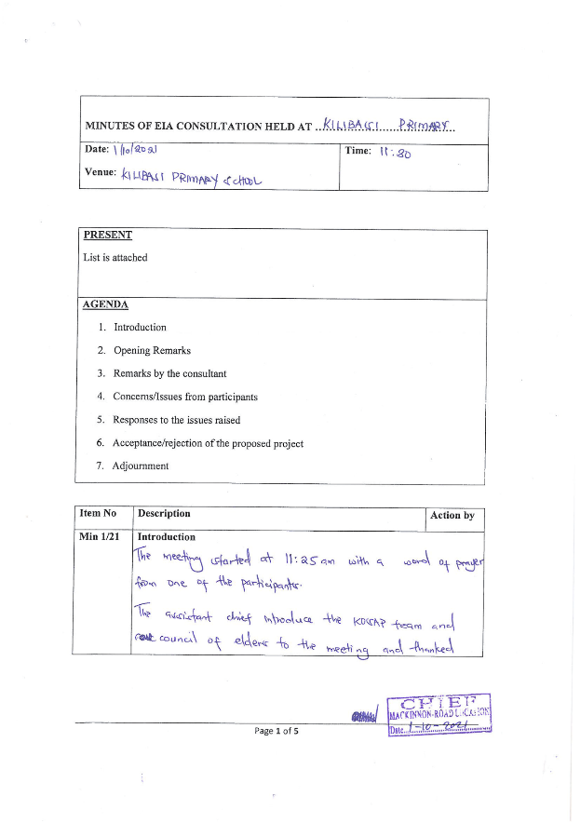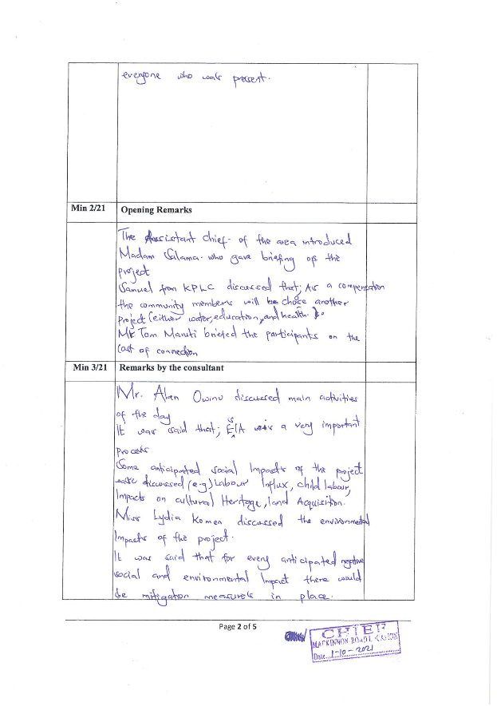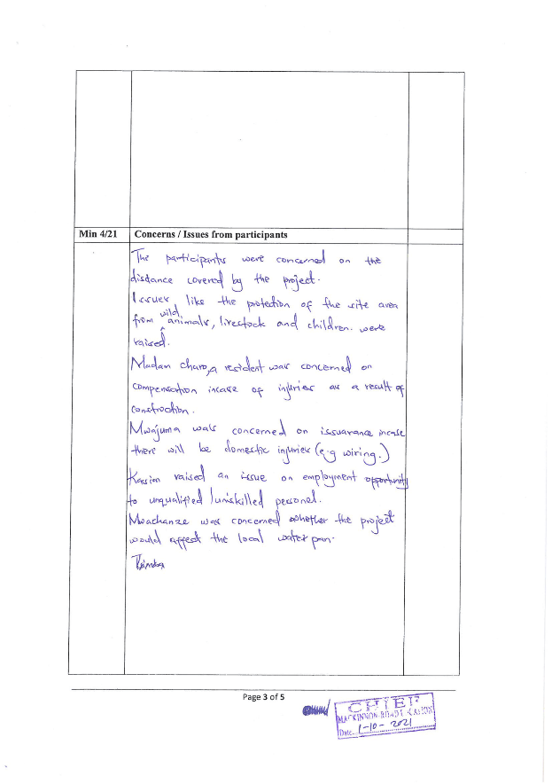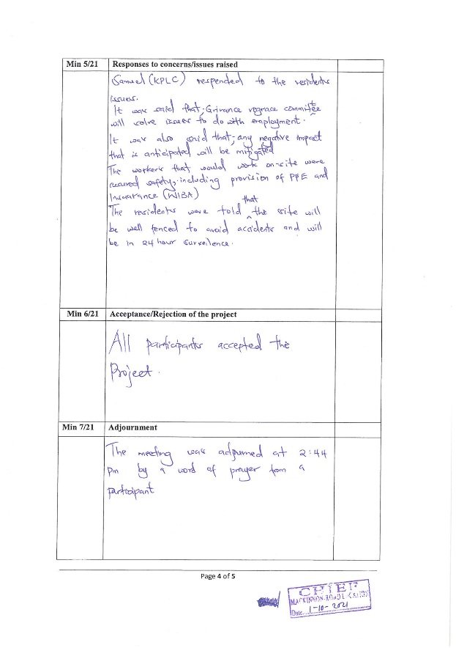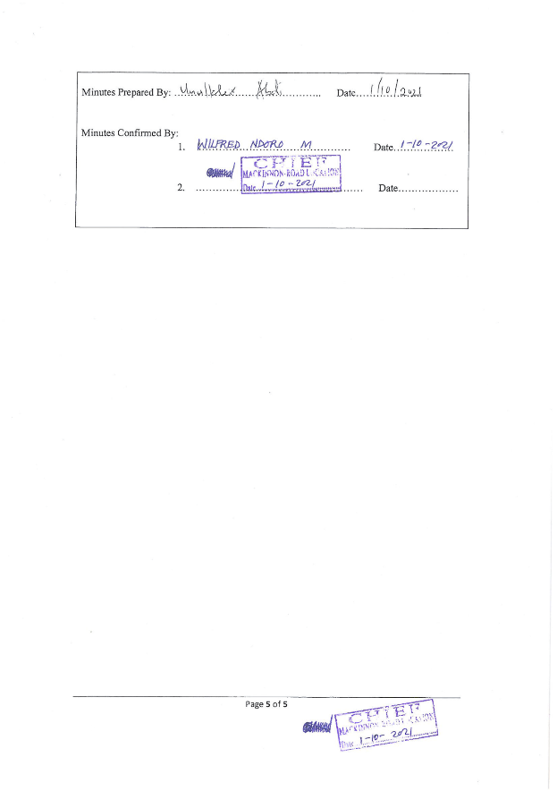

Public participation attendance List
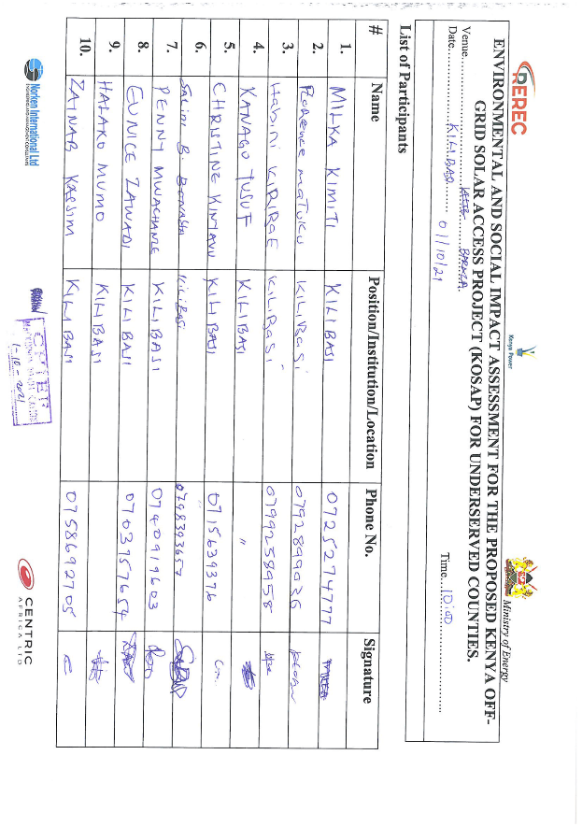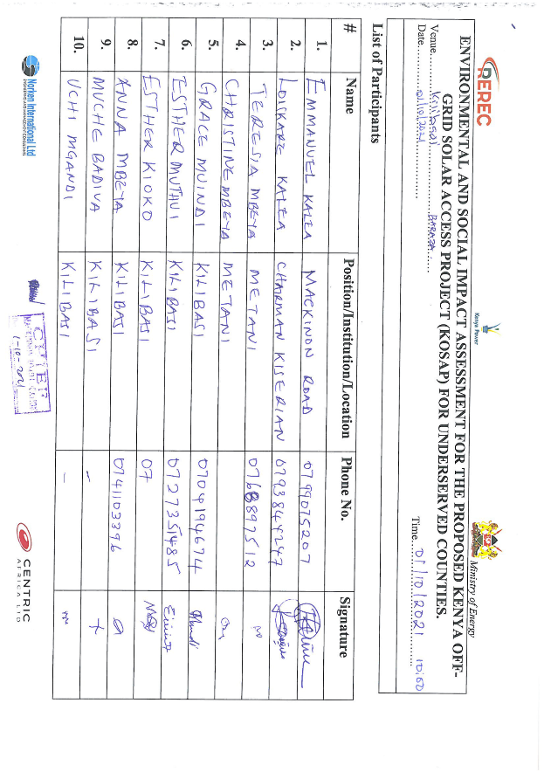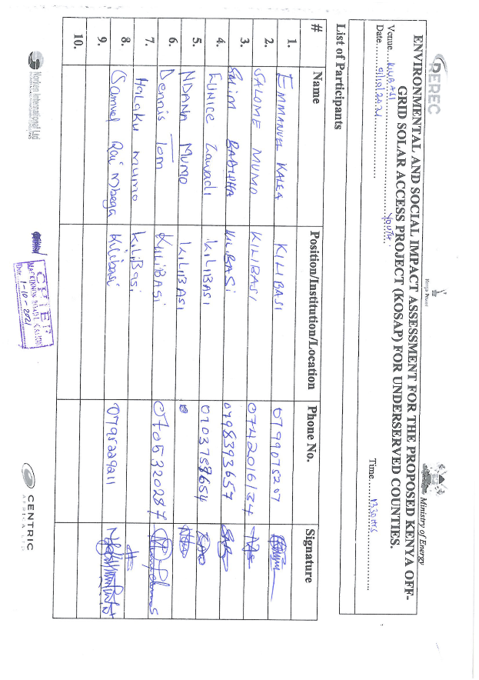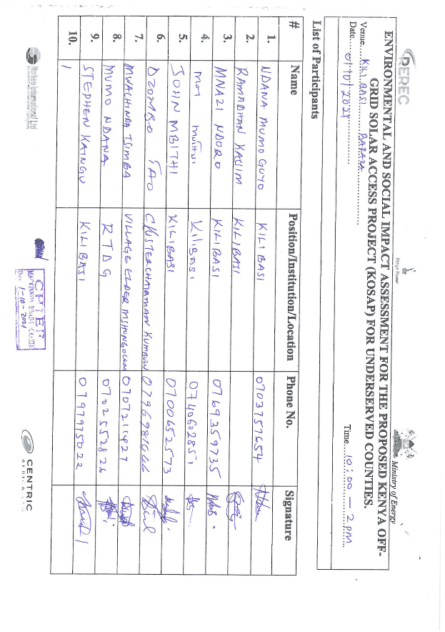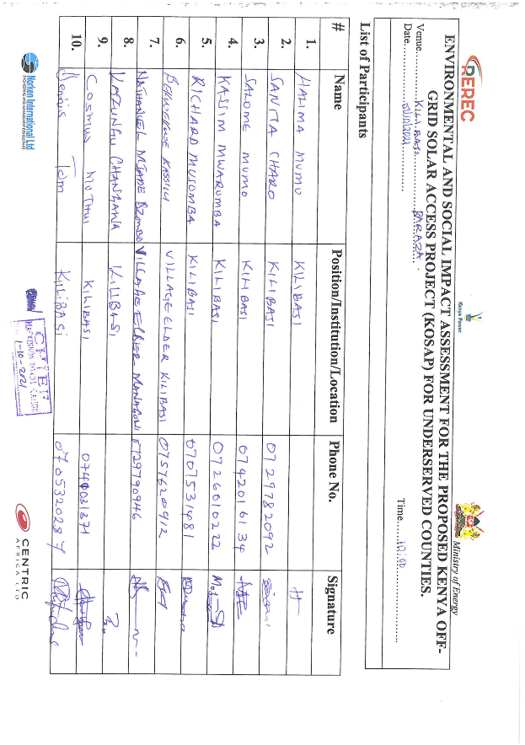

Men Focus Group Discussion Attendance List
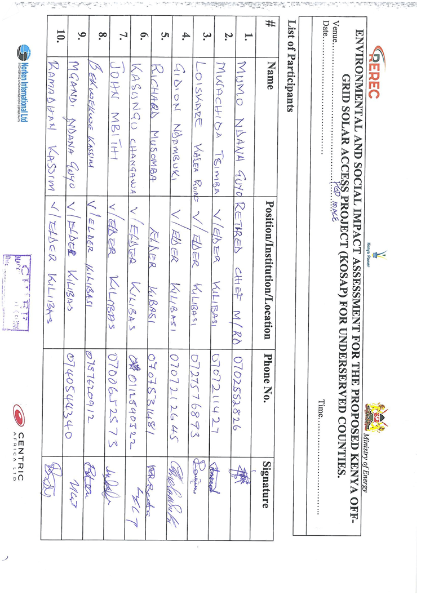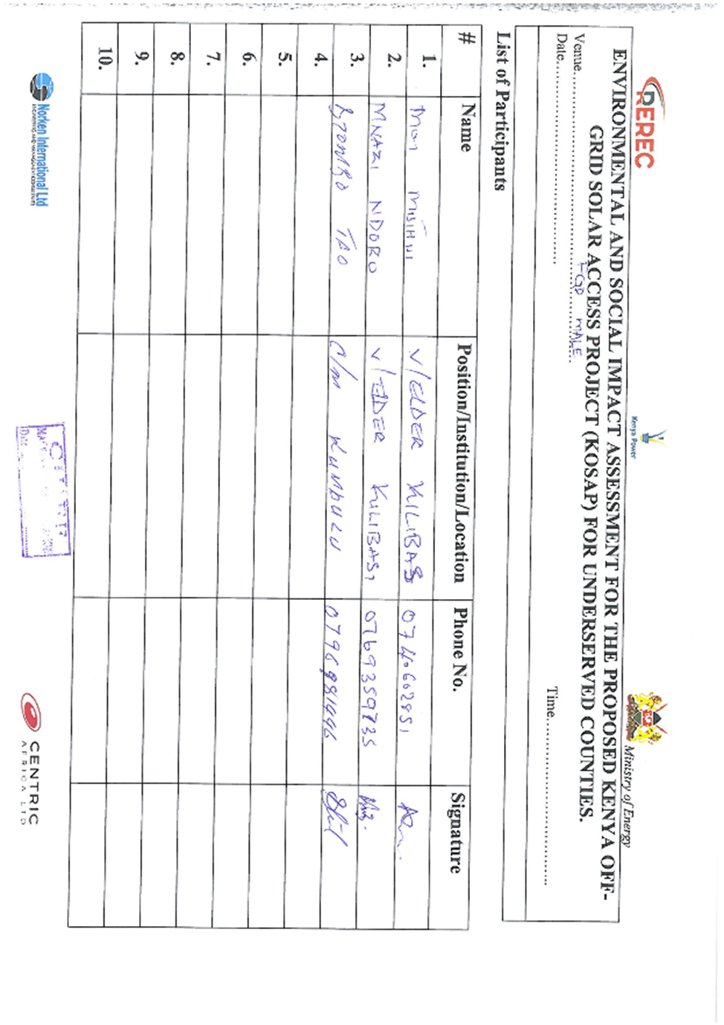

Women Focus Group Discussion Attendance List

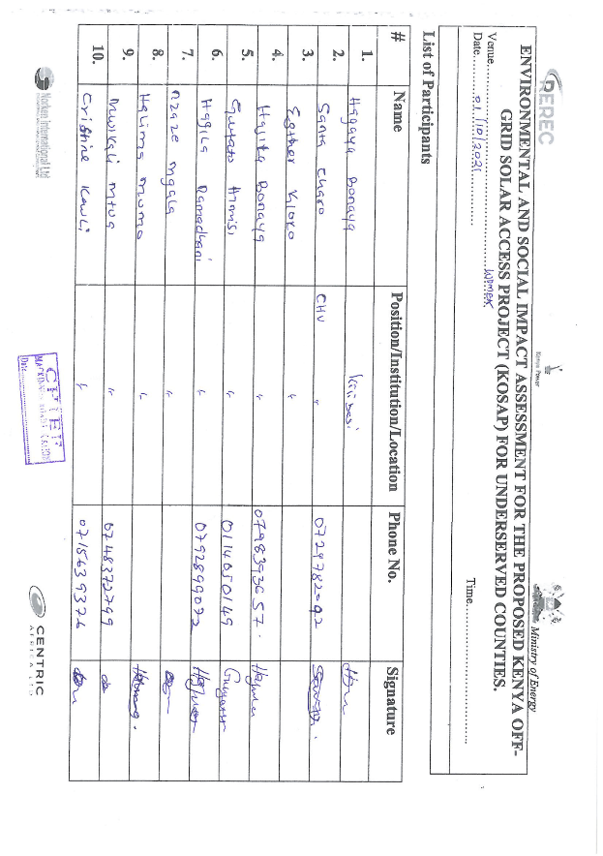

Youth Focus Group Discussion Attendance List
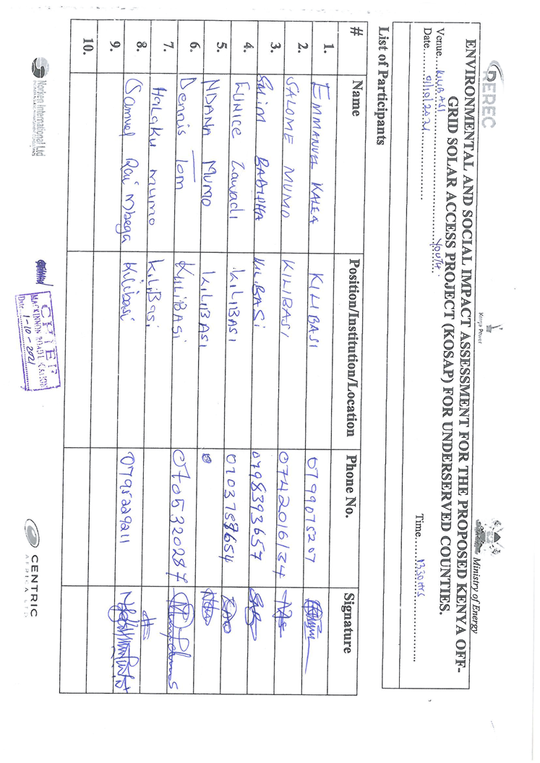

Annex 2: Minutes and attendance List for the Consultation meeting Leading to land Identification

Minutes of the consultation meeting

Minutes of community consultation meeting leading to voluntary land identification and Grievance Redress Committee constitution
Project: Proposed Kilibasi Solar Mini-grid
Venue of meeting; Kilibasi primary school in Kilibasi village, Kilibasi sub location in Mackinnon location, Kinango sub county of Kwale County

Date: 3/11/2020

AGENDAS
- Preliminaries
- Project description
- Positive Impacts of the project –Solar Mini-grid
- Negative Impacts of the project and mitigations measures
- Need for land for the project
- Grievance Redress Mechanism for the project

Minute 1/KOSAP/2020: Preliminaries
The meeting was called to order by the Assistant Chief (Mr. Ndolo) of Kilibasi location at 11.05 a.m. and an opening prayer was done by one of the community members The language used to communicate is Kiswahili as the local people speak Kiswahili and understand it well.
The chief welcomed all to the meeting and said that the team had visited the community with a development agenda which is to provide electricity/power to the people of Kilibasi. He welcomed all to the stakeholder engagement and asked them to ask all questions they could be having in regard to the project. He called on the head teacher of Kilibasi primary school to welcome people give his remarks.

The head teacher (Paul Mapi) welcomed all to the meeting and said that they were ready to hear what the project team had to say. He introduced the school committee and the teachers of Kilibasi who were present in the meeting.
The Chief welcomed the Ward Administrator (Ibrahim Ndolo) to make his remarks and welcome the KOSAP project team to the ward. He welcomed and thanked all for attending the meeting and noted that this is not our first meeting on this project. We have met before and I believe we are continuing to make progress. He noted that the team had come also to do more sensitization on the project among other things which will be discussed. The ward administrator said the ward have benefited from 3 solar Mini-grids namely Kilibasi Bumbri and Kinango. I request that we pay attention and participate so that our engagement can be fruitful. He noted that the county government is in support of the projects that come to make the lives of the people better. He then invited madam Salama Mwafrika (CREO) to welcome the project team to talk to the community. Madam Salama told the community that she was back again on the proposed project of KOSAP Mini-grid and said a team of experts had come to engage them on various issues regarding the project. She asked the community to feel free and participate because they are part of the key stakeholders of the project. She invited the project team leader Dr Kasomi from the Ministry of Energy (national government) to introduce the project team and proceed with the consultations.

Dr Kasomi asked the project team to make brief introductions before they engage the community in different issues of the proposed project. Below is a list of KOSAP team members and county officials present.

KOSAP team
S/No | Names | Position
1 | Dr Kasomi | Ministry of Energy -MOE
2 | Dorothy Kagweria | Environmental Social safeguards Expert-MOE
3 | Rebecca Muniu | Communication Expert -MOE
4 | Eunice Ndinda | Ministry of Energy -MOE
5 | Salama Mwafrika | County Renewable Energy Officer-Kwale county
6 | Joselyne Masiga | REREC –Social expert
7 | Stephen Magembe | REREC –wayleaves
8 | Nancy Ondicho | REREC –surveyor
9 | Philip Mabango | GIS Expert –Kwale county
10 | Wilfred Koech | Environmental and Social specialist-KPLC
11 | Onesmus Maina | Engineer-KPLC
12 | Roseline Njeru | Socio Economist-KPLC

Minute 2/KOSAP/2020: Project Description
Dr Kasomi explained that the national government is implementing KOSAP in partnership with County Government in 14 counties in areas are far away from the national grid. He said the proposed project is called KOSAP-Kenya Off-grid Solar Access Project is being implemented jointly by the Ministry of Energy, the Kenya Power and Lighting Company (KPLC) and the Rural Electrification and Renewable Energy Corporation (REREC) in partnership with the World Bank as a development partner, County Government as a partner and the communities in Off-grid areas being the beneficiaries. Off-grid areas are those places where the national electricity grid has not reached, and whose electricity access has been very low. The reason for choosing solar energy was because this area is far away from the national grid and the fact that the area is well endowed with natural sunlight with high temperatures. National Government strategy of having all households connected to electricity by 2023

He explained that the National Government strategy is to have all households connected to electricity by 2023 using various sources and solar energy is one of the identified sources with the added advantage of being clean energy. He further expounded that the proposed Solar Mini-grid being implemented under KOSAP is part of the government’s effort towards universal access to power. He said the proposed Kilibasi solar Mini-grid is one of the eight Solar Mini-grids to be funded by the KOSAP project. He told the community that the project was in the preliminary implementation stages which requires public participation of various stakeholders.

He further noted that the agenda of the visit was to undertake an environmental and social screening of the proposed sites to check suitability in terms of environmental, technical, social and health requirements. He said the second objective was to undertake community engagement to sensitize the community on the project. The other objective was to explain the land requirements for the project and the need for a project grievance redress mechanism.
He invited (Engineer- Onesmus) to sensitize the community on the technical aspects of the project.

Minute 3/KOSAP/2020: Technical aspects of the project
Onesmus (KPLC) explained the technical aspects of the Mini grids which entails: the installation of solar PV, usable battery, and thermal diesel units running with a capacity of 20 (kVA) to support solar and 15 street lights. He explained to them that once constructed the Solar mini-grid will be operated by the implementing agencies either KPLC or REREC and the community will be expected to pay for connection of electricity (one thousand shillings) and do wiring in their houses. He noted that the proposed Mini-grid will have a capacity of 50kWp with a target of 284 preliminary customers and the distribution or supply lines will cover a radius of 3km. He told them that once connected, the beneficiaries will be expected to pay for electricity consumed and that the tariff employed will be the same as what other Kenya power customers are paying.

He told them that connection of power will involve passing of electrical lines along the roads in order to reach their houses, business premises and public facilities and the route for passing the lines is called way leave. He noted that once the designs are done, the community will be notified of the exact routes during future consultations and that they will be required to give way leave consent (allowing the service lines to pass through their land in the extreme cases). He noted that the project will not compensate for way leaves due to budget constraints so that they can make an informed decision.
He called on the environmentalist (Koech) to explain the benefits and negative impacts of the project.

Minute 4/KOSAP/2020: Positive Impacts/Benefits of the Project
Koech explained that, every project has both positive impacts and negative impacts. Our assignment is to explain to you the impacts of the project so that you understand how the project will benefit you and the community at large. The project benefit both direct and indirect are as follows:
- Better source of lighting- replacement of Kerosene lamp and small de-lite lamps with electricity lighting which is clean and has better lighting
- Benefits to education- provide source of lighting which enables pupils and students to take advantage of longer hours of preps/study in homes. Electricity will be useful in availing power needed to enable use of radio and television sets. Once parents are able to buy these gadgets pupils can access electronic educational materials
- Business opportunities-Power provides energy needed to power some gadgets that are difficult and expensive to power with generators. Access to electricity will therefore allow the community to take advantage of new business opportunities and enhance the existing ones e.g. Barber shops, salons, posho/maize mills, welding, photo copying, printing, fuel stations, milk coolers and fridges to preserve meat among others
- Employment and wealth creation- community members will get opportunities to provide non-skilled and skilled labor during construction and operation phases
- Local Material Supplies and other requirements- the proposed project provides opportunities to supply some materials available locally
- Up Scaling Electricity Access to the off-grid areas- this area is far away from the grid and so the proposed project helps to reach such areas faster and in a cost effective manner as opposed to grid connections.
- Impact on HIV/AIDS-due to availability of power, communities can purchase communication equipment like radios and televisions which in turn provides access to information on various issues such as health topics on HIV/AIDs, nutrition and the current Covid-19 pandemic among other information
- Health benefits of the project- health benefits of the project includes replacement/elimination of use of kerosene lamps and candles, reduced or no use of fuel generators in the trading centres which emits smoke causing respiratory diseases, the health Centre under construction will also benefit from power that can be used to preserve drugs and vaccines alongside powering other medical equipment.
- Improved standard of living- Living standards of the community is bound to improve as they take advantage of small house hold appliances like e.g. TV, Fridges, radios, blenders, iron boxes e.t.c.
- Security- Enhanced security due to improvement in lighting up of the area through the street lights. Improved security also means more hours of business
- Communications- improve communication due to availability of electricity to charge phones, opportunities to set up information communication and technology related business like cyber cafes, access to e-government services among others.
- Presence of electricity will also attract other business investors to invest in the area

Minute 5/KOSAP/2020: Negative impacts of the project
Having discussed the benefits of the project, Koech explained that projects also have negative impacts. He noted that the most important thing is to be able to mitigate the negative impacts so that they do not affect the community. He said ‘’the proposed solar Mini-grid will have the following negative impacts and I will present them alongside their mitigation measures.
 | Negative impact | Mitigation measures to be implemented by contractor
 | Vegetation clearance | - Clear only the areas that are needed to put up the mini-grid according to designs  - After construction, do landscaping with grass to areas that have no electrical installation as opposed to living areas bare  - Re-vegetation by planting of trees
 | Air pollution linked to dust from construction activities | - Water active areas to suppress dust  - Fence off construction site  - Use of masks by workers  - Limit vehicle speed to minimum possible when passing residential areas and the centre
 | Air pollution from vehicle emissions | - Maintain and service vehicles  - No idling of vehicle’s engines
 | Solid waste | - Clear all solid waste and dispose in line with NEMA guidelines
 | Land.  As you had been briefed before, the site identified should; -must not result in displacement of community members  - We must avoid land that is currently settled or which has squatters. | - The MOE is asking for partnership with the community –requesting community to identify land for setting up the mini-grid.
 | Occupation safety and health hazards e.g. accidents, fall from heights, pricks by sharp objects | - Use of proper personal protective equipment like gloves, overalls, helmet, safety shoes  - Allocating work according to skills  - Toolbox talks to workers to identify hazards and risky activities and putting mitigation measures  - Close supervision of work
 | Labor influx. The nature of the project will require technical skills that are not all available in this community. This will require movement of construction workers (labour influx) into this community. There are some risks that are involved with labor influx and we need to mitigate them as follows to avoid negative impacts on our community. | - Reduction of labor influx by recruitment of local workforce to the extent possible especially unskilled and semi-skilled jobs by the contractor as much as possible.
 | Risk of social conflict due to competition for resources and opportunities | - We shall establishment and operationalize an effective Grievance Redress Mechanism accessible to community members where your grievances can be sorted  - Awareness-raising among local community and workers on the need to have a good /cordial working relation  - Consultations with and involvement of local communities in project planning  - Provision of cultural sensitization awareness for workers regarding engagement with local community.  - Contactor shall make provision to provide resources needed by the workers if the need for such resources may result to competition and conflicts e.g. water  - Working closely between contractor and the project grievance redress committee to address complains on time.
 | Increased illicit behavior and crime (including prostitution, theft and substance abuse) | - Sensitization campaigns both for workers and local communities against such social evils  - Enforcement of sanctions (e.g., dismissal) for workers involved in criminal activities
 | Spread of diseases (including STDs and HIV/AIDS) | - Education/awareness about transmission of diseases  - Awareness creation on STDs among the workers and local community on ethics, morals, general good behavior and the need for the project to co-exist with the neighbours during the community and worker engagement forums.  - Provide condoms to employees
 | Public health issues such as spread of diseases like Covid 19 | - Adherence to ministry of health protocols issued  - Avail hand washing facilities –water and soap  - Keeping social distance to the extent possible  - Use of face masks  - Encourage workers to be vaccinated
 | Gender-based violence i.e. sexual exploitation and abuse of the community members by workers | - Information and awareness raising campaigns to you community members and specifically women and girls on need to be on the look-out and raise such issues/complaints  - Mandatory awareness creation for workers by contractor on required lawful conduct in the community and legal consequences for failure to comply with laws  - Requirement of contractor to have code of conduct for the workers and to implement them  - Working closely with chiefs and local law enforcement to act on community complaints on time
 | Gender-based violence i.e. sexual harassment among workers | - Requirement of contractor to have code of conduct for the workers and to implement them  - Inclusion of GBV specific mitigation measures in the environmental and social management plan of contractor
 | Child labour | - Ensuring that children and minors are not employed directly or indirectly on the project.  - Enforcement of Employment Act that requires contractor to adhere to minimum age  - Allowing your children to be employed is illegal and punishable by law because it interferes with the children’s right to education  - Report any case to the chief’s office
 | Demand for Material/resources e.g water, sand, ballast | Contractor to consult with elders before using scarce resources in the community like the water to avoid conflicts.
 | Oil Spill Hazards | - Contractor not to repair vehicles or equipment on site  - Maintain vehicles and equipment in good state of repair
 | Storm water and erosion | - Contractor to put measures to harvest rainwater and control erosion during construction
 | Wastewater/ effluent | Contractor will provide sanitation facilities for workers
 | Noise resulting from excavation machinery, vehicles and workers | - Contractor to work only during the day  - In case of blasting contractor to give notice to community through the village elders, grievance committee and chiefs office
 | Visual and Aesthetic Landscape Impacts | - The visual negative impacts can be mitigated through putting up a wall round the facility to keep off/screen the project stacks, poles, panels  - Proper siting decisions can help to avoid aesthetic impacts to the landscape.
 | Hazardous materials from damaged Panels- Photovoltaic panels may contain hazardous materials, and although they are sealed under normal operating conditions, there is the potential for environmental contamination if they were damaged or improperly disposed upon decommissioning. | - Proper planning and good maintenance practices can be used to minimize impacts from hazardous materials.  - Proper disposal of used or damaged solar batteries and panels using NEMA registered disposers for such wastes
 | Fuel storage on site | - Contractor will undertake proper installation of the fuel storage tanks for the back-up generator.  - Have a budded wall 1.5 times the fuel stored to allow controlled collection in case of a spill.  - During operation implementing agency will ensure proper maintenance of the solar panels
 | Public safety –potential risk of shocks and electrocution | As explained below in details

Public safety in regards to electricity
Koech educated the community by highlighting the importance of using electricity safely. He said electricity is good but failure to take the precautions while interacting with it can result in electric shocks, fires and even electrocution/death. He emphasized the following precaution/preventive measures to observe in order to prevent risk of electric shocks, fires and electrocutions.
- Engage a certified technician to do wiring in your premises
- Use quality materials while wiring
- Do not engage in individual illegal extensions of power lines to other houses
- Don’t touch sockets and switches with wet hands or wipe with wet cloths
- Do not tie your livestock on electric poles
- Do not cut earth wires that run along some electric poles
- Do not touch any electric wire if you find it fallen on the ground
- Report any incident regarding electricity at the local office –staff in charge of operating the Mini-grid
- Vet all new people coming to the village by checking whether they registered their presence with the office of the chief.
- In case of a black out do not open sockets or switches

Minute 6/KOSAP/2020: Land requirements for the project
Koech told the community that one of the agendas of the project team’s visit was to progress land acquisition process for the proposed Mini-grid. He then invited Nancy (REREC) to talk to the people on matters of land acquisition. Nancy explained to the public forum that the proposed project will require about 2-3 acres of land. She asked them the nature of ownership of the land in the area and they answered that the ownership is communal where by the community has one title deed but no individual title deeds. They also noted that the land is not formally sub divided (implying not adjudicated). She explained to them that based on the ownership of land they had explained, their land falls under the category of community land and its use and management is governed by the Community Land Act 2016.
The surveyor (Nancy) explained to the community that;
- There are different legal frameworks/acts that guides land ownership and management in Kenya. The legal framework also establishes procedures and requirements of transfer and acquisition of land between individuals and groups and also provide procedures for the acquisition of land by the state or a public body for public projects.
- Land in Kenya is classified as public land, community land or private land (CoK 2010)
She asked them about the ownership of the portion they had identified and proposed to donate to the project. The community noted that the portion was part of a bigger land that belongs to Kilibasi primary school. The community noted that the land where the school is situated was donated by the community also. They noted that since the land is big part of it can be used for to set up the proposed solar Mini-grid.
Nancy educated the community on the following issues;
- The various forms of acquiring interest in land such as; allocation by the owner, land adjudication process, compulsory acquisition, settlement programs, transfers, donation and long term leases.
- Importance of public participation by key stakeholders including community members during the planning and operation phase of the project.
- You have a right to give your views, opinions or fears on a proposed project
- You have a right to accept or refuse the project
- You have a right to compensation for your land under the Kenya law. The various options for compensation for land include land for land, cash or in-kind compensation
- If you donate land, the ownership of the land will be transferred to KPLC and that the project will be managed by KPLC
- You have a right to choose whether to donate land or not to the project
- The community/beneficiaries of the project will pay Ksh 1000 for poser connection and also pay for consumption of power to KPLC
- She noted that the government of Kenya had secured a loan from its development partners i.e. World Bank to implement the KOSAP project. She explained that the government was extending a hand of partnership with the community to donate land for setting up the solar mini-grid and that the government was not in a position to pay compensation for the land due to budgetary constraints. Setting of a solar mini-grid needs land and the national government together with the implementing agencies and the county government have to follow the law in acquiring land for the proposed mini-grid. The government through the Ministry of Energy proposes to use World Bank guidelines on voluntary land donation for the project.

She informed them that for voluntary land donation, there is a criteria which must be fulfilled to allow for voluntary donation to be acceptable. She explained the criteria as follows;
- The infrastructure must not be site specific.
- The impacts must be minor, that is, involve no more than 10 percent of the area of any holding and require no physical relocation.
- The land required to meet technical project criteria must be identified by the affected community, not by line agencies or project authorities (nonetheless, technical authorities can help ensure that the land is appropriate for project purposes and that the project will produce no health or environmental safety hazards).
- The land in question must be free of squatters, encroachers, or other claims or encumbrances.
- Verification (for example, notarized or witnessed statements) of the voluntary nature of land donations must be obtained from each person donating land.
- If any loss of income or physical displacement is envisaged, verification of voluntary acceptance of community-devised mitigatory measures must be obtained from those expected to be adversely affected.
- If community services are to be provided under the project, land title must be vested in the community, or appropriate guarantees of public access to services must be given by the private titleholder. KOSAP project proposes to have the land donated to be registered under one of the implementing agencies of the project i.e., KPLC but be assured that public access to services is guaranteed to the community members.
- We need to set up a Grievance mechanism to help in addressing any issues/grievances that may arise in the course of the project implementation.

Survey of the land and request for advance possession.
The surveyor (Nancy) explained to the community that once agreed the surveyor will need to pick exact GPS points of the agreed area so that the process of land acquisition may start leading to titling of the land. Nancy noted that the process of land acquisition, land surveying and land transfers are long and requested the community for advance possession. The community agreed to the advance possession.

Steve (REREC) told the community that connection of power will involve passing of electrical lines along the roads in order to reach their houses, business premises and public facilities and the route for passing the lines is called way leave. He noted that once the designs are done, the community will be notified of the exact routes during future consultations and that they will be required to give way leave consent (allowing the service lines to pass through their land in the extreme cases). He noted that the project will not compensate for way leaves due to budget constraints so that they can make an informed decision when the time comes.

Dr Kasomi explained to the community that the rationale and importance of sharing all that information was to facilitate the community in making informed decisions about the project and also on land donation. Further, he made it clear to the community that they had the power of choice on the project which meant that the community had the option to agree or disagree with the land donation request without coercion.

Minute 7/KOSAP/2020: Plenary session
Rebecca (MOE) made a brief summary of what had been discussed and invited the community members to ask questions or seek clarifications on the information shared. The questions raised are presented in the table below.

 | Name | Questions/suggestions | Response | Response by agency on how feedback will be used or acted upon
1. | Jonathan Malabu | -thank for your coming.  -thank for educating us on various issues of the project. |  | -
 |  | How much land is needed for the project | We need 2-3 acres of land | N/A
2 | Ward Admin | We have heard that the people will be paying through token. How shall you ensure that they work because we hear in other places once buys tokens for so much money before getting power | Prepaid meters will be used. This work in the same way like the phones. The way you buy credit and feed to your phone. In prepaid meters you buy the electricity token/units before you consume. The units are fed into a consumer interface unit which will be issued during meter installations. Once the units are depleted then the power supply goes off. You then have to buy more units before you get power supply.  Those who had to buy many units before they got supply are those customers who had abandoned their postpaid meters and got prepaid meters without following due process. | N/A
3 | Hannah Katuro | We have heard about safety of the electric infrastructure of lines and in our houses. Repeat your explanation on the safety of our cattle and children from the solar Mini-grid | The solar Mini-grid will be fenced off to keep off the public and any livestock from access for safety purposes | N/A
4 | Gideon Ndambuki | What about households of people who are far away (beyond the 3km radius of the Mini-grid). what will happen to them | Those outside the 3km radius will not benefit from this proposed Mini-grid. | The matter will be communicated to the project coordinator
5 | Bernard Mutavi | In case I want to connect my house and also some business premise what is the payment | These are two different premises and they will need two meters so you will pay Ksh 2000. | N/A
6 | Asst chief | We have other villages that will not be reached by this Kilibasi proposed Mini-grid. Are there plans currently to put up other Mini-grids in those areas | Those outside the 3km radius will not benefit from this proposed Mini-grid. As at now we do not have a proposed project for them. | The matter will be communicated to the project coordinator
7 | Jonathan | Apart from the Ksh 1000 what is the other payment we are expected to pay. | You will be expected to pay for electricity consumed. | N/A
8 | Hildah Mwababa | We as parents of Kilibasi primary school. Who will pay for consumption of power at the school | This will be paid by the school | N/A
9 |  | What happens in case of an electric accident | In case of an accident, you should report through the technicians who will be operating the Mini-grid, Kwale office or even the chief. An investigation is done to establish the cause of the accident. Whoever is found liable pays for the damages | N/A
10 | Grace | Now that we have donated the land, whose ownership will it be | The ministry proposes that the ownership will be vested in KPLC who will be operating and maintaining the Mini-grid. | N/A

Photo of the community Meeting
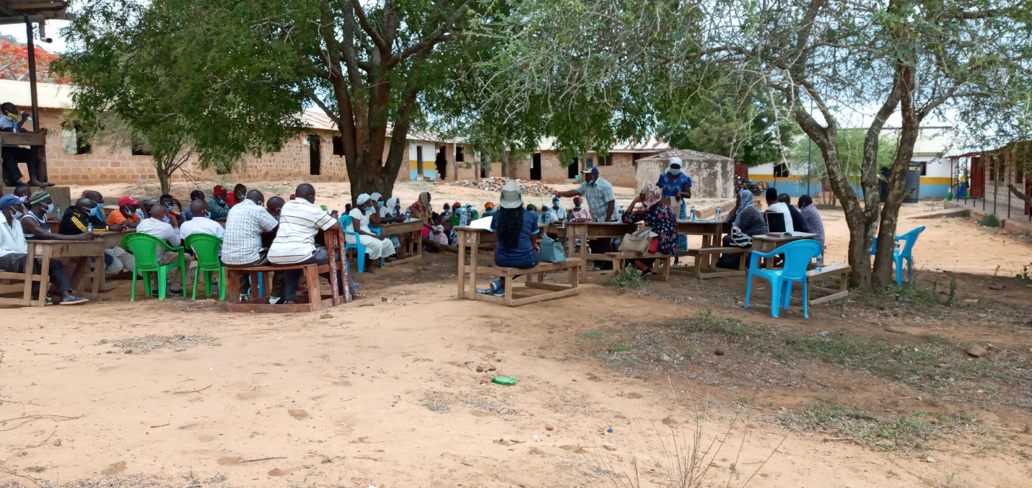

Minute 8/KOSAP/2020: Grievance Redress Mechanism
Dorothy explained that in a project, grievances may arise and it important to have a grievance redress mechanism that is known to all the community members and accessible with no costs to the community members. Before explaining how to set the GRM, she asked the community to explain how they deal with grievances/issues at the village level.

Existing grievance redress mechanism in the village.
One of the elders explained; ‘’we have elders in the community who provide leadership and oversight to the community. These elders are responsible for dealing with conflicts or grievances or any issue in the village/area. Any of the grievances that is difficult to resolve is referred to the office of the Chief. Most of the grievances are solved by the elders and we rarely have any cases going to the chief.

Project GRM:
Dorothy explained to the community that it is important to put in place a project grievance redress mechanism (GRM). She noted that the GRM to be set should borrow heavily from the existing conflict resolution structures in the community. She explained that the need for a GRM is to provide the community and other stakeholder’s opportunity to share project information and raise questions and grievances about the project. She told the community that they are free to raise any complain or request information about the project. She explained that the project will have a three-tier grievance redress mechanism as follows.
- Locational grievance redress committee. This is the lowest level (forum) where the community will get project information and also ask questions. At this level you the community will choose project committee members who will also double as grievance redress committee. The membership will comprises; elders/men representatives, representatives from women, youth, special needs (persons with disability), and the office of the chief as Ex-officials. This will be the first stop for receiving information and raising grievances. The members to be chosen should possess leadership skills and it is hoped that most of the grievances will be resolved at this level.
- The second level of grievance redress will be the county Grievance Redress committee comprising members of the county working group. This committee is at the county level and will resolve complains or issues that are unable to be resolved at the locational/project level. The chairman of the project grievance redress committee at the community will forward issues/ complains to the county grievance redress committee through CREO who will also be responsible for giving feed back to the local committee.
- The third level will be the National GRC comprising of KOSAP Project Implementation Unit at the Ministry of Energy and the implementing agencies. Matters that could not be resolved at the county level will be escalated to this National GRC by the CEC-Energy
- The last level of the GRM for the community or project affected persons will be arbitration or legal redress in a court of law once all the three levels have been exhausted.

She explained further that members of the project/ grievance redress committee will be chosen by the community members themselves. The committee chosen will be in charge of giving project information to the community and be a focal point for reporting project related issues of concern or grievances. She added that the composition of the committee should have representatives from all groups in the community including men, women, youth and persons with disability.

The members chosen to the grievance redress committee for Kilibasi are as follows;

Project Committee Members/grievance redress committee.
S/No | Name | Identification No. | Telephone No. | Category
1 | Bernard Mistavi | 11872439 | 0705228023 | Elder
2 | Bekwekwe Kassim | 20598024 | 0757620912 | Elder
3 | Loiskare k Roine | 21631040 | 0727576893 | Elder
4 | Munali N Munazi | 10955720 | 0769359735 | Elder
5 | Pen Mwanchanze | 25038942 | 0740919603 | Women
6 | Salim Badipha |  |  | Youth

Minute 9/KOSAP/2020: Focus Group Discussions
The community members were told of the need to have focus group discussions to discuss the project further and allow the people more opportunities to ask questions or give suggestions regarding the project. Therefore three separate meetings for men, women and youth were held. In these meetings the message on the project was echoed again especially on benefits and impacts (both positive and Negative) of the project to the community, rights of the community in regard to land donation and the need to have a grievance redress committee with representation from all groups in the community. Each group was to elect their representatives to the GRC.

a) Focus Group Discussion with the women
Dorothy (MOE) explained to the women that it was important to hold a separate discussion with them so that they have opportunity to freely express themselves. One focus group discussion was held with the women. She explained the agenda of the visit by the officers from national government and county government was to undertake an environmental and social screening of the proposed site to check suitability in terms of environmental, technical, social and health requirements. The second objective was to undertake community engagement to sensitize the community on the project. The third objective was to explain the land requirements for the project and the need for a project grievance redress mechanism. Dorothy then gave a summary of the project in terms of its positive and negative impacts and their mitigation measures and the requirements for donating land. She also explained the need for the women to select a representative to the project committee who would represent their views/issues to the committee for redress.
The discussion went further to bring out issues on how the women can take advantage of the project benefits rather than taking a back seat. She then explained to them that women would benefit more from the electricity because there are the ones who are more exposed to unclean energy as they are the ones who take more time in the kitchen. They would also benefit from access to information through use of radios and TV that are powered by electricity enabling them to make informed choices on different issues such as nutrition, health, farming among others. They were also set to benefit if they could set up small businesses like salons, cold drink kiosks, children will have time to study and enhanced security due to the fact that the area will be well lit among other benefits.
Gender based violence issues were also discussed and emphasized because women and girls are more affected by gender-based violence due to the subordinate status of women in many societies, discrimination against them and their higher vulnerabilities to violence. She noted Gender-based violence takes many forms, including sexual, physical, and psychological abuse. Other issues discussed were the importance of addressing GBV incidences and the need to report and document any complaints against workers, while ensuring survivor centred approach (respect for the choices, wishes, rights and dignity of the survivor). The women were told to be more vigilant to ensure young girls do not fall prey to GBV incidences. The women were requested to keep talking to the girls on GBV risks and the need to raise alarm in case of risks factors to ensure prompt redress. .
The women were allowed time to ask questions, give suggestions and or seek clarifications.

Table 25: Question, Suggestions, feedback and response for Focus group discussion with women
Name of Person making the contribution (e.g. comment or question) | Question, Comment, Suggestion | Feedback/Responses by project team | Response by agency on how feedback will be used or acted upon
Pen Mwadzale | Some people e border one side of people on private land will they be connected to power | -yes they have a right to be connected if they are within the 3km radius of the Mini-grid.  In addition it will depend on way leave issues because we shall have to consult the private owner to grant us way leave consent without compensation so that we can supply them. | N/A

Photo of the focus group discussion with the women
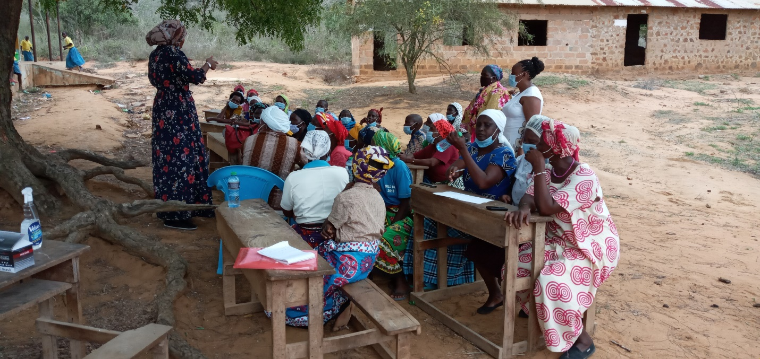

b) Focus group discussion with the youth
A separate discussion was held with the youth in Kilibasi. Steve (REREC) explained to the youth that it is good to engage in public participation especially in regard to happenings in their community. He told them that they are also key to the decisions that are made in the community and so discussion with them was necessary so that they have opportunity to express themselves. He explained the agenda of the visit by the officers from national government and county government was to undertake an environmental and social screening of the proposed site to check suitability in terms of environmental, technical, social and health requirements. The second objective was to undertake community engagement to sensitize the community on the project. The third objective was to explain the land requirements for the project and the need for a project grievance redress mechanism. He then gave a summary of the project in terms of its positive and negative impacts and their mitigation measures and the requirements for donating land. He told the youth to select a representative to the project committee who would represent their views/issues to the committee for redress. He explained to the youth that they should actively participate and be ready to take advantage of opportunities that come with the project. Such opportunities include; job opportunities, ability to set up shops or enhance their businesses due to power supply, entertainment, charging phones, use of ICT while those in school could benefit from better lighting for reading alongside accessing educational materials for those who have or will purchase radios and T.Vs among others.
He asked the youth to feel free to air their opinions on the project. The youth said they support the project. The youth were then allowed to ask questions.

Question, Suggestions, feedback and response for focus group discussion with Youth
Name of Person making the contribution (e.g. comment or question) | Question, Comment, Suggestion | Feedback/Responses by project team | Response by agency on how feedback will be used or acted upon
Haruni Dowani | This project is important and it will assist us and the community. I feel we should support it | Noted | N/A

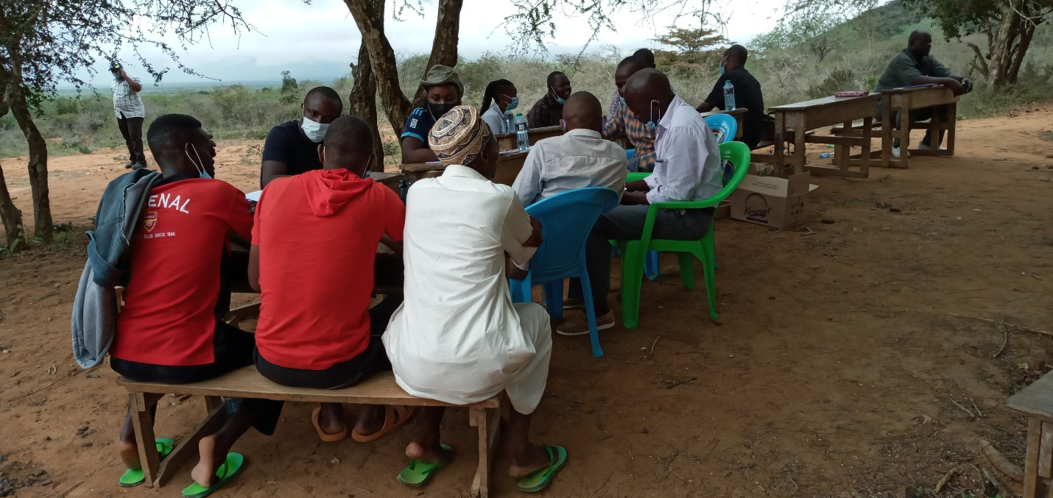

Photo of the youth in focus group discussion

c) Focus Group Discussion with the Elders/men discussions
One focus group discussion was held with the men. Dr Kasomi explained to the men that it was important to hold separate discussion so that the community members get enough opportunities to be informed of the project and be free to ask questions. He told the men that public participation in projects is crucial as it helps build consensus and enables people to make informed choices regarding projects. He repeated the agenda of the visit by the officers was to; undertake an environmental and social screening of the proposed site to check suitability in terms of environmental, technical, social and health requirements. The second objective was to undertake community engagement to sensitize the community on the project. The third objective was to explain the land requirements for the project, rights of the community in regard to the project and the need for a project grievance redress mechanism. Wilfred (KPLC) then gave a summary of the project in terms of its positive and negative impacts and their mitigation measures and the requirements for donating land. He also explained the need for the men to select a representative to the project committee who would represent their views/issues to the committee for redress.
Dr Kasomi also reiterated to the men on the need to provide leadership and to carry every one along including the youth and the women especially in decision making. The elders said they welcome the project and that they had already agreed on the portion of land where the project would be implemented in an earlier meeting. The elders noted they had identified a portion of land within the Kilibasi primary school for the project.
The discussion was then opened up for questions.
Name of Person making the contribution (e.g. comment or question) | Question, Comment, Suggestion | Feedback/Responses by project team | Response by agency on how feedback will be used or acted upon
Peter Githeka | Will the solar for the individual household give the same power as the one for the Mini-grid | No because the one at the individual household has no back-up generator so in the days of poor/low sun light the quality of power may be different | N/A
 | Will the power lines be overhead or underground | Overhead lines | N/A
Gideon Ndambuki | If I have five sons, can we use one meter | If your sons are married and everyone has their houses it will be good to have each their meter. This is also good so as to avoid conflicts in regard to tokens purchase since different household may have different uses. | N/A

Photo
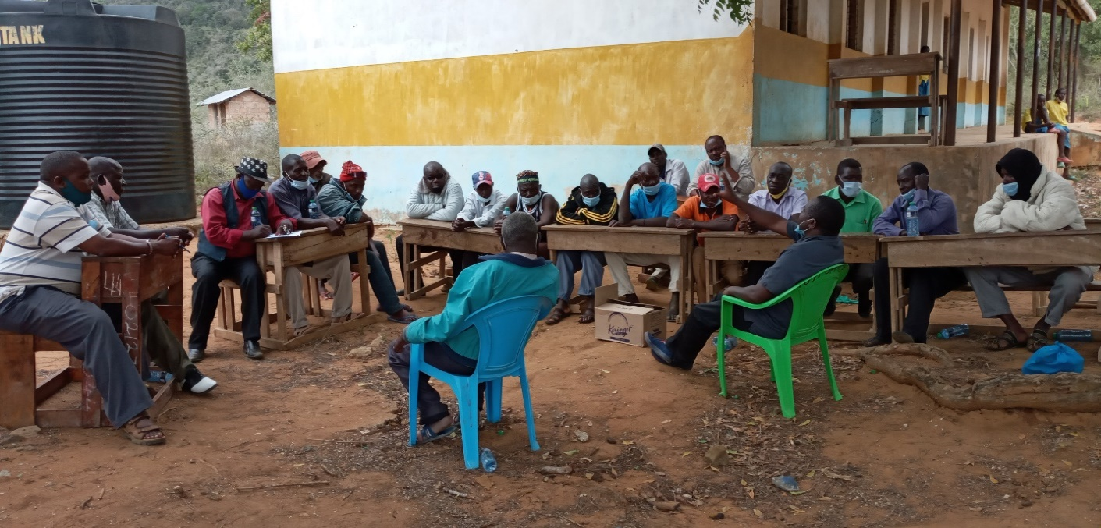

Minute 11/KOSAP/2020: Conclusion of the meeting and way forward.
1. The community welcomed the project and is in full support of the project.
2. The community willingly donated land for the proposed project with full understanding that it is their right to be paid but chose to forgo compensation of land in return for the project. Representatives of the community signed the land donation forms.
3. The need for a grievance redress mechanism (GRM) was explained to the community including the need and roles of a grievance redress committee (GRC). A GRC was chosen with representatives from the men, women, youth and special needs group.
4. It was clearly disclosed to the community that the ownership of the land will be transferred to KPLC and that the project will be managed by KPLC and not the community. The community agreed to the need to transfer the land to KPLC
5. The need for advance possession of the land as the process of survey and registration progresses was explained the community and the community agreed to the same.
6. It was explained to the community that it will be their responsibility to pay for power consumed
The meeting ended at 2.30 p.m. with a word of prayer.

Recommendations
1. ESIA can be progressed for the site

Public Participation attendance List

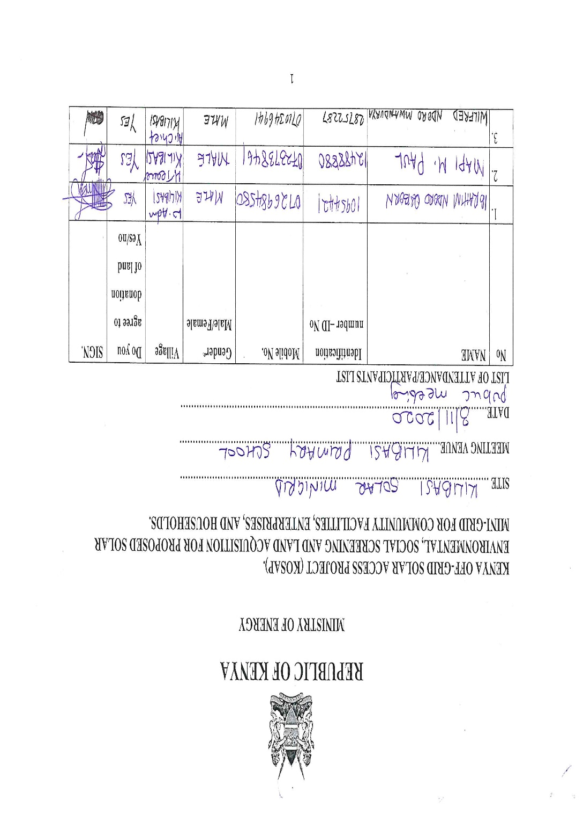
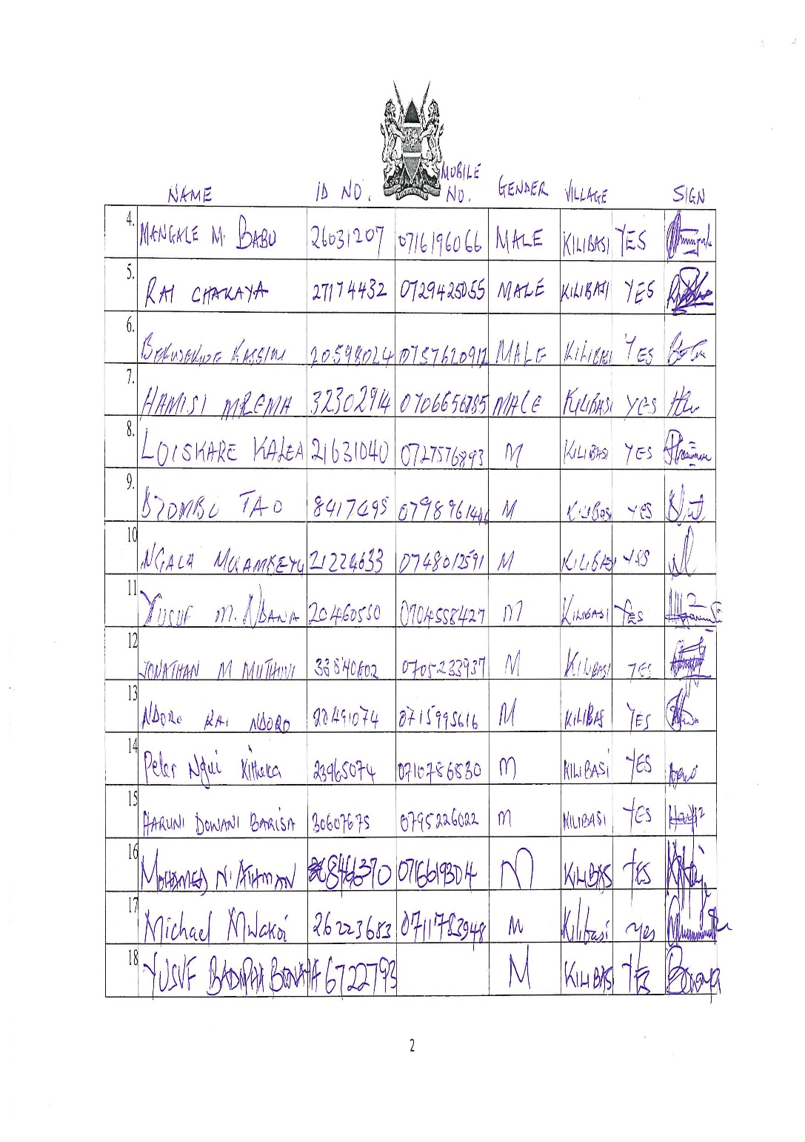
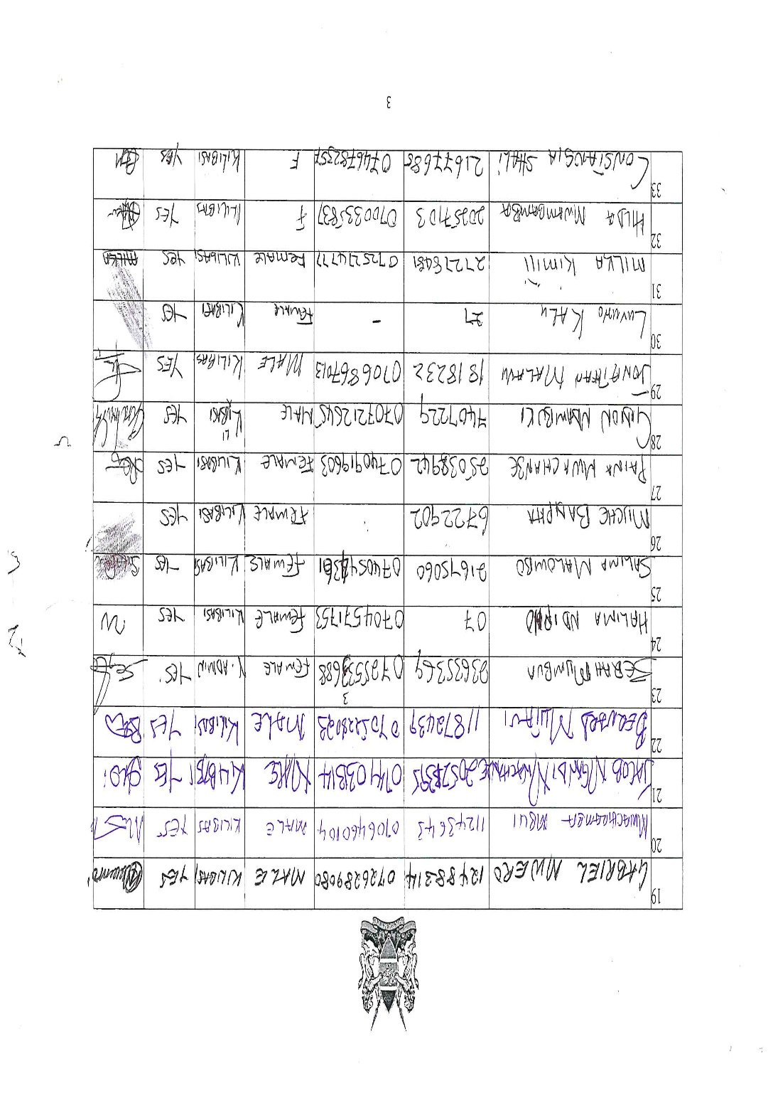
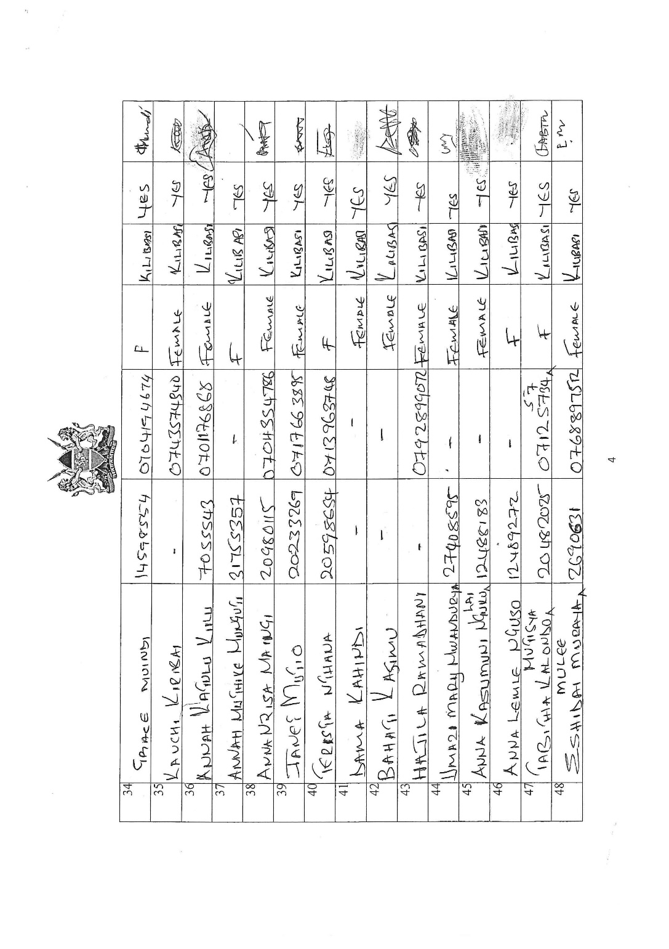
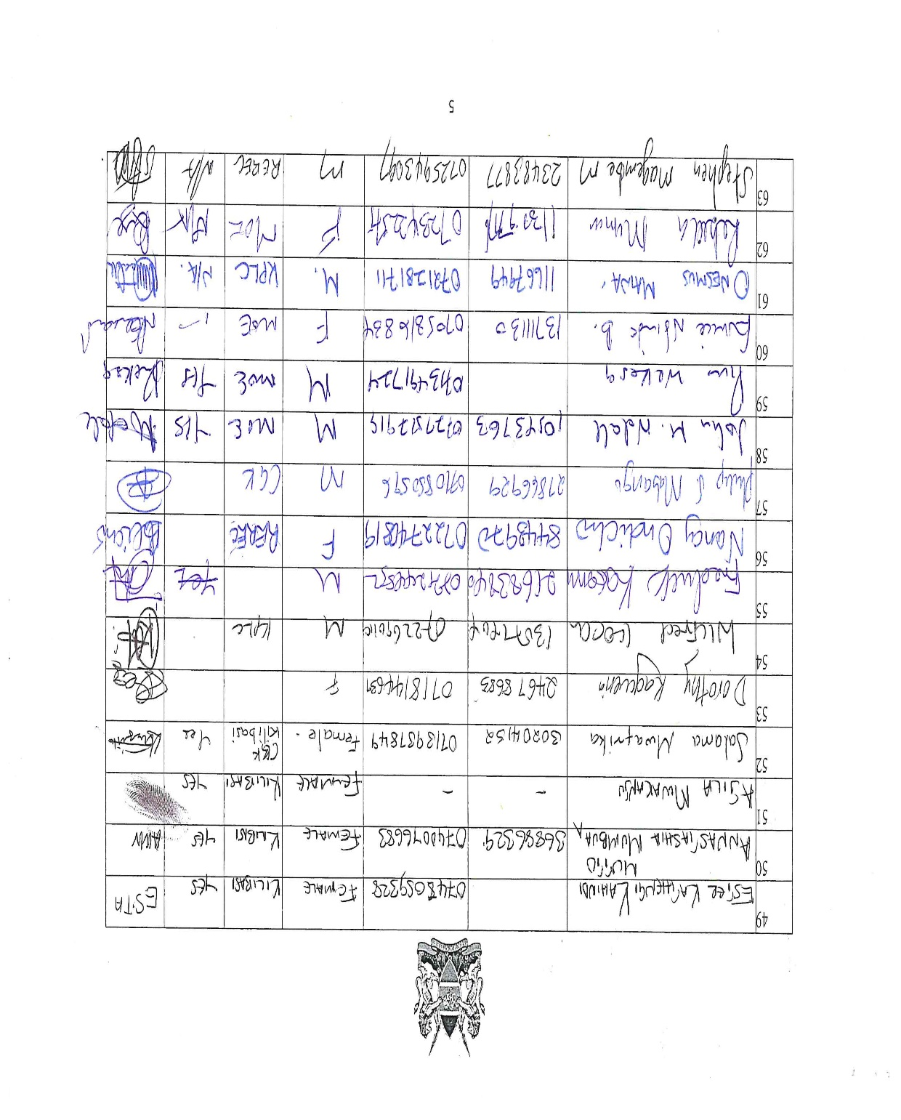
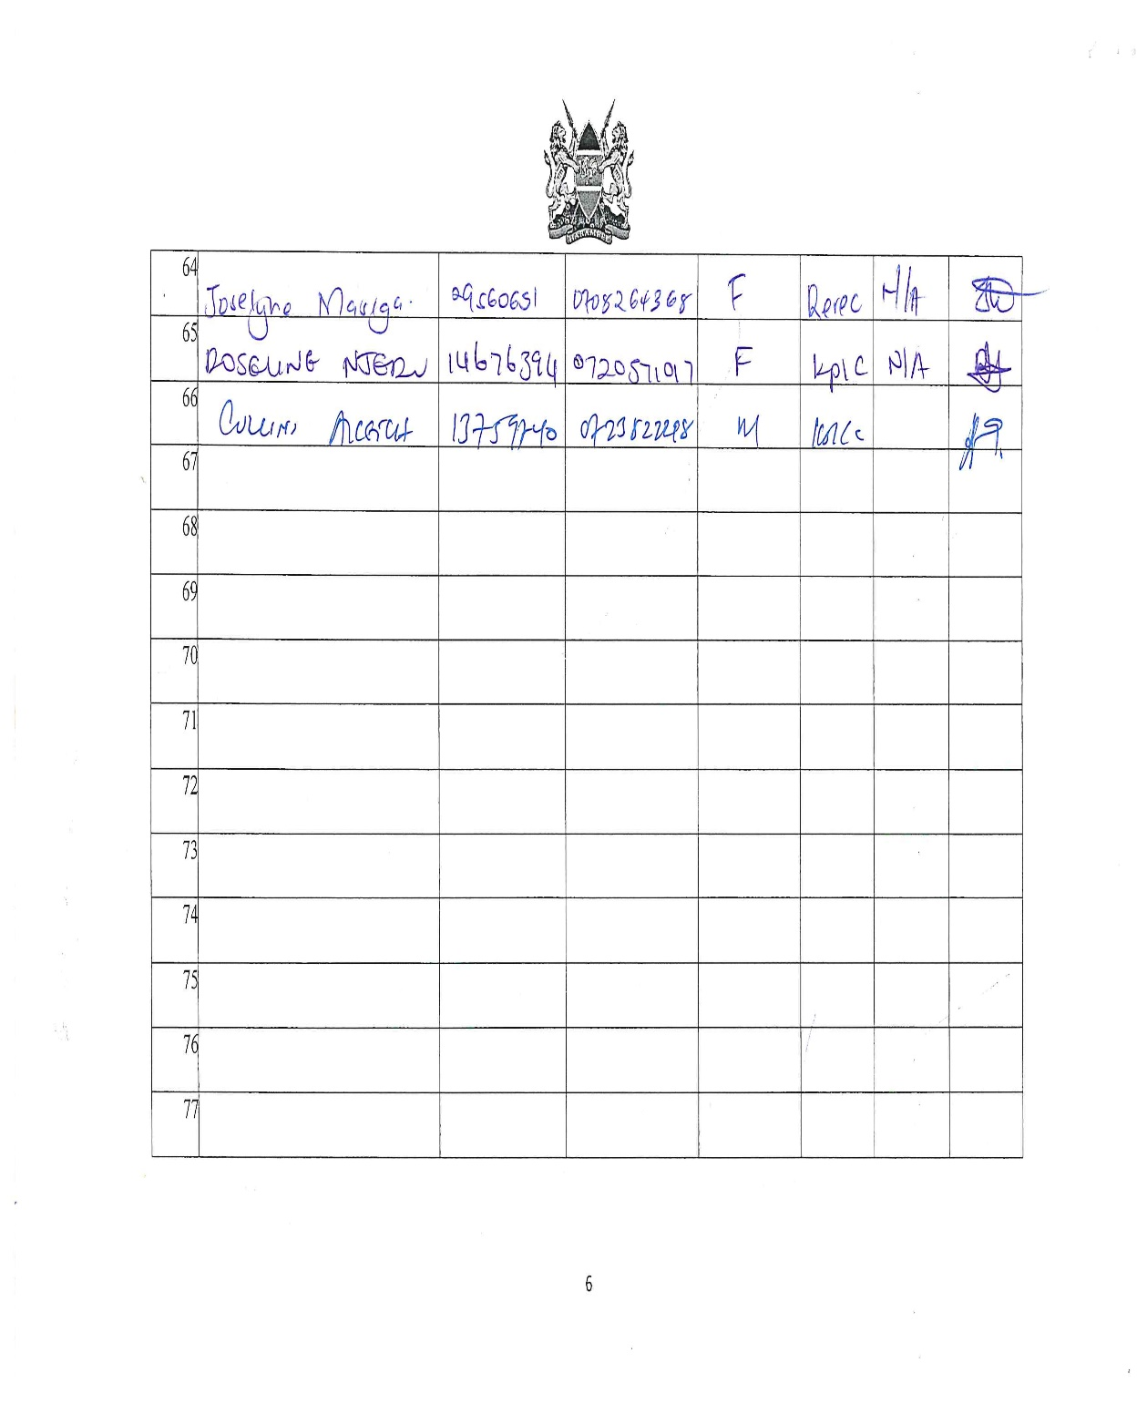

Men Focus Group Discussion Attendance List

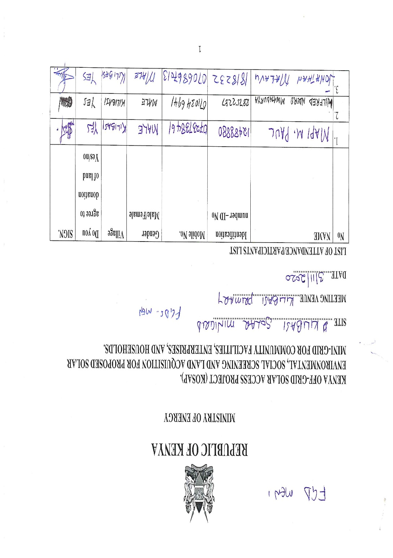
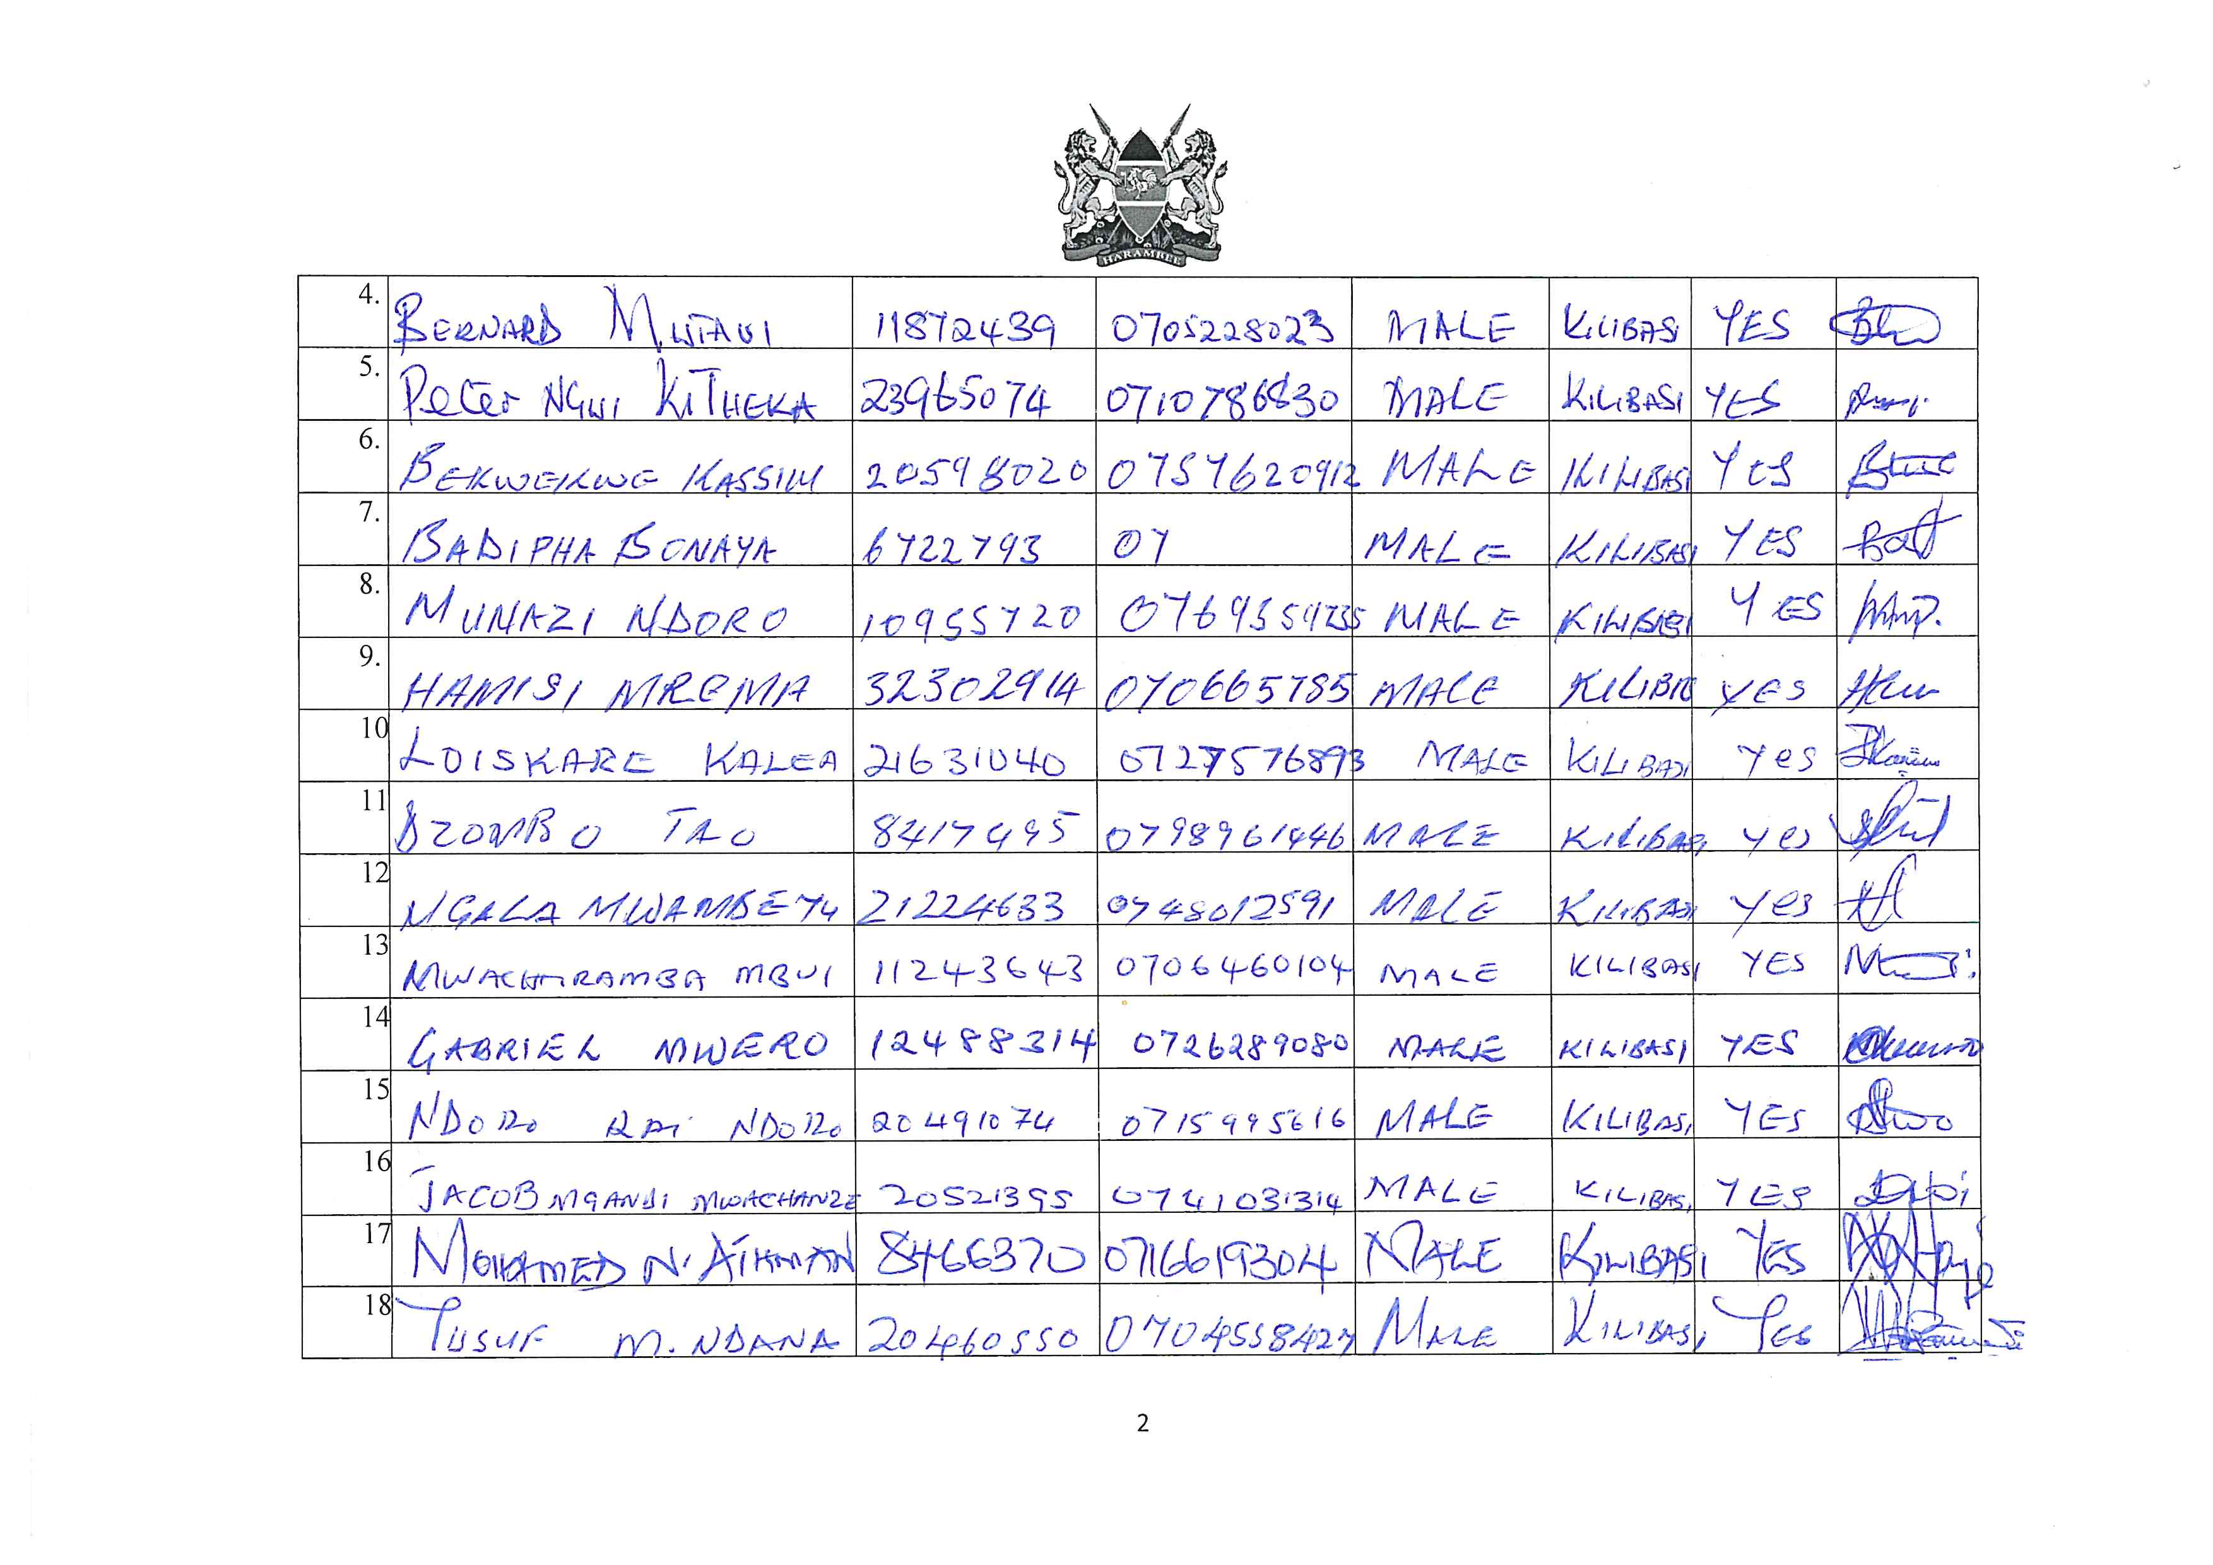

Women Focus Group Discussion Attendance List

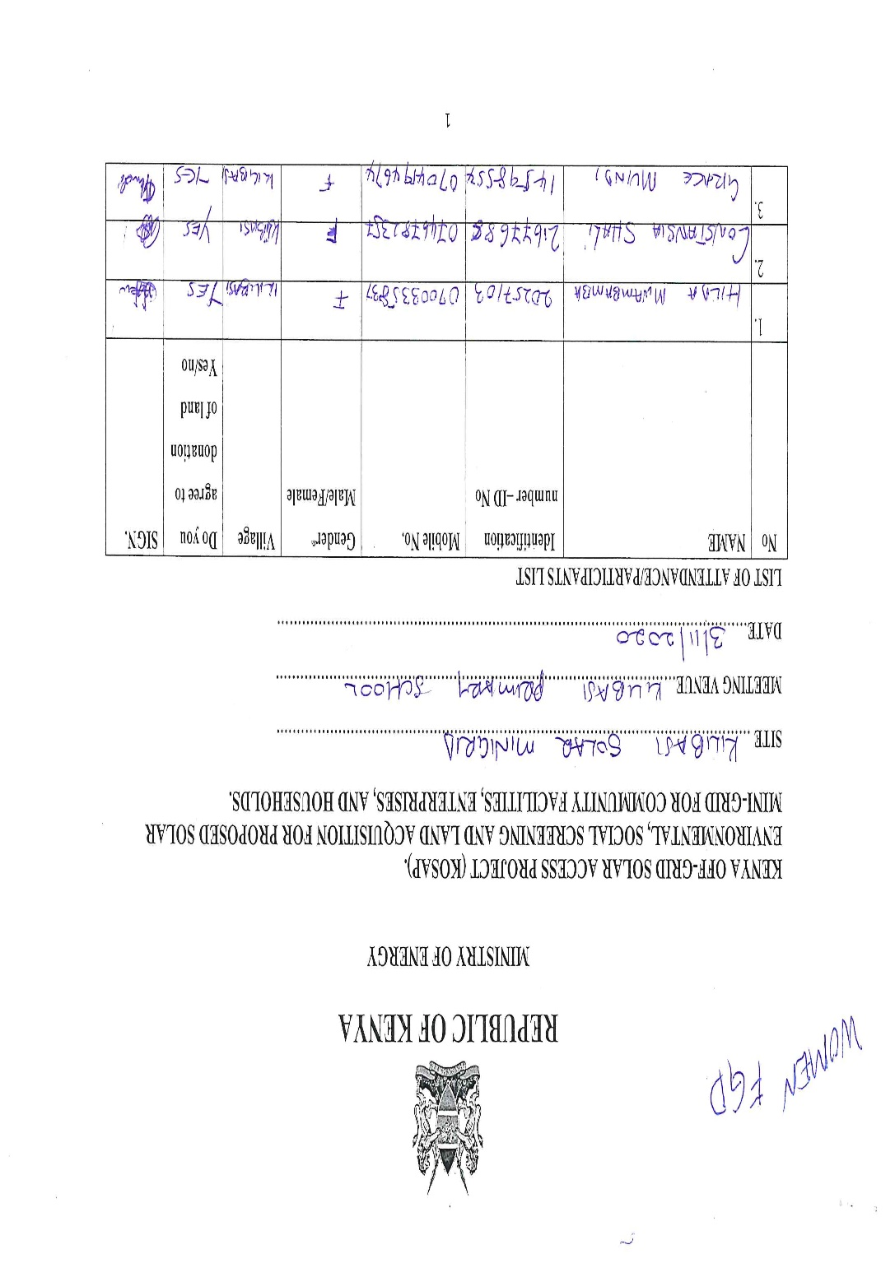
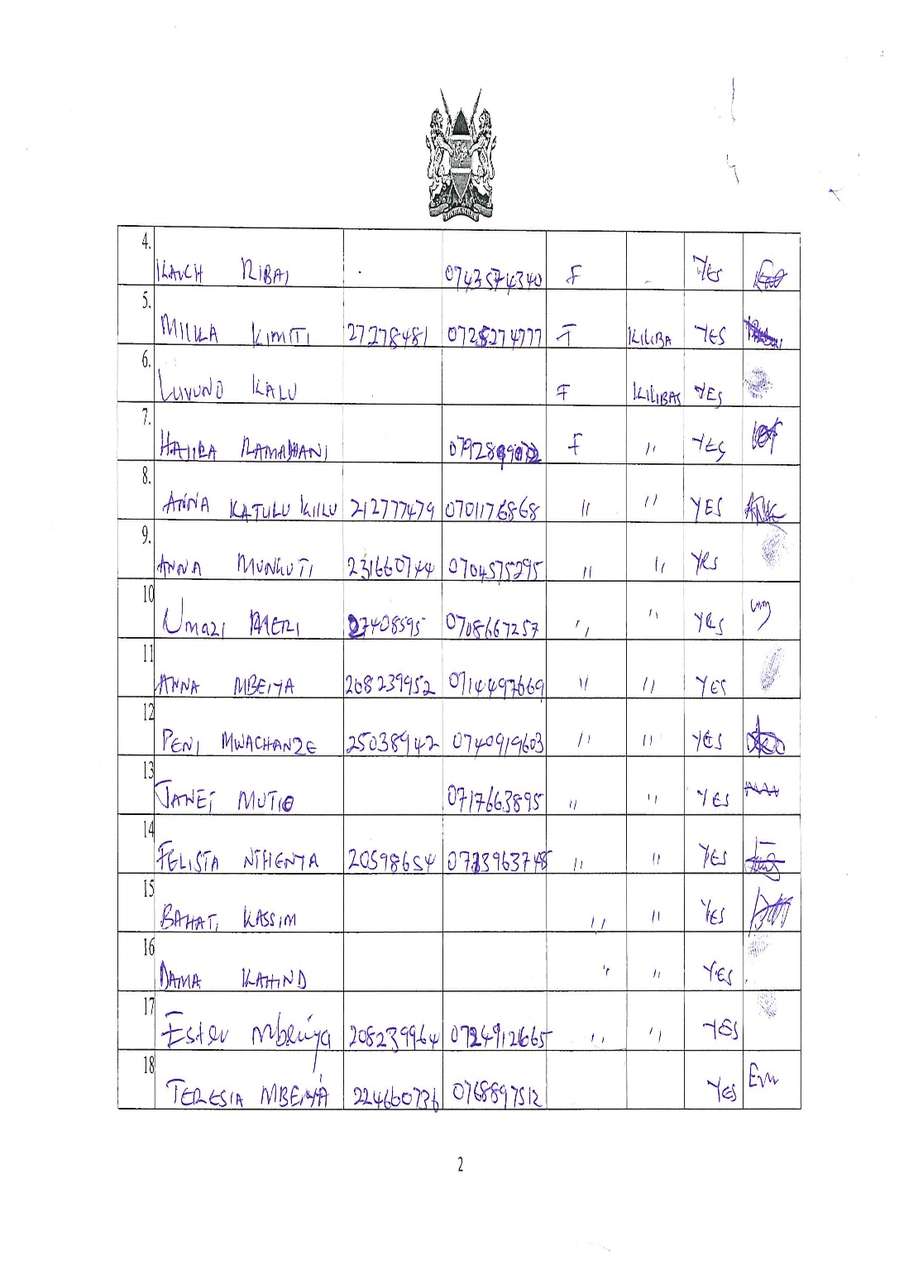
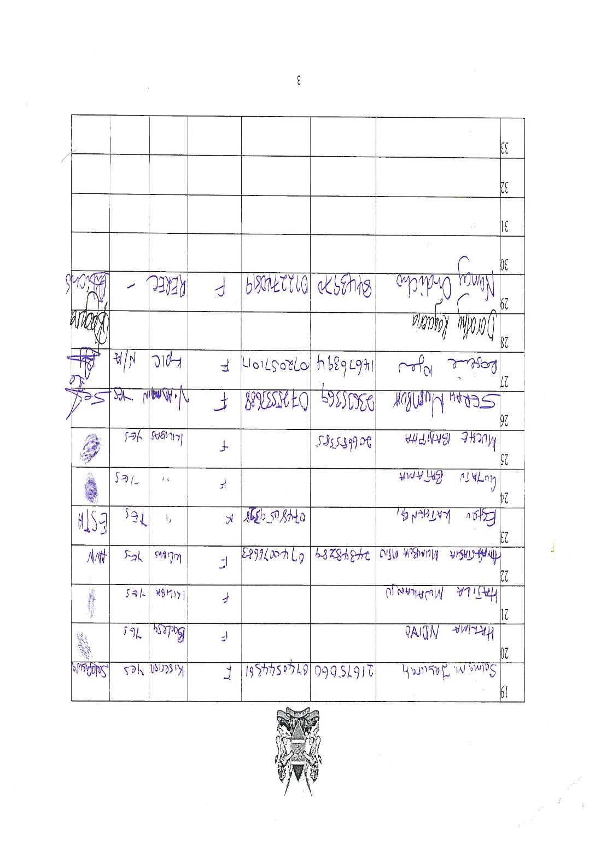

Youth Focus Group Discussion Attendance List

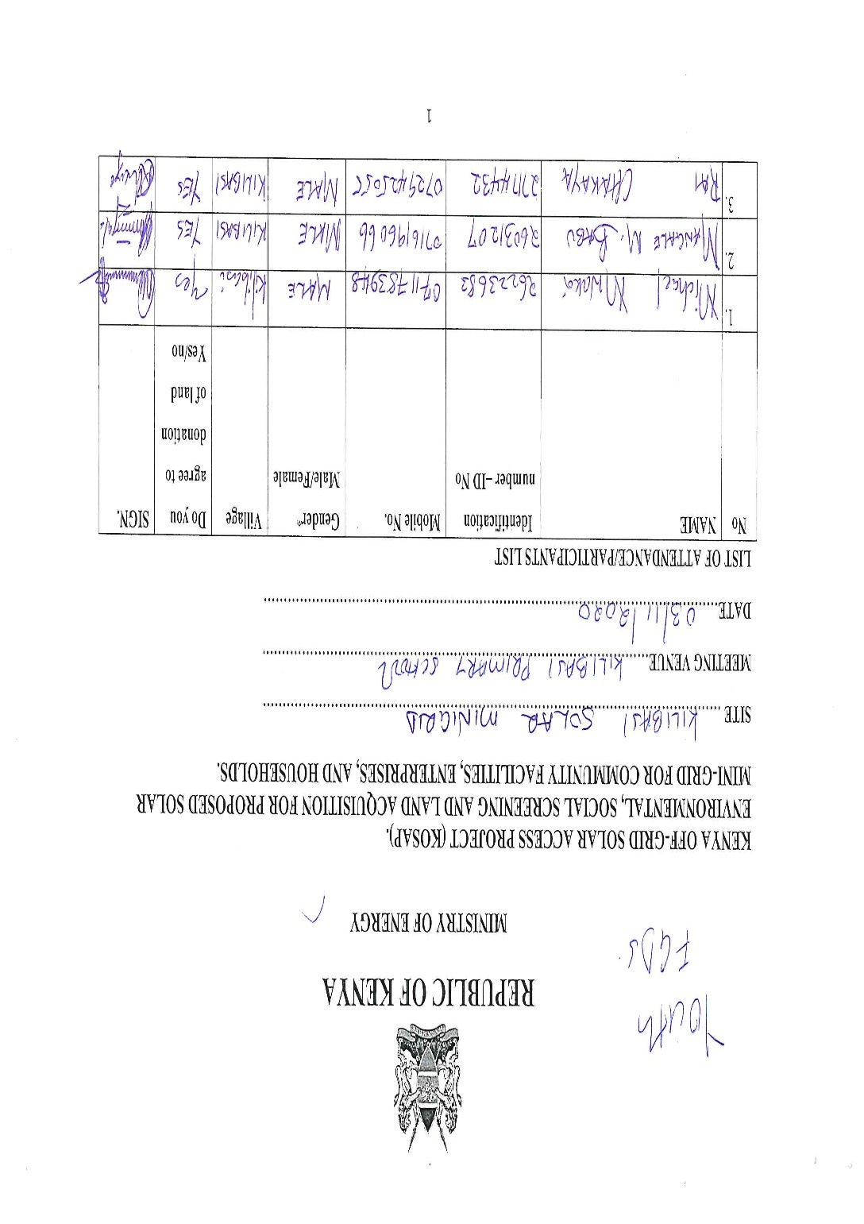
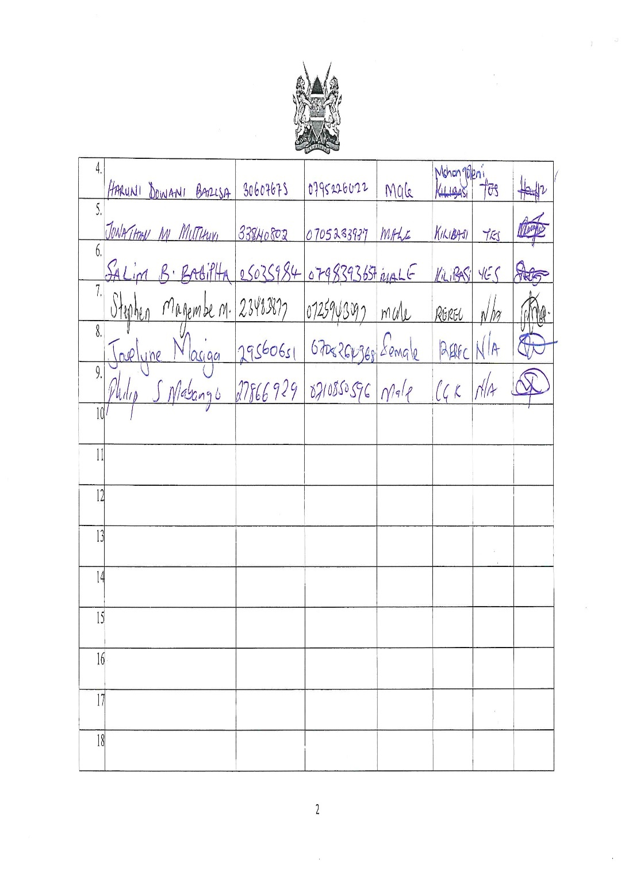

Annex 3: Firm and Lead Expert’s License
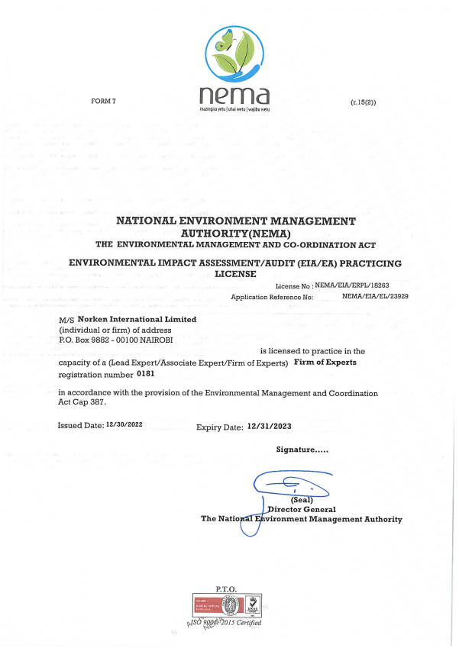

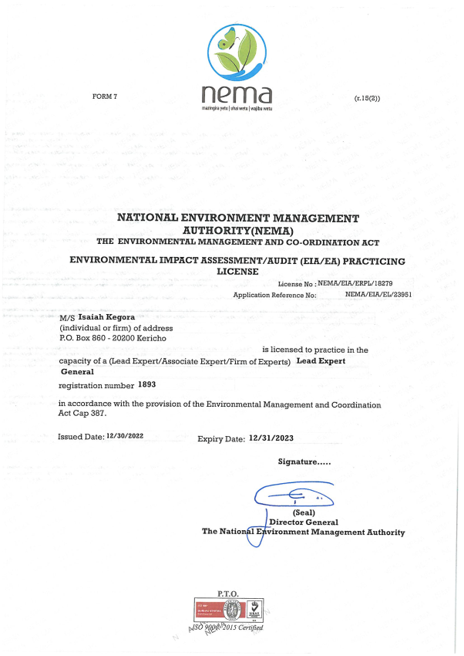

Annex 4: Abbreviated Resettlement Action Plan(A-RAP)

- Kilibasi Sub-project Site
The Kilibasi sub-project site is located on community land Puma ranch in Kilibasi Village, Kilibasi Sub location, Kinango Sub County in Kwale County. The land is held in trust by the County Government of Kwale on behalf of the community, in line with the Community Land Act 2016. The portion of land identified for the mini-grid by the community is part of the 1.214Ha set aside by the community for public purposes or social service projects. The proposed site is uninhabited, has no structures, community facilities, or incumbrances. The site has some trees, shrubs and little to no grass while the western part is characterized by shrubs with intermittent and sparse trees. Consultations leading to the identification and selection of the sub-project site are captured in the Environmental and Social Screening report for Kilibasi. Refer to Chapter 3 of the ESIA for the comprehensive socio-economic profile.

2. Actual Census Survey of PAPs and Valuation of Affected Assets
The number of project-affected persons (PAPs) is 3000 (approximately 250 households). The land acquisition-related impacts are loss of land and pasture. Mitigation measures include in-kind compensation for loss of land and pasture, and designing power distribution lines to avoid impacting trees, crops, structures, and community facilities. No physical displacement is anticipated; however, there is minimal loss of pasture occasioned by the acquisition of land utilized by the community for grazing. The 1.214Ha identified for the sub-project will be acquired compulsorily by the Land Commission (NLC). The proposed site will be valued and compensated in line with the provisions of the Resettlement Policy Framework (RPF) prepared under KOSAP. Refer to section 1.2 of the ESIA for the sketch map of the site.

3. Compensation Measures Agreed with the PAPs and other Resettlement Assistance to be Provided
The proponent requested the community identify three priority projects, whereby one out of the three would be provided as in-kind compensation for loss of land and pasture. The Kilibasi community proposed two projects in order of priority, (i) construction of classrooms at Kilibasi primary school and (b) rehabilitation of the existing water pan. The value of the priority community project will be proportional to or higher than the value of land under acquisition. In addition, any loss or damage to crops, trees, structures, and community facilities will be compensated at full replacement cost, in line with the provisions of the RPF, and as summarized in the entitlement matrix below. Refer to Table 3 of the RPF for a detailed Entitlement Matrix.

3.1 Entitlement Matrix

Types of Impact | Person(s) Affected/Eligible for Compensation | Compensation/Entitlement/Benefits | Responsible organization
- Loss of Land
Loss of unregistered community land. | Community. | Compensation in-kind as prioritized by the community. | KPLC
Loss of land in unregistered group ranches. | Group ranch members. | Compensation in-kind as prioritized by the community.
Loss of land in registered group ranches. | Group ranch members. | Compensation in-kind as prioritized by the community.
Loss of land owned by the National Police, county governments and the Ministry of Interior | Government agencies. | No compensation for public land allocated to another government body.
Loss of land owned by the Kenya Forest Service (KFS) and Kenya Wildlife Service (KWS). | Government agencies. | No compensation for public land allocated to another government body. However, payment of conservation fees to KWS and KFS as stipulated under their respective regulations is foreseen.
- Loss of Use on Land
Loss of use on public land (e.g., grazing, farming etc.). | Communities utilizing public land. | Communities do not own public land; however, they utilize public land with consent from the relevant agencies. The project will implement the infrastructure project prioritized by the community as compensation for the loss of public land use. | KPLC
Loss of use on unregistered community land, unregistered group ranches and registered group ranches ( e.g., grazing, farming etc.). | Communities utilizing unregistered community land, unregistered group ranches, and registered group ranches. | Compensation in-kind as prioritized by the community.
- Loss of /Damage to Assets on Land
Trees | Community members on unregistered community land; community members utilizing public land; members of registered and unregistered group ranches and government entities. | During detailed design for power distribution lines and construction of the mini grid and community project, any crops, structures, trees, and community facilities shall be avoided to the extent possible. However, loss or damage to the above will be compensated/restored at full replacement cost, in line with the provisions of the RPF. | KPLC
Crops
Structures
Community facilities e.g., water sources (earth pans, boreholes etc.). | Community members on unregistered community land, community members utilizing public land, and members of registered and unregistered group ranches.

4. Consultations with PAPs About Acceptable Compensation Options and Alternatives that have been Considered
Detailed consultations with PAPs on land acquisition and compensation, including the modalities of acquiring land and compensation options, were undertaken during the Environmental and Social Screening, Environmental and Social Impact Assessment, and the NLC land valuation process. The following sections provide a summary of the consultations.

4.1 Engagement of Project -Affected Persons (PAPs)
Local administration and County Renewable Energy Officers (CREOs) supported the proponent and implementing agency (IA) to mobilize community members and other stakeholders for public consultations and engagement activities. National and county government entities, community segments (men, women, youth, elders, persons with disability, vulnerable and marginalized groups, etc.), NGOs, and local leaders were engaged through key informant interviews, community meetings, and focus-group discussions. The proponent and IA implemented appropriate measures to ensure PAPs effectively participated in the consultations. Refer to Chapter 6 of the ESIA on Stakeholder Engagement.
Once the compensation award and Bill of Quantities (BoQs) are known, the Implementing Agency (IA) will engage the community and agree on the community project to be executed as in-kind compensation. During these consultations, the IA and the community will define the roles and responsibilities of the community in monitoring the implementation of in-kind compensation and maintenance once the IA hands it over to the community. Thus, the IA and the community will effect an agreement to be signed by the local leadership; representatives of the Grievance Redress Committees at the locational, county, and national levels; A-RAP Implementation Committee, and Implementing Agencies.

4.2 Identification of Community Representatives
The Kilibasi Locational Grievance Redress Committee (LGRC) constituting a chairperson, secretary, and three members, was formed through community consensus. The committee comprises representation from men, women, youth, persons with disabilities, and ethnic minorities. The LGRC is responsible for engaging PAPs and resolving complaints. Refer to chapter 7of the ESIA on the Grievance Redress Committees. Further, the community will constitute the A-RAP Implementation Committee responsible for coordinating community engagements on the A-RAP and monitoring the implementation and closure of the A-RAP. The representation of the committee will consider gender, vulnerability, and intergenerational sensitivities.

4.3 Summary of Consultations on Land Acquisition and Compensation Options
Date | Objective | Implementing  Entities | Land Acquisition and Compensation Aspects  Discussed | Key Issues Raised | Responses  Given
November 2nd 2020 | - Environmental and Social Screening.  - Voluntary land donation (VLD).  - Constitution of the Locational Grievance Redress Committee (GRC). | - Ministry of Energy (MoE).  - Kenya Power (KPLC). | - Site identification and land allocation for the sub-project.  - Criteria for VLD.  - Community entitlements (forms of compensation and implications for each). | Now that we have donated the land, whose ownership will it be. | The ministry proposes that the ownership will be vested in KPLC who will be operating and maintaining the Mini-grid.
 |  |  |  | Some people border one side of people on private land will they be connected to power. | yes they have a right to be connected if they are within the 3km radius of the Mini-grid. In addition, it will depend on way leave issues because we shall have to consult the private owner to grant us way leave consent without compensation so that we can supply them.
October 1st 2021 | - Environmental and Social Impact Assessment. | - Consultants.  - MoE.  - KPLC. | - Land acquisition through compulsory acquisition (not voluntary land donation).  - Selection of three priority community projects, whereby one is to be implemented as in-kind compensation for land. | Community proposed three projects –  -Construction of a new Outpatient Department at Kilibasi dispensary,  - Improvement of existing water supply source by installing solar powered pumps, dispensing unit and other amenities,  Priority  -Supply of electricity to the existing social facilities such as school. | The proponent has set aside KES 1 million to implement the priority in-kind compensation project.  The value of the project will be proportional to or greater than the value of land.  NLC will determine the value of land.
May 2023 | Compulsory Land Acquisition. | - NLC. | - Site inspection and inquiries.  - Land valuation.  - Award of compensation.

5. Institutional Responsibility for Implementation of the ARAP
Entity | Role
Ministry of Energy | - Coordinate A-RAP implementation and provide budget for in-kind compensation.
National Land Commission | - Implement the statutory process for compulsorily land acquisition, including site gazettement and inspections, inquiries, valuation, and award of compensation.
Kenya Power | - Monitor all land acquisition and compensation aspects (including A-RAP closure), complemented by a third-party monitor.  - Provide budgets for stakeholder engagement, grievance management, and monitoring, including the facilitation of the Land Acquisition and Compensation Implementation Committee, and the Grievance Redress Committee.
Mini-grid Contractor | - Implement in-kind compensation concurrently with the solar mini-grid project.
Supervising Consultant | - Monitor and report on implementation of in-kind compensation, and overall project compliance with social safeguards.
Grievance Redress Committees | - Formed at the locational, county, and national levels, and responsible for resolving complaints, including A-RAP related grievances.
A-RAP Implementation Committee | - Coordinate A-RAP engagements at the community level, monitoring A-RAP implementation and closure.
Affected Community | - Responsible for the operation and maintenance (O&M) of in-kind compensation project. An agreement stipulating the O&M roles and responsibilities of the community will be effected.

6. Procedures for Grievance Redress
The Project procedures for grievance redress were established through a public consultation process and informed by the existing conflict resolution structures in the community. The Grievance Redress Mechanism (GRM) comprises tiers at the project, county, and national levels. Refer to Chapter 6 of the ESIA for a detailed GRM.

7. Implementation Timetable and Budget for the ARAP Implementation

7.1 Timelines
The proponent will commission the community project by May 25th, 2025, before operationalizing the mini-grid. The mini-grid contractor will implement the mini-grid and the community project simultaneously. The Supervision Consultant and IAs will implement a commitment register to ensure the mini-grid contractor can achieve the agreed-upon milestones. The register will be complete with clear and practical timebound indicators, which can be monitored by all parties – the PAPs, IAs, the Ministry, third-party monitor, and the Bank.

7.2 Budget
The proponent has set aside KES 1 million for the community project (budget captured in the ESMP). The compensation award from NLC and the Bill of Quantities will inform the final cost of the community project. The costs for in-kind compensation, stakeholder engagement, grievance management (including the facilitation of the GRCs and the A-RAP Implementation Committee), and monitoring are covered under the project..

A cost basis that will yield compensation sufficient to replace assets, plus necessary transaction costs associated with asset replacement).

